**UNIT-1**



**Analysis of three phase balanced circuits**

1



Overview

* An electric power distribution system looks like:

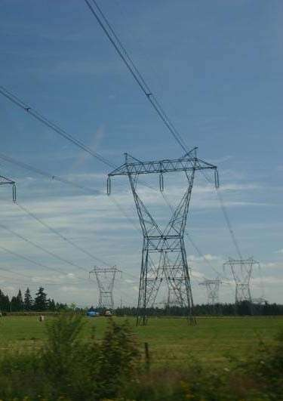

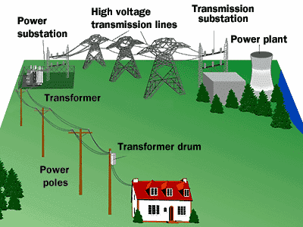

Where the power transmission uses“ balanced three-phase” configuration.



Whythree-phase?

* Three-phase generators can be driven by constant force or torque(to be discussed).
* Industrial applications, such as high-power motors, welding equipments, have constant power output if they are three-phase systems (to be discussed).



Keypoints

* What is a three-phase circuit (source, line, load)?
* Why a balanced three-phase circuit can be analyzedbyanequivalentone-phasecircuit?
* How to getalltheunknowns(e.g.linevoltageof the load) by the result of one-phase circuit analysis?
* Why the total instantaneous power of a balancedthree-phasecircuitisaconstant?



Section 11.1, 11.2 Three-PhaseSystems

* 1. Three-phase sources
  2. Three-phasesystems



One-phase voltage sources

* One-phase ac generator: static magnets, one rotatingcoil,singleoutputvoltage*v*(*t*)=*Vm*cos*t*.

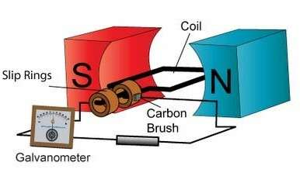

[(www.ac-motors.us)](http://www.ac-motors.us/)

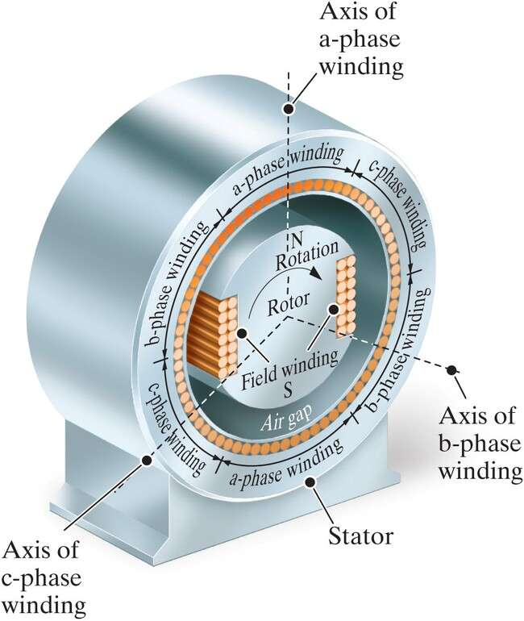



Three-phase voltage sources

* Three static coils, rotating magnets, threeoutputvoltages *va*(*t*), *vb*(*t*), *vc*(*t*).



IdealY-and -connected voltage sources

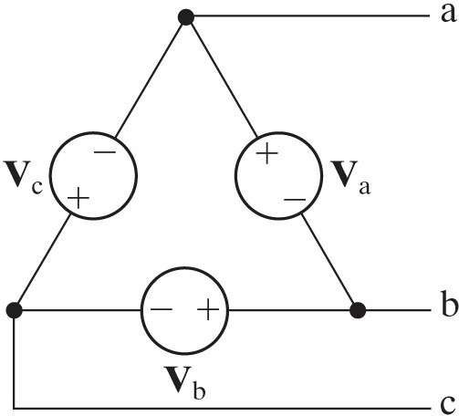

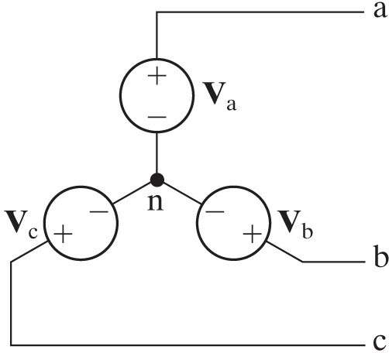

Neutral



RealY-and -connected voltage sources

* Internalimpedanceofageneratorisusually inductive (due to the use of coils).

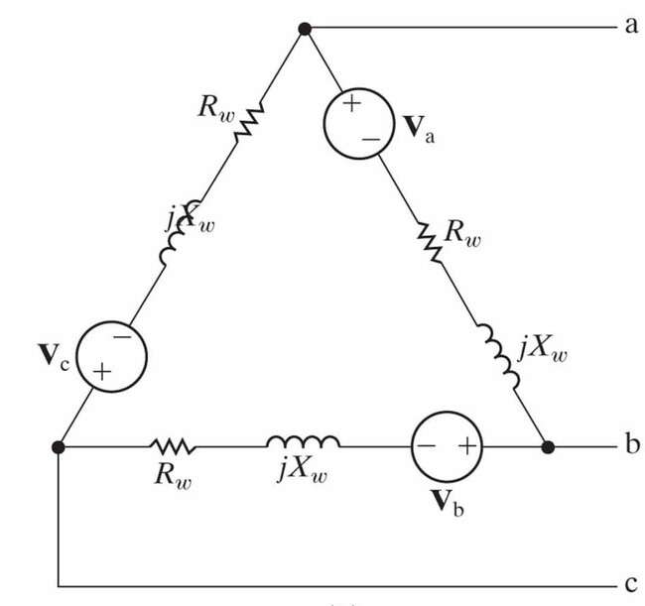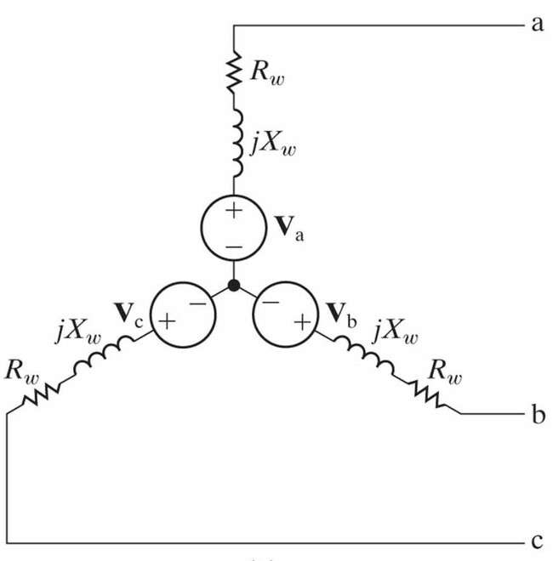

Balancedthree-phasevoltages

* Three sinusoidal voltages of the same amplitude,frequency,butdifferingby120phase difference with one another.
* There are two possible sequences:

1. abc(positive)sequence: *vb*(*t*)lags*va*(*t*)by120ͦ
2. acb(negative)sequence:*vb*(*t*)leads*va*(*t*)by

120ͦ.

abcsequence

* + *vb*(*t*) lags *va*(*t*) by120ͦ or *T*/3.
  + 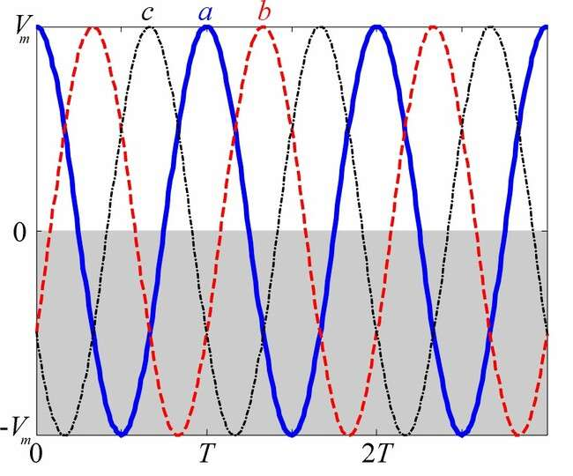**V***a*

=*Vm*

∟0∘,

**V***b*=*Vm*

∟120∘,

**V***c*=*Vm*

∟120∘.

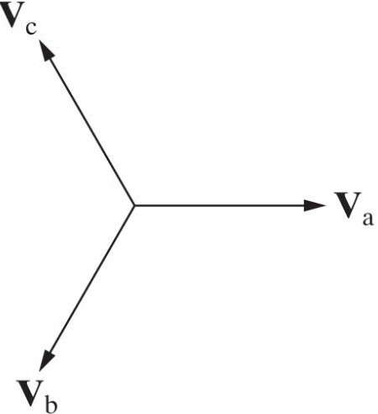

Three-phasesystems

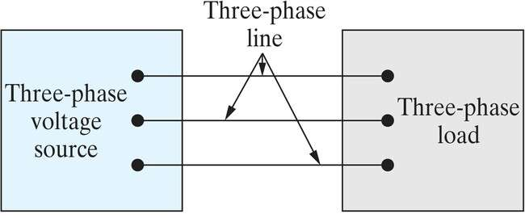

(Y or )

(Y or )

* + Source-load can be connected in four configurations: Y-Y, Y-∆, ∆-Y, ∆-∆
  + It’s sufficient to analyze Y-Y, while the others can be treated by ∆-Y and Y-∆ transformations.



Section11.3

AnalysisoftheY-YCircuit

1. Equivalentone-phasecircuitfor balanced Y-Y circuit
2. Linecurrents,phaseandline voltages

General Y-Y circuit model

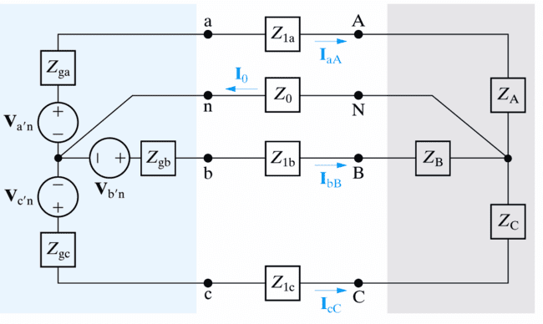

Ref.

The only essential node.

Unknowns to be solved

* + Line (line-to-line) voltage: voltage acrossanypairof lines.

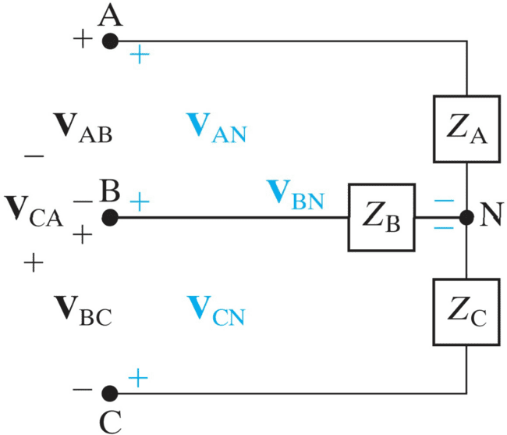

Linevoltage

Phase voltage

Phase current

* + Phase (line-to- neutral) voltage: voltageacrossa single phase.

Linecurrent

* + ForY-connectedload,linecurrentequalsphase current.



Solution to general three-phase circuit

* + Nomatterit’sbalancedorimbalanced three- phase circuit, KCL leads to one equation:

**I**0

**I***aA*

* **I***bB*
* **I***cC*,

**V***N* 

**V***a**n*

* **V***N*
  + **V***b**n*
* **V***N*
  + **V***c**n*
* **V***N*

…(1),

*Z*0 *Zga*

*Z*1*a*

*ZA*

*Zgb*

*Z*1*b*

*ZB*

*Zgc*

*Z*1*c*

*ZC*

Impedance of neutral line.

Total impedance alonglineaA.

Total impedance alonglinebB.

Total impedance alonglinecC.

whichissufficienttosolve**V***N*(thustheentire circuit).



Solution to “balanced”three-phase circuit

* For balanced three-phase circuits,

1. {**V***a'n*,**V***b'n*,**V***c'n*}have equalmagnitude and120

relative phases;

1. {*Zga*=*Zgb*= *Zgc*},{*Z*1a=*Z*1b=*Z*1c},{*ZA*=*ZB*= *ZC*};

total impedance along any line is the same

*Zga*+*Z*1a+*ZA*=… =*Z*.

* + Eq. (1) becomes:

**V***N* 

**V***a**n*

* **V***N*
* **V***b**n*
* **V***N*
* **V***c**n*
* **V***N*,

*Z*0 *Z* *Z* *Z*





1

**V***N*



*Z*0

3 **V***a**n*





 

*Z*



* **V***b**n*

*Z*

* **V***c**n*

0,

**V***N* 0.

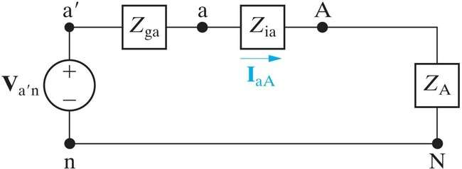



Meaning of the solution

* + **V***N*= 0 means no voltage difference between nodes ***n*** and***N*** inthepresenceof *Z*0.Neutral line is both short (*v* = 0) and open (*i* = 0).
  + Thethree-phasecircuitcanbeseparatedinto3 one-phase circuits (open), while each of them has a short between nodes ***n*** and ***N***.

Equivalent one-phase circuit



Linecurrent

**I**nn=0**I**aA

Phase voltage of load

Phase voltage ofsource

* + Directly giving the line current & phase voltages:

**I***aA*



,**V***AN* 

**I***aAZA*,

**V***an*

**I***aA*

*Z*1*a*

*ZA*.

* + Unknownsofphasesb,ccanbedeterminedby the fixed (abc or acb) sequence relation.



*Z*

*ga*

*Z* *Z**Z*

**V***a**n***V***N*

1*a*

*A*



The 3 line and phase currents in abcsequence

* + Given**I***aA***V***a**nZ*,theother2linecurrentsare:

**I** **V***b**n* **I** 120∘, **I** **V***c**n* **I** 120∘,

*Z*

*Z*

*bB aA*



*cC*



*aA*

which still followtheabc sequence relation.



**I***cC*

**I***aA*



**I***bB*

The phase & line voltages of the load in abcseq.

**V***AN*

**V***a**n*

*ZA*,

*Z*

**V***BN*

**V***b**n B*

*Z*

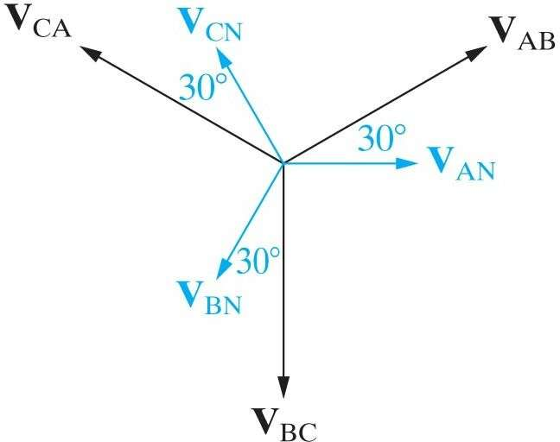

120∘

Phase

voltage

Line voltage

*Z*

**V***AN*

120∘,

**V***CN*

**V***AN*

120∘.

**V***AB*



**V***AN*

**V***AN*

−

−

**V***BN*

**V**

*AN*

120∘

(abc sequence)

 3**V***AN*

**V**

*AN*

*AN*

30∘,

**V***BC*

120∘**V** 

 3**V***AN*90∘,

**V**

**V***CA* 120∘

*AN*

**V***AN*

 3**V***AN*



150∘.

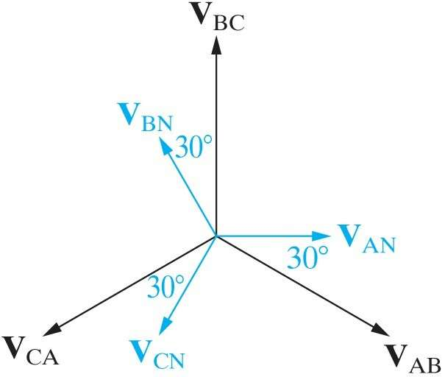Thephase & line voltages of the load in acb seq.

**V***AB*

**V***AN*

**V***AN*

* **V***BN*
* *AN*

**V**

120∘

(acb sequence)

 3**V***AN*30∘,

Phase voltage

**V**

**V**

**V***BC* 120∘

*AN*

*AN*

120∘

 3**V***AN*90∘,

**V**

**V***CA* 120∘

Line voltage

*AN*

**V***AN*

 3**V***AN*

150∘.

* + Linevoltagesare 3 timesbigger,leading(abc) or lagging (acb) the phase voltages by 30.



Example 11.1 (1)

* + Q: What are the line currents, phase and line voltagesoftheloadandsource,respectively?

*Zga Z*1*a*

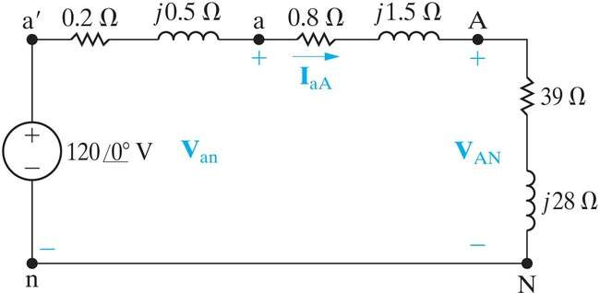

Phase voltages *Z*A

(abc sequence)

*Z**=Zga*+*Z*1a+*Z*A=40+*j*30.

Example 11.1 (2)

* + The 3 line currents(of both load & source) are:

*a**n*

2.4

36.87∘

A,

 **V** 

**I**

1200∘  

*aA*

*Z*

*ga*

* *Z*1*a*
* *ZA*

40

*j*30

**I***bB* **I**

**I***aA*

**I**

120∘

120∘

2.4156.87∘A,

2.483.13∘A.

*cC aA*

* + The3 phasevoltagesofthe load are:

**V***AN*

**I***aAZA*2.436.87∘39

*j*28115.221.19∘V.

**V***BN* **V***CN*



**V***AN*120∘

**V***AN*120∘

115.22121.19∘V,

115.22118.81∘V.

Example 11.1 (3)

* + The3 linevoltagesofthe loadare:

**V***AB*



330∘**V**

330∘115.221.19∘

*AN*

199.5828.81∘V,

**V***BC*

**V***AB*

120∘

199.5891.19∘V,

**V***CA*

**V***AB*

120∘

199.58148.81∘V.



Example 11.1 (4)

* + The3 phasevoltagesofthe source are:

**V** **V****I** *Z* 1202.436.87∘0*.*2

*j*0*.*5

*an an aA ga*

118.90.32∘V,

**V***bn* **V***cn*

**V***an*

**V***an*

120∘

120∘

118.9

118.9

120.32∘V,

119.68∘V.

* + Thethree linevoltagesofthesource are:

**V***ab*330∘**V** 330∘118.90.32∘

*an*

205.9429.68∘V,

**V***bc* **V**



**V***ab*

**V**

120∘

120∘

205.9490.32∘V,

205.94149.68∘V.



Section11.4

AnalysisoftheY-Circuit



Load in configuration

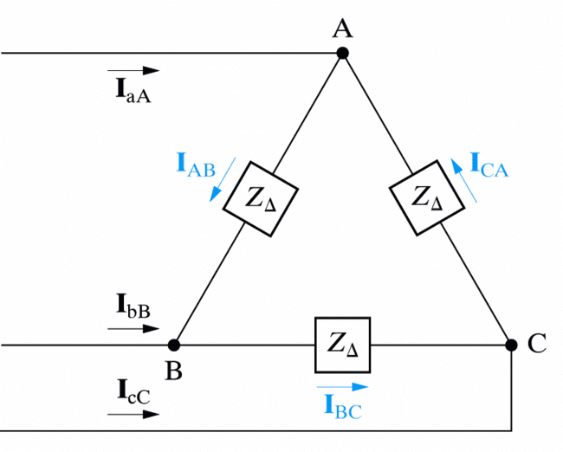

Linecurrent

Phase current

Linevoltage= Phasevoltage

-Y transformation for balanced 3-phase load

* The impedance of each leg in Y-configuration

(*Z*Y)is one-third ofthat in -configuration(*Z*):

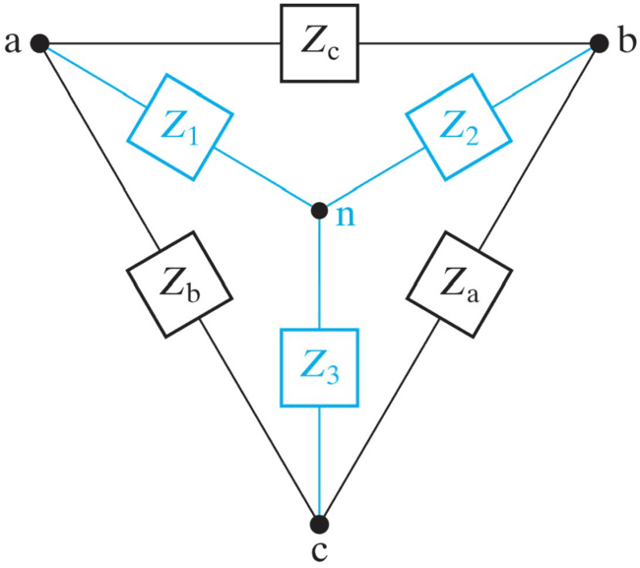*Z* *ZbZc* ,

1

*Z*



*Z*



*Z*

*a b c*

*Z*  *ZcZa* ,

2

*Z*



*Z*



*Z*

*a b c*

*Z*  *ZaZb* .

3

*Z*



*Z*



*Z*

*a b c*

*Z*

3

*ZY*

*Z**Z*

3*Z*

 .





Equivalent one-phase circuit

* The1-phaseequivalentcircuitinY-Yconfig. continues to work if *Z*Ais replaced by *Z*/3:



Linecurrent

Line-to-neutral voltage Phasevoltage

Line voltage

directly giving the line current:**I** 

**V***a**n* ,

*aA*

*ga*

*Z*1*a**ZA*

and line-to-neutral voltage:



*Z*

**V***AN*

**I***aAZA*.

The 3 phase currents of the load in abcseq.

* Canbesolvedby3nodeequationsoncethe3 line currents **I**aA, **I**bB, **I**cCare known:

**I***aA*

**I***AB*

* **I***CA*,

**I***bB*

**I***BC*

* **I***AB*,

**I***cC*

**I***CA*

* **I***BC*.

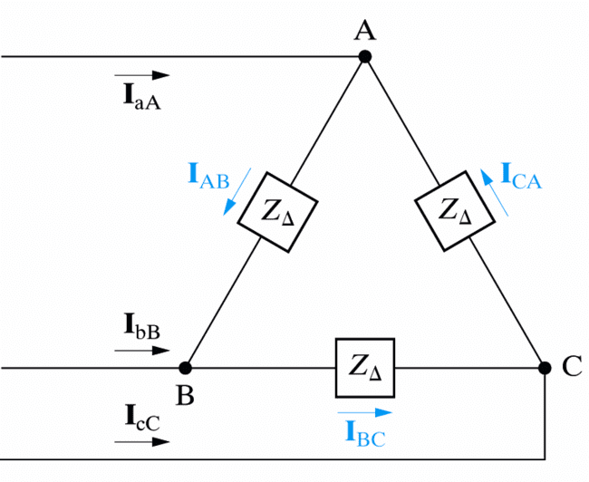

Linecurrent

Phase current

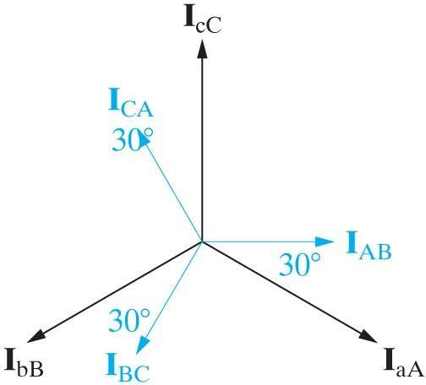

(abc

sequence)

Linecurrent

Phase current



Section11.5

Power Calculations in BalancedThree-Phase Circuits

1. Complexpowersofone-phaseand the entire Y-Load
2. Thetotalinstantaneouspower

Average power of balanced Y-Load

* The average power delivered to*ZA*is:

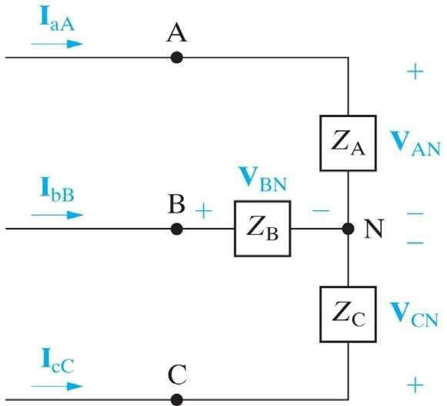*PA**V**I*cos,

*V*

**V***AN*

*VL* ,



*I*

**I***aA*

3

*IL*,

(rmsvalue)





*V*

* *I*

*ZA*.

* + The total powerdelivered to the Y-Load is:

*Ptot*



3*PA*

3*V**I*

cos

3*VLIL*

cos.

Complex power of a balanced Y-Load

* + Thereactivepowersofonephaseandthe entire Y-Load are:

*Q*



*V**I*sin,

*Qtot*

3*V**I*

sin

3*VLIL*

sin.

* + Thecomplexpowersofonephaseandthe entire Y-Load are:

*S* *P*

*jQ*

*VI*

*ej*

**V I**\*;

 



    

*j* *j*



*S*



*tot*

3*S*

3*V*

*I**e* 

3*VL*

*ILe* .



One-phase instantaneous powers

* The instantaneous power of load *ZA*is:

*pA*(*t*)*vAN*(*t*)*iaA*(*t*)*VmIm*cos*t*cos(*t*).

* + The instantaneous powersof*ZA*,*ZC*are:

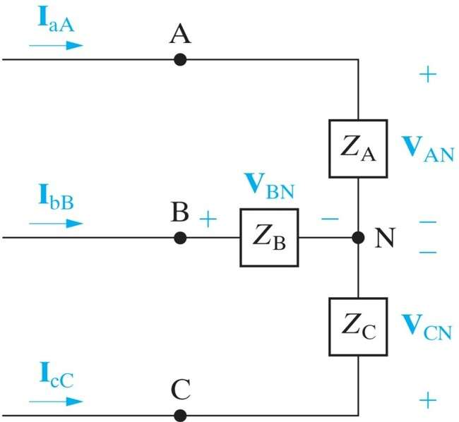

(abc sequence)

*pB*(*t*) *vBN*(*t*)*ibB*(*t*)

*VmIm*cos*t*120∘

cos*t*120∘,

*pC*(*t*)*VmIm*cos*t*120∘

cos*t*120∘.

Total instantaneous power

* TheinstantaneouspoweroftheentireY-Load is a constant independent of time!

*ptot*(*t*)*pA*(*t*)

*pB*(*t*)

*pC*(*t*)1.5*VmIm*

cos

## 1.5

2*V*2*I*

cos

3*V**I*

cos.

* Thetorquedevelopedattheshaftofa3-phase motor is constant, less vibration in machinery powered by 3-phase motors.



* The torque required to empower a 3-phase generatorisconstant,needsteadyinput.



Example 11.5 (1)

* Q: What are the complex powers provided by

the source and dissipated by the line of a-phase?

* Theequivalentone-phasecircuitinY-Y configuration is:

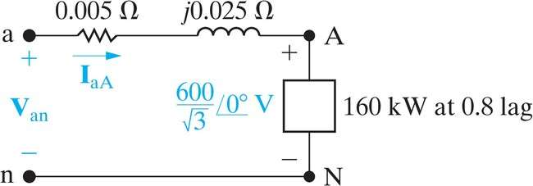

***Z*1*a***

*S*

(rmsvalue)

Example 11.5 (2)

* Thelinecurrentofa-phasecanbecalculatedby the complex power is:

*S*

**V****I**\*,

160

*j*120103

# 600*

*aA*

3

**I**

,

**I***aA*



# 577.35

36.87∘A.

* Thea-phasevoltageof thesource is:

**V***an***V***AN*

**I***aAZ*1*a*

## 600 3577.35

36.87∘0.005

*j*0.025

## 357.511.57∘V.



Example 11.5 (3)

* Thecomplexpowerprovidedbythe sourceofa- phase is:

**I**



*San*

**V***an*

* 357.511.57∘577.3536.87∘

# 206.4138.44∘kVA.

*aA*

* Thecomplexpowerdissipatedbythelineofa- phase is:

*SaA*

**I***aA*

*Z*1*a*

577.3520.005

*j*0.025

# 8.5078.66∘kVA.



2



Keypoints

* What is a three-phase circuit (source, line, load)?
* Why a balanced three-phase circuit can be analyzedbyanequivalentone-phasecircuit?
* Howtogetalltheunknowns(e.g.linevoltageof the load) by the result of one-phase circuit analysis?
* Why the total instantaneous power of a balancedthree-phasecircuitisaconstant?

S.Boyd EE102

## **UNIT-II**

**The Laplace transform**

* definition&examples
* properties&formulas
  + linearity
  + theinverseLaplacetransform
  + timescaling
  + exponentialscaling
  + timedelay
  + derivative
  + integral
  + multiplicationby*t*
  + convolution

#### Idea

theLaplacetransformconverts*integral*and*differential*equationsinto

*algebraic*equations

thisislikephasors,but

* appliestogeneralsignals,notjustsinusoids
* handlesnon-steady-stateconditions

allowsustoanalyze

* LCCODEs
* complicatedcircuitswithsources,Ls,Rs,andCs
* complicatedsystemswithintegrators,differentiators,gains

#### Complexnumbers

complexnumberinCartesianform:*z*=*x*+*jy*

* *x*=঩*z*,the*realpart* of*z*
* *y*==*z*,the*imaginarypart*of*z*

*j*=√1(engineeringnotation);*i*=√1ispoliteterminmixed

* — —

company

complexnumberinpolarform:*z*=*rejφ*

* *r*isthe*modulus*or*magnitude*of*z*
* *φ*isthe*angle*or*phase*of*z*
* exp(*jφ*)=cos*φ*+*j*sin*φ*

complexexponentialof*z*=*x*+*jy*:

*ez*=*ex*+*jy*=*exejy*=*ex*(cos*y*+*j*sin*y*)

#### TheLaplacetransform

we’llbeinterestedinsignalsdefinedfor*t*≥0

theLaplacetransformofasignal(function)*f*isthefunction*F*= (*f*)

L

definedby

∫

*F*(*s*)=

∞

*f*(*t*)*e*−*stdt*

0

forthose*s*∈Cforwhichtheintegralmakessense

* *F*isacomplex-valuedfunctionofcomplexnumbers

*s*iscalledthe(complex)*frequencyvariable*,withunitssec−1the*timevariable* (insec);*st* isunitless

•

* fornow,weassume*f*containsnoimpulsesat*t*=0

;*t*iscalled

commonnotationconvention:lowercaseletterdenotessignal;capital letterdenotesitsLaplacetransform,*e.g.*,*U*denotesL(*u*),*V*indenotes L(*v*in), etc.

#### Example

let’sfindLaplacetransformof*f*(*t*)=*et*:

*F*(*s*)=

∞

##### ete−stdt=

∫

0

∞

*e*(1−*s*)*tdt*=

∫

0

1 1—*s*

(1−*s*)*t*

¯0

*e*

= 1

*s*—1

∞

providedwecansay*e*(1−*s*)*t*→0as*t*→∞,whichistruefor঩*s>*1:

*e*(1−*s*)*t* = *e*−*j*(=*s*)*t e*(1−঩*s*)*t* =*e*(1−঩*s*)*t*

¯ ¯ ¯ ¯

¯ ¯

` =˛¸1 x

the*integral*defining*F*makessenseforall*s* Cwith *s>*1(the

* ∈ ঩

##### ‘regionofconvergence’ofF)

* buttheresulting*formula*for*F*makessenseforall*s*∈C*excepts*=1

we’llignorethese(sometimesimportant)detailsandjustsaythat

L(*et*)=

1

*s*—1

#### Moreexamples

constant:(orunitstep)*f*(*t*)=1(for*t*≥0)

*F*(*s*)=

∞

*e*−*stdt*=

∫

—

0

1*e*−*st* =1

*s* ¯0 *s*

∞

providedwecansay*e*−*st*→0as*t*→∞,whichistruefor঩*s>*0since

¯*e*−*st*¯=¯*e*−*j*(=*s*)*t*¯ *e*−(঩*s*)*t* =*e*−(঩*s*)*t*

¯ ¯

` =˛¸1 x

* the*integral*defining*F*makessenseforall*s*with঩*s>*0
* buttheresulting*formula*for*F*makessenseforall*sexcepts*=0

sinusoid:firstexpress*f*(*t*)=cos*ωt*as

*f*(*t*)=(1*/*2)*ejωt*+(1*/*2)*e*−*jωt*

nowwecanfind*F*as

∞

∫

*F*(*s*) =

0

*e*−*st*

¡(1*/*2)*ejωt*+(1*/*2)*e*−*jωt*¢*dt*

= (12)∫∞

+(12)∫∞

*/ e*(−*s*+*jω*)*tdt*

0

*/ e*(−*s*−*jω*)*tdt*

0

= (1*/*2) 1

*s*—*jω*

+(1*/*2) 1

*s*+*jω*

= *s*

*s*2+*ω*2

(validfor঩*s>*0;finalformulaOKfor*s*/=±*jω*)

powers of *t*: *f*(*t*) =*tn*(*n*≥1) we’llintegratebyparts,*i.e.*,use

∫*b*

*u*(*t*)*v*′(*t*)*dt*=*u*(*t*)*v*(*t*)

*a*

¯ ∫*b*

*a*

*a*

with*u*(*t*)=*tn*,*v*′(*t*)=*e*−*st*,*a*=0,*b*=∞

∫∞ µ—*e*−*st*¶¯∞ *n*∫∞

*b*

¯

—

*v*(*t*)*u*′(*t*)*dt*

*F*(*s*)=

*tne*−*stdt* = *tn*

*s*

¯

+

*tn*−1*e*−*stdt*

*n*

0

0

*s*

0

= (*tn*−1)

L

##### s

provided*tne*−*st*→0if*t*→∞,whichistruefor঩*s>*0

applyingtheformularecusively,weobtain

*n*!

*F*(*s*)=

*sn*+1

validfor঩*s>*0;finalformulaOKforall*s*/=0

#### Impulsesat*t*=0

if*f*containsimpulsesat*t*=0wechooseto*include*themintheintegral defining *F*:

∫

*F*(*s*)=

∞

*f*(*t*)*e*−*stdt*

0−

(youcanalsochoosetonotincludethem,butthischangessomeformulas we’ll see & use)

example:impulsefunction,*f*=*δ*

=1

*F*(*s*)=

∞

*δ*(*t*)*e*−*stdt*=*e*−*st*

∫

¯

0−

*e*

−*st*

¯

=*ske*−*st*¯

=*sk*

*t*=0

similarlyfor*f*=*δ*(*k*)wehave

∫∞

*δ*(*k*)(*t*)*e*−*stdt*=(—1)*k*

*F*(*s*)=

0−

*dk* ¯ ¯

*dtk*

*t*=0

*t*=0

#### Linearity

theLaplacetransformis*linear*:if*f*and*g*areanysignals,and*a* isany scalar,wehave

L(*af*)=*aF,* L(*f*+*g*)=*F*+*G*

*i.e.*,homogeneity &superposition hold

example:

L3*δ*(*t*)—2*et* = 3L(*δ*(*t*))—2L(*et*)

¡ ¢

= 3 2

—

*s*—1

= 3*s*—5

*s*—1

#### One-to-oneproperty

theLaplacetransformis*one-to-one*:ifL(*f*)=L(*g*)then*f*=*g*

(well,almost;seebelow)

* *F*determines*f*
* inverseLaplacetransformL

−1

(noteasytoshow)

example(previouspage):

iswelldefined

L−1µ3*s*—5¶=3*δ*(*t*)—2*et*

*s*—1

inotherwords,the*only*function*f*suchthat

*F*(*s*)=3*s*—5

*s*—1

is*f*(*t*)=3*δ*(*t*)—2*et*

what‘almost’means:if*f*and*g*differonlyatafinitenumberofpoints

(wheretherearen’timpulses)then*F*=*G*

examples:

* *f*definedas

*f*(*t*)=

1 *t*=2

0

½

has*F*=0

* *f*definedas

*f*(*t*)=

½1*/*2

*t*/=2

*t*=0

1 *t>*0

has*F*=1*/s*(sameasunitstep)

#### InverseLaplacetransform

inprinciplewecanrecover*f*from*F*via

()=1∫*σ*+*j*∞ ()

*st*

##### ft 2πj Fse ds

*σ*−*j*∞

where*σ*islargeenoughthat*F*(*s*)isdefinedfor঩*s*≥*σ*

surprisingly,thisformulaisn’treallyuseful!

#### Timescaling

definesignal*g*by *g*(*t*)=*f*(*at*),where*a>*0; then

*G*(*s*)=(1*/a*)*F*(*s/a*)

makessense:timesarescaledby*a*,frequenciesby1*/a*

let’scheck:

*G*(*s*)=

∞

*f*(*at*)*e*−*stdt*=(1*/a*)

∫

0

∞

*f*(*τ*)*e*−(*s/a*)*τdτ*=(1*/a*)*F*(*s/a*)

∫

0

where*τ*=*at*

example:L(*et*)=1*/*(*s*—1)so

*at* 1 1

L(*e* )=(1*/a*)(*s/a*)—1=*s*—*a*

#### Exponentialscaling

let*f*beasignaland*a*ascalar,anddefine*g*(*t*)=*eatf*(*t*);then

*G*(*s*)=*F*(*s*—*a*)

let’scheck:

*G*(*s*)=

∞

*e*−*steatf*(*t*)*dt*=

∫

0

∞

*e*−(*s*−*a*)*tf*(*t*)*dt*=*F*(*s a*)

∫

—

0

example:L(cos*t*)=*s/*(*s*2+1),andhence

L(*e*−*t*

cos*t*)=

*s* + 1 = (*s* + 1)2+ 1

*s*+1

*s*2+2*s*+2

#### Timedelay

let*f*beasignaland*T>*0;definethesignal*g*as

0 0≤*t<T f*(*t* —*T* ) *t* ≥*T*

*g*(*t*)=½

(*g*is*f*,delayedby*T*seconds&‘zero-padded’upto*T*)

*f*(*t*) *g*(*t*)

*t t*

*t*=*T*

thenwehave*G*(*s*)=*e*−*sTF*(*s*)

derivation:

*G*(*s*)=

∞

*e*−*stg*(*t*)*dt* =

∫

0

∞

*e*−*stf*(*t T*)*dt*

∫

—

*T*

∫

∞

= *e*−*s*(*τ*+*T*)*f*(*τ*)*dτ*

0

= *e*−*sTF*(*s*)

example:let’sfindtheLaplacetransformofarectangularpulsesignal

*f*(*t*)=½ ≤≤

1 if*a t b*

0 otherwise

where0*<a<b*

wecanwrite*f*as*f*=*f*1—*f*2where

*f*1(*t*)=½1 *t*≥*a*

0 *t<a*

*f*2(*t*)=½1 *t*≥*b*

0 *t<b*

*i.e.*,*f*isaunitstepdelayed*a*seconds,minusaunitstepdelayed*b*seconds hence

*F*(*s*) = L(*f*1)—L(*f*2)

= *e*−*as*—*e*−*bs*

*s*

(cancheckbydirectintegration)

#### Derivative

ifsignal*f*iscontinuousat*t*=0,then

L(*f*′)=*sF*(*s*)—*f*(0)

time-domain differentiation becomesmultiplication byfrequency variable*s* (aswithphasors)

•

* *plus* atermthatincludesinitialcondition(*i.e.*,—*f*(0)) higher-orderderivatives:applyingderivativeformulatwiceyields

|  |  |  |
| --- | --- | --- |
| L(*f*′′) | = | *s*L(*f*′)—*f*′(0) |
|  | = | *s*(*sF*(*s*)—*f*(0))—*f*′(0) |
|  | = | *s*2*F*(*s*)—*sf*(0)—*f*′(0) |

similarformulasholdforL(*f*(*k*))

examples

* *f*(*t*)=*et*,so*f*′(*t*)=*et*and

L(*f*)=L(*f*

′)=

1

*s*—1

usingtheformula,L(*f*′)=*s*( 1 )—1,whichisthesame

*s*—1

* sin*ωt*=—*ω*

1

*dt*

1. cos*ωt*,so

1

L(sin*ωt*)=—*ω*

*s s*2+*ω*2

1 = *ω*

*s*2+*ω*2

—¶

* + *f*isunitramp,so*f*

µ*s*

′

isunitstep

L(*f*′)=*s*µ1¶—0=1*/s*

*s*2

derivationofderivativeformula:startfromthedefiningintegral

*G*(*s*)=

∫∞

0

*f*′(*t*)*e*−*stdt*

integrationbypartsyields

¯∞ ∫∞

*G*(*s*) = *e*−*stf*(*t*)¯

—

*f*(*t*)(—*se*−*st*)*dt*

0

0

= lim

*t*→∞

*f*(*t*)*e*−*st*—*f*(0)+*sF*(*s*)

for঩*s*largeenoughthelimitiszero,andwerecovertheformula

*G*(*s*)=*sF*(*s*)—*f*(0)

derivativeformulafordiscontinuousfunctions

ifsignal*f*isdiscontinuousat*t*=0,then

L(*f*′)=*sF*(*s*)—*f*(0—)

example:*f*isunitstep,so*f*′(*t*)=*δ*(*t*)

L(*f*′)=*s*µ1¶—0=1

*s*

#### Example:RCcircuit

1Ω

1F

*u y*

* + capacitorisunchargedat*t*=0,*i.e.*,*y*(0)=0
  + *u*(*t*)isaunitstep

fromlastlecture,

*y*′(*t*)+*y*(*t*)= *u*(*t*)

takeLaplacetransform,termbyterm:

*sY*(*s*)+*Y*(*s*)=1*/s*

(using*y*(0)=0and*U*(*s*)=1*/s*)

solvefor*Y*(*s*)(just algebra!)toget

*Y*(*s*)=

1*/s s*+1

= 1

*s*(*s*+1)

tofind*y*,wefirstexpress*Y*as

*Y*(*s*)=

1 1

*s*—*s*+1

(check!)therefore we have

*y*(*t*)=L−1(1*/s*) —L−1(1*/*(*s*+1))=1—*e*−*t*

Laplacetransformturneda*differentialequation*intoan*algebraicequation*

(moreonthislater)

#### Integral

let*g*betherunningintegralofasignal*f*,*i.e.*,

then

*g*(*t*)=

*f*(*τ*)*dτ*

0

∫*t*

1

*G*(*s*)=

*F*(*s*)

*s*

*i.e.*,*time-domainintegral*becomes*divisionbyfrequencyvariables*

example:*f*=*δ*,so*F*(*s*)=1;*g*istheunitstepfunction

*G*(*s*)=1*/s*

example:*f*is unit step function, so *F*(*s*) =1*/s*; *g*is the *unit ramp function* (*g*(*t*) = *t*for *t* ≥0),

*G*(*s*)=1*/s*2

derivationofintegralformula:

*G*(*s*)=

∞

*t*=0

∫

*t*

*τ*=0

µ∫

*f*(*τ*)*dτ*¶

*e*−*stdt*=

∞

*t*=0

∫

*t*

*τ*=0

∫

*f*(*τ*)*e*−*stdτdt*

hereweintegratehorizontallyfirstoverthetriangle0≤*τ*≤*t*

*t*

*τ*

let’sswitchtheorder,*i.e.*,integrateverticallyfirst:

*G*(*s*)=

∞

*τ*=0

∫

∞

*t*=*τ*

∫

*f*(*τ*)*e*−*stdtdτ* =

∞

*τ*=0

∫

∫

*f*(*τ*)

∞

*t*=*τ*

µ∫

*e*−*stdt*¶*dτ*

= ∞

*τ*=0

*f*(*τ*

)(1*/s*

)*e*−*sτdτ*

= *F*(*s*)*/s*

#### Multiplicationby*t*

let*f*beasignalanddefine

*g*(*t*)=*tf*(*t*)

thenwehave

*G*(*s*)=—*F*′(*s*)

toverifyformula,justdifferentiatebothsidesof

*F*(*s*)=

∫∞

0

*e*−*stf*(*t*)*dt*

withrespectto*s*toget

*F*′(*s*)=

∞

( *t*)*e*−*stf*(*t*)*dt*

∫

—

0

examples

* *f*(*t*)=*e*−*t*,*g*(*t*)=*te*−*t*

L(*te*−*t*

) = *d ds*

1 =

*s*+1

—

1

(*s*+ 1)2

* *f*(*t*)=*te*−*t*,*g*(*t*)=*t*2*e*−*t*
* ingeneral,

—

L(*t*2

*e*−*t*

) = *d ds*

1 =

(*s*+1)2

(*k*—1)!

2

(*s*+1)3

L(*tke*−*t*)=

(*s*+1)

*k*+1

#### Convolution

the*convolution*ofsignals*f*and*g*,denoted*h*=*f*∗*g*,isthesignal

∫*t*

*h*(*t*)= *f*(*τ*)*g*(*t τ*)*dτ*

—

0

∫*t*

* sameas*h*(*t*)=

—

*f*(*t τ*)*g*(*τ*)*dτ*;inotherwords,

0

*f*∗*g*=*g*∗*f*

* (verygreat)importancewillsoonbecomeclear intermsofLaplacetransforms:

*H*(*s*)=*F*(*s*)*G*(*s*)

Laplacetransformturns*convolution*into*multiplication*

let’sshowthatL(*f*∗*g*)=*F*(*s*)*G*(*s*):

∫

µ∫

*H*(*s*) =

∞

*t*=0

∫

*e*−*st*

*t*

*τ*=0

*f*(*τ*)*g*(*t*—*τ*)*dτ*¶*dt*

= ∞

*t*=0

*t*

*τ*=0

∫

*e*−*stf*(*τ*

)*g*(*t*—*τ*)

*dτdt*

whereweintegrateoverthetriangle0≤*τ*≤*t*

∫

∫

* changeorderofintegration:*H*(*s*)=

∞

*τ*=0

∞

*t*=*τ*

*e*−*st*

*f*(*τ*)*g*(*t*—*τ*)*dtdτ*

* changevariable*t*to*t*=*t*—*τ*;*dt*=*dt*;regionofintegrationbecomes

*τ*≥0,*t*≥0

∫

∫

*H*(*s*) =

∞

*τ*=0

∞

*t*=0

*e*−*s*(*t*+*τ*)*f*(*τ*)*g*(*t*)*dtdτ*

= µ∫∞ ( ) ¶µ∫∞  () ¶

*τ*=0

##### e−sτfτ dτ

*t*=0

##### e−stgt dt

= *F*(*s*)*G*(*s*)

examples

* *f*= *δ*, *F*(*s*) = 1, gives whichisconsistentwith

*t*

∫

0

*H*(*s*)=*G*(*s*)*,*

*δ*(*τ*)*g*(*t*—*τ*)*dτ*=*g*(*t*)

* *f*(*t*)=1,*F*(*s*)=*e*−*sT/s*,gives

*H*(*s*)=*G*(*s*)*/s*

whichisconsistentwith

*h*(*t*)=

*t*

*g*(*τ*)*dτ*

∫

0

* moreinterestingexampleslaterinthecourse...

#### Finding the Laplace transform

youshould*know*theLaplacetransformsofsomebasicsignals,*e.g.*,

* unitstep(*F*(*s*)=1*/s*),impulsefunction(*F*(*s*)=1)
* exponential:L(*eat*)=1*/*(*s*—*a*)
* sinusoidsL(cos*ωt*)=*s/*(*s*2+*ω*2),L(sin*ωt*)=*ω/*(*s*2+*ω*2)

these,combinedwithatableofLaplacetransformsandtheproperties givenabove(linearity,scaling,...)willgetyouprettyfar

andofcourseyoucanalwaysintegrate,usingthedefiningformula

*F*(*s*)=

∫∞

0

*f*(*t*)*e*−*stdt ...*

#### Patterns

whilethedetailsdiffer,youcanseesomeinterestingsymmetricpatterns between

* thetimedomain(*i.e.*,signals),and
* thefrequencydomain(*i.e.*,theirLaplacetransforms)

differentiationinonedomaincorrespondstomultiplicationbythe variable in the other

•

multiplicationbyanexponentialinonedomaincorrespondstoashift (or delay) in the other

•

we’llseethesepatterns(andothers)throughoutthecourse

**TRANSIENT ANALYSIS**

7.1 INTRODUCTION

So far steady state analysis of electric circuits was discussed. Electric circuits will be subjected to sudden changes which may be in the form of opening and closing of switches or sudden changes in sources etc. Whenever such a change occurs, thecircuit which was in a particular steady state condition will go to another steady state condition. Transient analysis is the analysis of the circuits during the time it changes from one steady state condition to another steady state condition.

Transient analysis will reveal how the currents and voltages are changing during thetransient period.To get such time responses, the mathematical models should necessarily be a set of differential equations. Setting up the mathematical models for transient analysis and obtaining the solutions are dealt with in this chapter.

A quick review on various test signals is presented first. Transient response of simple circuits using classical method of solving differential equations is then discussed. Laplace Transform is a very useful tool for solving differential equations. After introducing the Laplace Transform, its application in getting the transient analysis isalso discussed.

WhatisTRANSIENTANALYSIS?

S1 R

S2

C

E

S1 R

S2

iC

E

1 vC

C

0

R

Withsteady vC

iC

1

state

condition,at

timet=0 C

switchposition

ischanged 0

fromS1andS2

Fort≥0,bothvCandiCchangewith respecttime.

Stepfunction

Stepfunctionisdenotedasu(t)andisdescribedby

u(t)=Xfort≥0

=0fort<0

Fig.(a)showsastepfunction.

u(t)

u(t)

X

1.0

0

t

0

t

(a)

(b)

The step function with X = 1 is called as unit step function. It is described asu(t) = 1.0 for t ≥ 0

=0fort<0

UnitstepfunctionisshowninFig.(b).

(7.2)

(7.3)

Exponentiallydecayingfunction

Exponentiallydecayingfunctionisdescribedby x(t) = X e -αtfor t ≥ 0

= 0fort<0

(7.4)

ThevalueofthisfunctiondecreasesexponentiallywithtimeasshowninFig.below.

x(t)

x(t)

X

X

0

t

0

t

(a) (b)

For exponentially decaying function, the time required for the signal to reach zero value, when it is decreased at a constant rate, equal to the rate of decay at time t = 0, is called TIME CONSTANT. Time constant is the measure of rate of decay.

x(t)

X

0.368X

0

τ

t

Considertheexponentiallydecayingsignalshown anddescribedby

x(t)=Xe-αt (7.5)

Itsslopeattimet =0isgivenby

t =0

dx

dt

=-αXe-αt

t =0

= -αX (7.6)

Minussignindicatesthatthefunctionvalueisdecreasingwithincreaseintime.Then,

as statedbythedefinition,timeconstantτisgiven by τ=

X = 1 (7.7)

αX α

Forthisexponentiallydecayingfunction,knowing ατ=1,thevalueofx(t)attimet=τ

isobtainedas

x(t)

t=τ

=Xe-αt

=Xe -1=0.368X

t=τ

Therefore, for exponentially decayingfunction, timeconstantτis also defined as the time required for the function to reach 36.8 % of its value at time t = 0. This aspect is shown in previous Fig.

Nowconsiderthetwoexponentiallydecayingsignals shown.Theyaredescribedby

x1(t)=X

eα1t

x(t)

X

x1(t)=X e-α1t

x2(t)=Xe-α2t

x2(t)=X

eα2t

0 τ

τ

t

1 2

Their time constants are

τand

1

τrespectively.Itisseenthat

2

< τandhence

1 2

τ

α1>α2.Further,itcanbenotedthat,smallerthetimeconstantfasteristherateof decay.

Exponentiallyincreasingfunction

Theplotofx(t)=X(1-e-αt) (7.36)

is shown in the Fig. It is to be seen that at time t = 0, the function value is zero and the functionvalue tends to X as time t tends to ∞. Thisisknownasexponentiallyincreasing function

x(t)

X

0.632X

τ

t

For such exponentially increasing function, time constant,τ is the time required for the functiontoreachthefinalvalue,ifthefunctionisincreasingattherategivenattime t = 0.

t=0

dx

dt

=0+αXe-αt

t=0

=αX Therefore τ=

X 1

αX α

(7.37)

The valueof x(t) at time t =τ is obtained asx(t)= X (1 - e-1) = 0.632 X (7.38) Thus, for exponentially increasing function, time constantτ is also defined as the time taken for the functionto reach63.2 % ofthefinal value.Thisisshown inFig.above.

IntheFig.(a)shown below,x(t)iscontinuous.

x(t)

t1

t

(b)

x(t

)

0

t

0

(a)

InFig. (b) shown, x(t) hasdiscontinuityattimet=t1.The valueof tends to infinity.

dxattimet=t1

dt

* 1. CERTAINCOMMONASPECTSOFRCANDRLCIRCUITS

While doing transient analysis on simple RC and RL circuits,we need to make use ofthe following two facts.

1. **The voltage across a capacitor as well as the current in an inductor cannot have discontinuity.**
2. **With dc excitation, at steady state, capacitor will act as an open circuit and inductor will act as a short circuit.**

Thesetwoaspectscanbeexplainedasfollows.

The current through a capacitor is given by iC = C (dv / dt). If the voltage across the capacitor has discontinuity, then at the time when the discontinuity occurs, dv / dt becomesinfinityresultingthecurrentiCtobecomeinfinity.However,inphysical system, we exclude the possibility of infinite current. Then, we state that in a capacitor, the voltage cannot have discontinuity. Suppose, ifthe circuit condition is changed attimet=0,thecapacitorvoltagemustbecontinuousattimet=0andhence vC(0+) = vC(0-). (7.14)

wheretime0+refersthetimejustaftert=0andtime0-refersthetimejustbeforet=0.

Similarly the voltage across an inductor is vL = L (di / dt). If the current through the inductor has discontinuity, then at the time when the discontinuity occurs, di / dt becomes infinity resulting the voltage vL to become infinity. However, in physicalsystem, we exclude the possibility of infinite voltage. Then, we state that in an inductor, the current cannot have discontinuity. Suppose, if the circuit condition is changed attimet=0,theinductorcurrentmustbecontinuousattimet=0andhenceiL(0+)=iL(0-) (7.15)

With dc excitation, at steady state condition, all the element currents and voltages areof dc in nature. Therefore, both di / dt and dv / dt will be zero. Since iC = C (dv / dt) and vL = L (di / dt), with dc excitation, at steady state condition, the current through the capacitor as well as the voltage across the inductor will be zero. In other words, with dcexcitation, at steady state condition, the capacitor will act as an open circuit and theinductor will act as a short circuit.

### Switchingoccursattimet=0

vC(0+)=vC(0**-**) iL(0+)=iL(0**-**)

### With DC excitation, at steady state capacitor acts as OPEN CIRCUIT and inductor acts as SHORT CIRCUIT

* 1. TRANSIENTINRCCIRCUIT

Whilestudying the transient analysis of RC and RL circuits, we shall encounter with two types of circuits namely,source free circuit and driven circuit.

Sourcefreecircuit

A circuit that does not contain any source is called a source free circuit. Consider the circuit shown in Fig. 7.7 (a). Let us assume that the circuit was insteadystate condition withtheswitchisinpositionS1foralongtime.Now,thecapacitorischargedto voltageE and will act as open circuit.

S1 R R 1

S2

iC

vC

E C C

(a)

Fig.7.7SourcefreeRCcircuit.

(b) 0

Suddenly, at time t = 0, the switch is moved to position S2. The voltage across the capacitorandthecurrentthroughthecapacitoraredesignatedasvCandiC respectively.The voltageacrossthe capacitorwill becontinuous.Hence

vC(0+)=vC(0-)=E (7.16)

The circuit for time t > 0 is shown in Fig. 7.7 (b). We are interested in finding the voltage acrossthecapacitorasafunctionoftime.Later,ifrequired,currentthroughthe

capacitorcanbecalculatedfromiC=Cdv.Voltageatnode1isthecapacitorvoltage

dt

vC.Thenodeequationforthenode1is

R 1

vC

iC

vCCR

dvC0 dt

(7.17)

C

i.e.

dvC

dt

vC 0RC

(7.18)

Fig.7.7(b) 0

We have to solve this first order differential equation (DE) with the initial conditionvC(0+) = E (7.19)

We notice that DE in Eq. (7.18) is a **homogeneous equation** and hence will have **only complementary solution**. Let us try vC(t) = K est (7.20)

asa possiblesolution ofEq.(7.18).

dvC

dt

vC

RC

0withtheinitialconditionvC(0+)=E

A possible solutionis: vC(t)=K est Substitutingthe solutioninthe DE.weget

sKest 1

RC

Kest=0 i.e.Kest(s+

1)=0

RC

Theaboveequation willbesatisfiedif

K est=0andor(s+

1)=0

RC

FromEq.(7.20)itcan beseen thatKest=0willleadtothetrivialsolution ofvC(t)=0. Weare looking for the non-trivialsolution ofEq. (7.18). Therefore

s+ 1=0 (7.21)

RC

s+ 1 =0 (7.21)

RC

ThisisthecharacteristicequationoftheDEgiveninEq.(7.18).Itssolutions=-

1is

RC

calledtherootofthecharacteristicequation.Itisalsocalledasthenaturalfrequency becauseitcharacterizestheresponseofthecircuitintheabsenceofanyexternal

source.ThusthesolutionoftheDE(7.18)isobtainedbysubstitutings=- solution vC(t) = K est. Therefore,

1inthe

RC

vC(t)=K

− 1t

1. RC

(7.22)

TheconstantKcanbefoundoutbyusingtheinitialconditionofvC(0)=ESubstituting t = 0 in the above equation, we get

vC(0)=K=E (7.23)

Thusthesolutionis vC(t)=E

− 1t

eRC

(7.24)

Thus the solution is vC(t)=E It can be checked that this solution satisfy

* 1t

eRC

(7.24)

dvC

dt

* vC 0 RC

withtheinitialconditionvC(0+)= E

Obtained solutionissketchedinFig. 7.8.It isanexponentiallydecaying function.

vC(t)

E

0

t

Fig.7.8PlotofvC(t)asgivenbyEquation(7.24).

In this case, the time constantτ = RC. By varying values of R and C, we can get different exponentially decaying function for vC(t). The dimension of time constant RC can be verified as time as shown below.

RC=

volt amp.

coulomb

volt

amp.sec.sec. amp.

vC(t)=E

− 1t

eRC

(7.24)

Thecurrentthroughthecapacitor,inthedirectionasshowninFig.7.7(b),is givenby

i(t)=C

dvC

CE(

1 1t R 1

)eRC

vC

iC

Fig.7.7(b)

0

C dt RC

C

E 1t

=- eRC

R

(7.25)

Sincethecapacitorisdischarging,thecurrentisnegativeinthedirectionshownin Fig. 7.7 (b). The plot of capacitor current iC(t) is shown in Fig. 7.9.

t

iC(t)

E

R

-

Fig.7.9PlotofiC(t)asgivenbyEquation(7.25).

Drivencircuit

Again consider thecircuit shown in Fig. 7.7(a) whichis reproduced inFig. 7.10 (a). Let ussaythattheswitch wasin position S2longenough sothat vC(t) = 0andiC(t) = 0i.e. all the energy in the capacitor is dissipated and the circuit is at rest. Now, the switch is moved to position S1. We shall measure time from this instant. As discussed earlier, since the capacitorvoltage cannot havediscontinuity,

vC(0+)=vC(0-)=0 (7.26)

Thecircuitapplicablefor timet>0,isshowninFig.7.10(b).

S1 R

S2

E C

R vC

E C

1

iC

(a)

Fig.7.10DrivenRCcircuit.

0

(b)

Nodeequationforthenode1gives

vCER

* C dvC0 dt

(7.27)

i.e.dvC

dt

* vC  E RC RC

(7.28)

dvC

dt

* vC  E RC RC

(7.28)

Unlike in the previous case, now the right hand side is not zero, but contains a term commonly called the forcing function. For this reason, this circuit is classified as driven circuit. The initial condition for the above DE is

vC(0+)=0 (7.29)

Thecomplete solutionisgivenby

vC(t)=vcs(t)+vps(t) (7.30)

where vcs(t) is the complementary solution andvps(t) is the particular solution. The complementary solution vcs(t) is the solution of the homogeneous equation

dvC

dt

* vC 0 RC

(7.31)

Recalling thatEq.(7.22)isthesolutionofEq.(7.18),weget

vcs(t)=K

1t

eRC

(7.32)

Sincetheforcingfunctionisaconstant,theparticularsolutioncanbetakenas

vps(t)=A

Since it satisfies the non-homogeneous equation given by Eq. (7.28), on substitution,we get

dvC

dt

* vC  E RC RC

0 A  E

RC RC

i.e.A=E.

Thus vps(t)=E (7.33)

Additionofvcs(t)andvps(t)yields vC(t)=K

1

eRC

t

+E (7.34)

TodeterminethevalueofK,applytheinitialconditionofvC(0)=0totheabove equation. Thus

0=K+E i.e.K=-E

Thus,thecompletesolutionis vC(t)=-E

1

eRC

t

+E = E (1-

1

eRC

t

) (7.35)

1

TheplotofcapacitorvoltagevC(t)=E(1-eRC

Forthisfunction,timeconstantτis=RC.

t

)isshowninFig.7.11.

Thecurrentthroughthecapacitoriscalculatedas

R vC

iC(t)=C

E

dvC=C E

dt RC

* 1t
* 1t 1

eRC

E C

iC

RC

e

=R

0

Fig.7.10(b)

(7.39)

Now, the capacitor current as markedin Fig. 7.10 (b), is positive and the capacitor gets charged. This capacitor current is plotted as shown in Fig. 7.12.

0

vC(t)

E

0.632E

τ

t

Fig.7.11PlotofvC(t)asgivenbyEqn. (7.35).

iC(t)

E

R

t

Fig.7.12PlotofiC(t)asgivenbyEqn.(7.39).

Wehavesolvedthecircuitsshown in Fig. 7.10(b)andthe resulting solutions are shown in Figs. 7.11and7.12. Theyare reproducedin Fig. 7.13.

iC(t)

R

vC

1

E

iC

C

E

R

0

t

vC(t)

E

t

0

Fig.7.13RCdrivencircuitandvoltageandcurrentresponses.

Theseresultscanbeobtainedstraightawayrecognizingthefollowingfacts.

The solution of first order differential equation will be either exponentially decreasing or exponentially increasing.Itisknown thatvC(0+)=0.With dcexcitation, at steady state, the capacitor will act as open circuit and hence vC() = E. Thus, the capacitor voltage exponentiallyincreases from 0 to E.

SincevC(0+)=0,initiallythecapacitorisshortcircuitedandhenceiC(0)=

E.Withdc

R

excitation,atsteadystate,thecapacitorwillactasopencircuitandhenceiC()=0.

Thusthecapacitorcurrentexponentiallydecreasesfrom

Etozero.

R

Similarreasoningoutispossible,inothercasesalso,toobtain theresponsesdirectly.

More general case offindingthecapacitor voltage

In the previous discussion, it was assumed that the initial capacitor voltage vC(0) = 0. There may be very many situations wherein initial capacitor voltage is not zero. There may be initial charge in the capacitor resulting non-zero initial capacitor voltage (Example 7.8). Further, the circuit arrangements can also cause non-zero initial capacitor voltage. For this purpose consider the circuit shown below. The switch was in position S1 for a long time. It is moved from position S1 to S2 at time t = 0.

R1 S1 S2 R2



C

t=0

E1 E2

R1 S1 S2 R2



C

t=0

E1 E2

Weshallassumethefollowing:

1. Attimet=0-thecircuitwasatsteadystateconditionwiththeswitchinpositionS1
2. After switching to position S2, the circuit is allowed to reach the steady state conditionThus,weareinterestedaboutthetransientanalysisforoneswitchingperiodonly.

Initial capacitor voltage vC(0) is E1 and the final capacitor voltagevC(),will be E2.Themoregeneralexpressionforthecapacitorvoltagecanbeobtainedas

vC(t)=vC()+[vC(0)-vC()]

* 1 t

eR2C

(7.47)

SummaryofformulaeusefulfortransientanalysisonRCcircuits

1. Timeconstantτ=RC α=1/RC
2. WhenthecapacitorisdischargingfromtheinitialvoltageofE

vC(t)

E

t

1

vC(t)=E

* t

eRC

1. WhenthecapacitorischargedfromzeroinitialvoltagetofinalvoltageofE

vC(t)

E

1

vC(t)=E(1-

− t

eRC )

1. WhenthecapacitorvoltagechangesfromvC(0)to

vC()

vC(t)

t

vC(t)=vC()+[vC(0)-vC()]

* 1t

eRC

vC(∞)

PlotofvC(t)dependsonvaluesofvC(0)andvC()

dvC(t) t

1. CapacitorcurrentiC(t)=C dt

vC(0)

Example7.1AnRCcircuithasR=20ΩandC=400µF.Whatisitstimeconstant?

Solution For RC circuit, time constantτ= RC. Therefore,τ= 20 x 400 x 10-6 s = 8 ms

Example7.2AcapacitorinanRCcircuitwithR=25ΩandC=50µFisbeing chargedwithinitialzerovoltage.Whatisthetimetakenforthecapacitorvoltageto reach 40 % of its steady state value?

SolutionWithR=25ΩandC=50µF,τ=RC=1.25x10-3s;hence1/RC=800s-1.

TakingthecapacitorsteadystatevoltageasE, vC(t)=E(1-

1t

eRC)

Lett1bethetimeatwhichthecapacitorvoltagebecomes0.4E.Then

0.4E=E(1-e800t1)i.e.0.4=1-e800t1

e800t1=0.6i.e.-800t1=ln0.6=-0.5108

Therefore,t1=

0.5108s 0.6385x103

800

s0.6385ms

Example 7.3In an RC circuit, having a time constant of 2.5 ms, the capacitordischarges with initial voltage of 80 V. (a) Find the time at which the capacitor voltage reaches 55V,30Vand10V(b) Calculate thecapacitor voltageattime1.2ms,3ms and 8 ms.

Solution (a) TimeconstantRC=2.5ms;Thus

1=1000=400s-1

RC 2.5

Duringdischarge,capacitorvoltageisgivenby vC(t)=80e-400tV

Lett1,t2andt3bethetimeatwhichcapacitorvoltagebecomes55V,30Vand10V.

55=80e400t1;-400t1=ln

55 =-0.3747;Thust1=0.93765ms

80

30=80

10=80

e400t2;-400t2=ln

e400t3;-400t3=ln

30 =-0.9808;Thust2=2.452ms

80

10=-2.0794;Thust3=5.1985ms

80

1. vC(1.2x10-3)=80e-400t=80e-0.48=49.5027V

vC(3x10-3)=80e-400t=80e-1.2=24.0955V

vC(8x10-3)=80e-400t=80e-3.2=3.261V

Example 7.4 Considerthecircuitshownbelow.

Given

i

C

R

+

vC(t)

**-**

vC(t)= 56 e-250 t Vfor t > 0 i(t) = 7 e- 250 t mA fort>0

* 1. FindthevaluesofRandC. (b) Determinethetimeconstant.

(c) AtwhattimethevoltagevC(t)willreachhalfofitsinitialvalue?

Solution (a) GiventhatvC(t)=56 e-250tV.Thereforeτ=RC=

1 s

250

ResistanceR=vC(t)

i(t)

8000Ω;ThuscapacitanceC=

1 F

250X8000

0.5μF

* 1. Timeconstant=RC=4x10-3s=4ms
  2. Lett1bethe timetakenforthevoltagetoreachhalfofitsinitialvalueof56V.

Then,56e250t1=28; i.e.e250t1=0.5 i.e.-250t1=ln0.5=-0.6931;

Timet1=

0.6931

s 2.7724x10



3

250

s2.7724ms

Example7.5

FindthetimeconstantoftheRCcircuitshowninbelow.

20Ω

44Ω

30V

+

80Ω

0.5mF

**-**

Solution Thevenin’sequivalentacrossthecapacitor,isshownbelow.

RTh

20Ω

44Ω

VTh



+

0.5mF

**-**

80Ω

RTh

(a) (b)

Referring to Fig. (b) above, RTh = 44 + (20││80) = 60 Ω Time constantτ= RC = 60 x 0.5 x 10-3 s = 30 ms

Example 7.6 The switch in circuit shown was in position1 fora long time.Itis moved from position1toposition2at timet =0. SketchthewaveformofvC(t)for t >0.

5kΩ

1

+

t=0

2

8kΩ

**-**

75V

500µF

Solution Withswitchisinposition1,capacitorgetschargedtoavoltageof75V.

i.e.vC(0+)= 75V.Theswitchismovedtoposition2attimet=0.

Time constantRC =8 X 103 X 500 X 10-6 = 4 s Finally thecapacitorvoltage decaystozero.Thus,

vC(t)=75e-0..25t

Waveformofthecapacitorvoltageisshown.

vC(t)

75

V

0

t

Example 7.7A series RC circuit has a constant voltage of E, applied at time t = 0 as showninFig.below.Thecapacitorhasnoinitialcharge.Findtheequationsfori,vR and vC.Sketch the wave shapes.

E=100 V



t=0

+ vR

**-**

1

R

C

i

+

E vC R=5000Ω

**-** C=20 µF

0

Solution Sincethereisnoinitialcharge,vC(0+)=vC(0-)=0

V

vC(t)

vR(t)

Fort ˃ 0, capacitorischargedtofinalvoltageof 100V. Time constantRC= 5000 x 20 x 10-6 = 0.1 sec.

100

vC(t)=E(1-

dvC

1

eRC

t

). Thus, vC(t)=100(1-e-10t)V t

i(t)

A

0

t

i(t)=C dt

=20 X10-6X100 x10e-10t=0.02e-10tA

0.02

Voltage acrosstheresistor isvR(t)= R i(t) = 100e-10tV Wave shapes of i, vR(t)and vC(t)are shown.

Example7.8A20µFcapacitorintheRCcircuitshownhasaninitialchargeof q0=500µCwiththepolarityasshown.Theswitchisclosedattimet=0.Findthe current transient and the voltage across the capacitor. Find the time at which thecapacitor voltage is zero. Also sketch their wave shape.

**-**



R

1

t=0

C

i

E q0

E=50V

R=1000Ω

+ C=20µF

0

Solution Initialchargeofq0inthecapacitorisequivalenttoinitialvoltageof

vC(0)=-

q0

C

500X106

20X106

25V;

Further,vC()=E=50V

TimeconstantRC=1000X20X10-6=20X10-3s. Thus1/RC=50s-1

vC(t)=vC()+[vC(0)-vC()]

1t

eRC

vC(t)=50+[-25-50]e-50t =50-75e-50t

Currenti(t)=C

dt

dvC=20X10-6X75X50e-50tA=0.075e-50tA

Lett1bethetime atwhichthecapacitorvoltagebecomeszero.Then

50-75

e50t1

=0 i.e.

e50t1

=0.6667

-50t1=-0.4054i.e.t1=8.108X 10-3s

Thecapacitorvoltagebecomeszeroattimet1=8.108ms

WaveformsareshowninFig.7.24

i(t)

vC(t)

V

t

V

50

0.075A

0 t - 25

Fig.7.24Waveforms-Example 7.8.

Example7.9

Consider the circuit shown below. The switch was in closed position for a long time. It is opened at time t = 0. Find the current i(t) for t > 0.



500Ω

t=0

+

50Ω

**-**

2mF

i

35V

200Ω

500Ω

Solution Circuitattimet=0-isshown.



**-**

iC(t)

vC(0-)

**-**

+

50Ω

+

v(0-)=35X 200 10V

35V

200Ω

C 200500

For time t > 0, capacitor voltage of 10 V is discharged through a resistor of 250 Ω. Time constant RC = 250 X 2 X 10-3 = 0.5 s; vC(t) = 10 e-2t V

iC(t)=CdvC=2X10-3X(-20)e-2tA=-40X10-3e-2tA=-0.04e-2tA

dt

Thusi(t)=-iC(t)=0.04e-2tA

Example7.10Consider thecircuit shown. The switch was in open position for a long time. It is operatedasshown. Computeand plot the capacitor voltage for t > 0. Also find thetime at whichthe capacitor voltageis 50 V.

2.5F

+

vC

**-**

+

80V

t=0

20Ω

**-**

16Ω

3A

Solution Circuitattimet=0-is showninFig.(a).

A 2.5F B

+ vC(0) **-**

+

80V

**-**

16Ω

20Ω

0

3A 3A

(a) (b)

A

2.5F

B

+ vC

+

**-**

80V

**-**

16Ω

0

Capacitoractsas open circuit.I16 Ω=0. VoltageVA= 80 V andvoltageVB= 60 V ThusvC(0)= 20 V

Withtheswitchisinclosedposition,thecircuitwillbeasshowninFig.(b).Withthe steadystatereached,Capacitoractsasopen circuit.I16Ω= 0.

VoltageVA=80VandvoltageVB=0V. ThusvC()=80V

RC=16X2.5=40s

UsingvC(t)=vC()+[vC(0)-vC()]

− 1t

eRC

80

weget

vC(t)

V

V

t

vC(t)=80+[20-80]e-0.025t=80-60e-0.025tV 20

Plotofthecapacitorvoltageisshown.

Lett1bethetimeatwhichthecapacitorvoltage=50V.Then

80 -60

e0.025t1

=50 i.e.60

e0.025t1

=30 i.e.

e0.025t1

=0.5i.e.-0.025t1=-0.6932

Thust1=27.728s

Capacitorvoltagebecomes50Vattimet1=27.728s

Example7.11Consider the circuit shown below. The switch was in position S1for a longtime.Itisoperatedasshown. Computeandplot thecapacitor voltagefor t > 0. Also find the time at which the capacitor voltage becomes zero.

5Ω S2 S1 8Ω

t=0

+

**-**

20Ω

**-**

0.5F

+

25V

20V

Solution VoltagevC(0)=-20V

Circuitfortimet>0anditsThevenin’sequivalentareshownbelow.

5Ω S2

+

20Ω

**-**

i

+

**-**

i

RTh S2

25V 0.5F

VTh 0.5F

VTh=

20

205

X2520V

RTh=5││20=4Ω;ThusRC=4x0.5=2s

UsingvC(t)=vC()+[vC(0)-vC()]

1

eRC

t

weget

vC(t)=20+[-20-20]e-0.5t=20-40e-0.5tV

vC(t)=20-40e-0.5tV

iC(t)=C

dt

dvC =0.5X20e-0.5tA=10e-0.5tA

WaveshapesofvC(t)andiC(t)areshownbelow.

vC(t)

i(t)

A

0

t

20V 10

t

-20 V

Lett1bethetimeatwhichthecapacitorvoltagereacheszerovalue.Then

20-40

e0.5t1

=0;i.e.

e0.5t1

=0.5;i.e.-0.5t1=-0.6931;Thust1=1.3863s

Capacitorvoltagereacheszerovalueattimet1=1.3863s

So far wehavedonetransientanalysis for oneswitching period.Now weshall illustrate how tocarry outtransient analysisfortwoswitchingperiod through anexample.

Example7.12IntheinitiallyrelaxedRCcircuitshowntheswitchisclosedonto position S1 at time t = 0. After one time constant, the switch is moved on to position S2. Findthecompletecapacitorvoltageandcurrenttransientsandshowtheirwaveforms.

S1 R vC S2



E1 C

E

2 iC

0

E1=20V;E2=40V R = 500 Ω

C=0.5µF

Solution RC=500X0.5X10-6s=0.25X10-3s=0.25ms 1/RC=4000s-1

Duringthefirstswitchingperiod,capacitorgetschargedfromzerovolt.Itsvoltage exponentially increases towards 20 V. Thus

vC(t)=20 (1-e-4000t)V

Att=1timeconstant,vC=20(1-e-1)=12.64V

Forthesecondswitchingoperation,thereisinitialcapacitorvoltageof12.64V.

Letthesecondswitchingoccursattimet’=0.Timet’=0impliestimet=0.25X10-3s

i.e. t’= t - 0.25X10-3. For t’>0,capacitorvoltage changes fromits initialvalue,vC(0), of 12.64 V to final value, vC(), of - 40 V. Knowingthat

vC(t) =vC()+[vC(0)-vC()]

− 1 t

eRC

weget

vC(t’)=-40+[12.64+40]e-4000t’=52.64e-4000t’-40 V

Therefore,capacitorvoltagesforthetwoswitchingperiodsare

vC(t)=20 (1 - e- 4000t) Vfor t >0 and ≤ 0.00025 s vC(t)=52.64 e-4000(t -0.00025)-40 Vfor t ≥0.00025s with vC(0.00025-) = vC(0.00025+)= 12.64 V

(Notethatthecapacitorvoltageshallmaintaincontinuity)

Knowingthat

vC(t)= 20 (1 - e-4000 t) Vfor t > 0 and≤ 0.00025 s vC(t)= 52.64 e-4000(t- 0.00025)- 40Vfort≥0.00025s

Forthefirstswitchingperiod

CapacitorcurrentiC(t)=C

dvC =0.5X10-6X20X4000e-4000t=0.04e-4000tA

dt

iC(0.00025-)=0.04e-1=0.01472A

Forthe secondswitchingperiod, vC(t’)= 52.64 e-4000 t’- 40 V

iC(t’)=0.5X 10-6X(-52.64X4000e-4000t’)=-0.10528e-4000 t’A

i.e.iC(t-0.00025)=-0.10528e-4000 (t-0.00025)A iC(0.00025+)=-0.10528 A

1

0.04A

0.01472A

vC(t)

20 V

2.64V

τ

t

τ

-40V

25ms

iC(t)

t

τ

-0.10528A

Note:Attheswitchingtime,voltageacrossthecapacitordoesnothavediscontinuityi.e. vC(0.25 X 10-3)- =vC(0.25 X 10-3)+. On the other hand,the currentthrough the capacitor has discontinuity at the instant of switching. The current just before switching and just after switching can be calculated by considering the circuit conditions at the respective

time. Attimet =(0.25 X10-3)-, current i=

2012.64

500

0.01472A

Attime t =(0.25X10-3)+, current i=

-4012.64

500

0.10528A

|  |  |
| --- | --- |
| RCCircuit | RLCircuit |
| τ=RC α=1/RC | τ=L/R α=R/L |
| Switchingatt=0 vC(0+)=vC(0**-**) | Switchingatt=0 iL(0+)=iL(0**-**) |
| WithDC,atSScapacitoractsasopencircuit | WithDC,atSSinductoractsasshortcircuit |
| vC(0)≠0;vC()=0;Then   1 t  vC(t)=vC(0) e RC | iL(0)≠0; iL()=0;Then  Rt  iL(t)=iL(0)e L |
| vC(0)=0;vC()≠0;Then   1 t  vC(t)=vC() (1-eRC) | iL(0)=0;iL()≠0; Then  Rt  iL(t)=iL()(1-e L ) |
| vC(0)≠0;vC()≠0; Then   1 t  vC(t)=vC()+[vC(0)-vC()]e RC | iL(0)≠0; iL()≠0;Then  R   t  iL(t)=iL()+[iL(0)-iL()]e L |
| dvC(t)  iC(t)=C dt | diL(t)  vL(t)=L dt |

* 1. TRANSIENTINRLCIRCUIT

NowweshallconsiderRLcircuitforthetransientanalysis.Asstatedearlier,

1. Thecurrentinaninductorcannothavediscontinuityatthetimewhenswitching occurs.
2. Withdcexcitation,atsteadystate,inductorwillactasashortcircuit.

NowalsoweshallendupwithfirstorderDEwhosesolutionwillbeexponentialin nature.

Sourcefreecircuit

A circuit that does not contain any source is called a source free circuit. Consider the circuitshowninFig.7.35(a).Letusassumethatthecircuitwasinsteadystate conditionwiththeswitchisinpositionS1foralongtime.Nowtheinductoractsasshort

circuitanditcarriesacurrentofE.

R

S1

E

(a)

R

L

iL



S2

iL

Fig.7.35SourcefreeRLcircuit.

R 1

vL

L

(b) 0

Suddenly,attimet=0,theswitchismovedtopositionS2.Thecurrentthroughthe

inductorandthevoltageacrosstheinductoraredesignatedasiLandvLrespectively. The currentthroughthe inductor will becontinuous.Hence

R 1

iL

vL

iL(0+)=iL(0-)=E

R

L

0 (7.49)

Thecircuitfortimet>0isshownabove.Weareinterestedinfindingthecurrent throughtheinductorasafunctionoftime.Later,ifrequired,voltageacrosstheinductor

canbecalculatedfromvL=Ldi.Themeshequationforthecircuitis

dt

RiL

* L diL0 dt

(7.50) i.e.

diL dt

* R i 0 L L

(7.51)

Weneedtosolvetheaboveequationwiththeinitialcondition

iL(0+)=

E (7.52)

R

Thestructureoftheequation(7.51)isthesameasEq.(7.18).Inthiscase,thetime

constant,τis

L. The inductorcurrentexponentiallydecays fromthe initialvalue ofE R R

tothefinalvalueofzero.Thusthesolutionofequation7.51yields

iL(t)=E

R

Rt

e L

(7.53)

TheplotofinductorcurrentisshowninFig.(a).

t

iL(t)

E

R

vL(t)

0

t

- E

(a) (b)

ItcanbeseenthatthedimensionofL/Ristime.Dimensionally

LFluxlinkage R amp.

amp.

volt

Flux linkage Fluxlinkage/ sec

sec.

Thevoltageacrosstheinductoris: vL(t)=Ldi

dt

=LE(-

R

R)e

L

* RtL

=-E

* + Rt

e L

(7.54)

TheplotofthevoltageacrosstheinductorisshowninFig.(b).

Drivencircuit

Consider the circuit shown in Fig. 7.37 (a). After the circuithas attained the steadystate with the switch in position S2, the switchis moved to positionS1at time t = 0. We like to find the inductor currentfor time t > 0.

S1 R

S2

iL

E L

R vL

E L

iL

0

(a) (b)

Fig.7.37DrivenRLcircuit.

Sincethecurrentthroughtheinductor mustbecontinuous

iL(0+)=iL(0-)=0 (7.55)

Thecircuitfortimet>0isshowninFig.7.37(b).Themeshequationis

RiL

* L diLE dt

(7.56) i.e.

diL dt

* R i E L L

(7.57)

WeneedtosolvetheaboveDEwiththeinitialconditioniL(0)=0

diL dt

* R i E L L

ics=K

Rt

e L

andips=A

SubstitutingipsintheDE,weget

0=R L

AE

L

andhenceAE

R

Thisgives,ips=E/R

Thetotalsolutionis iL(t)=K

Rt E

e L +

R

Usingtheinitialconditionintheabove, weget

0=K+

Ei.e.K= -E R R

Thereforetheinductorcurrentis

iL(t)=-

E Rt E

e L +

R R

=E(1-

R

* Rt

e L

) (7.58)

InductorcurrentiL(t)exponentiallyincreasesfrom0to shownin Fig. 7.38 (a).

Ewithtimeconstant,τ=

R

Las

R

E R

0.632E

R

iL(t)

τ

(a)

t

Fig.7.38PlotofiL(t)and vL(t).

vL(t)

E

0

t

(b)

Now,thevoltageacrosstheinductorisobtained as

vL(t)=L

diL E dt R

R Rt

e L

L

=Ee

* Rt L

(7.59)

ItcanbeseenthatthevoltagevL(t)exponentiallydecreasesfromEtozerowiththe time

constant,τ=

LasshowninFig.7.38(b).

R

It istobenotedthat theinitial andthefinal valuesof theinductor current and the voltage across it can be readily computed by considering the circuit condition at that time.

Moregeneralcaseoffindingtheinductorcurrent

In the previous discussion, it was assumed that the initial inductor current iL(0) = 0. There may be very many situations wherein initial inductor current is not zero.

The circuit arrangements can cause non-zero initial inductor current. For this purpose consider the circuit shown below. The switch was in position S1 for a long time. It is moved from position S1 to S2 at time t = 0.

R1 S1 S2 R2



t=0

L

E1 E2

R1 S1 S2 R2



t=0

L

E1 E2

Weshallassumethefollowing:

1. Attimet=0-thecircuitwasatsteadystateconditionwiththeswitchinpositionS1
2. After switching to position S2, the circuit is allowed to reach the steady state condition Thus, we are interested about the transient analysis for one switching period only.

Initial inductor current iL(0) is E1/ R1 and the final inductor current iL(),will be E2 / R2. The more general expression for the inductor currentcan be obtained as

iL(t)=iL()+[iL(0)-iL()]

R2t

e L

(7.63)

SummaryofformulaeusefulfortransientanalysisonRLcircuits

1. Timeconstantτ=L/R Henceα=R/L
2. WhentheinductorcurrentisdecayingfromtheinitialvalueofiL(0)tozero

iL(t)

iL(0)

0

t

R

* + t

iL(t)=iL(0)e L

1. WhentheinductorcurrentisexponentiallyincreasingfromzerotoiL()

iL(t)

iL(∞)

iL(t)=iL()(1-

Rt

eL )

1. WhentheinductorcurrentchangesfromiL(0)to

iL()

i(t)=i

()+[i

1. -i

R

* + t

iL(t)

iL(∞)

t

iL(0)

t

()]e L

L L L L

PlotofiL(t)dependsonvaluesofiL(0)andiL()

di(t)

L

1. InductorvoltagevL(t)=L dt

Example 7.13 AnRL circuit withR = 12 Ω has time constant of 5 ms. Find the value of the inductance.

Solution R=12Ω; Timeconstant,L/R=5X10-3s

InductanceL=12X5X10-3=60mH

Example7.14

InanRLcircuithavingtimeconstant400mstheinductorcurrent decaysanditsvalue at 500 msis 0.8 A. Findtheequationof iL(t) for t > 0.

R

− t

Solution L/R=400X10-3s; R/L=2.5s-1; AsiL(t)decays, iL(t)=iL(0)e L

Whent=500 ms, iL(t)=0.8A. Usingthis

0.8=iL(0)e-2.5X0.5=iL(0)e-1.25=0.2865iL(0)

ThusiL(0)=0.8/0.2865=2.7923A

ThereforeiL(t)=2.7923e-2.5t

Example 7.15 In a RL circuit with time constant of 1.25 s, inductor current increases from the initialvalueof zero to the final value of 1.2 A.

1. Calculatetheinductorcurrentattime0.4s,0.8sand2s.
2. Findthe time atwhich theinductor currentreaches 0.3A,0.6 Aand 0.9 A. Solution L / R = 1.25 s iL(0) = 0 iL() = 1.2 A α = 1/1.25 = 0.8 s-1
3. iL(t)=1.2(1-e-0.8t)A

When time t = 0.4s, iL = 1.2(1 - e-0.32)=0.3286 A Whentimet =0.8s,iL=1.2(1-e-0.64)=0.5672A

Whentimet=2s,iL=1.2(1-e-1.6)=0.9577A

1. Lett1,t2andt3bethetimeatwhichcurrentreaches0.3A,0.6Aand0.9A.

0.3=1.2(1-

0.6=1.2(1-

0.9=1.2(1-

e0.8t1)

e0.8t2)

e0.8t3)

i.e.

i.e.

i.e.

e0.8t1

e0.8t2

e0.8t3

=0.75i.e.0.8t1=0.2877i.e.t1=0.3596s

=0.5i.e.0.8t2=0.6931i.e.t2=0.8664s

=0.25i.e.0.8t3=1.3863i.e.t3=1.7329s

Example7.16

IntheRLcircuitshowninFig.below,thevoltageacrosstheinductorfort>0isgiven

byvL(t)=0.16e200tV.DeterminethevalueoftheinductorLandobtaintheequation

forcurrentiL(t).AlsocomputethevalueofvoltageE.

E L



t=0

0.2Ω

vL

iL

0

Solution vL(t)=0.16e200tV; R=0.2Ω α=R200; i.e. L0.2H1mH

L 200

Whentheswitchisclosedinductorcurrentexponentiallyincreasesfrom0toiL().Itis

iL(t)=iL()(1-

Rt

eL )

AlsovL(t)=L

diL

dt

LiL

()R

L

Rt

e L

RiL

()e

* Rt L

ComparingvL(t)=

RiL()e

* Rt L

withvL(t)=0.16

e200tV

Therefore,0.2iL()=0.16 i.e. iL()=0.16/0.2=0.8A

Thus,iL(t)=0.8(1-e200t)

AlsoiL()= E

0.2

Therefore,

E 0.2

0.8;

ThusE0.16V

Example 7.17 The switchinthe circuit shownwas inopenpositionforalongtime.It is closed at time t = 0. Find iL(t) for time t > 0.



t=0

2Ω

+

8Ω

**-**

iL

24V

0.8H

Solution CurrentiL(0)=0

Whentheswitchisclosed,CurrentiL()=24/2=12A

Thevenin’sresistance = 8││2 = 1.6 Ω τ = L / R = 0.8 / 1.6 = 0.5 s ; α=2s-1 Inductorcurrentexponentiallyincreases from 0to 12A.

CurrentiL(t)=12(1-e-2t)A

SameresultcanbeobtainedbygettingtheThevenin’sequivalentcircuitfortimet>0

asshowninFig.below.



+

**-**

iL

1.6Ω

19.2V

0.8H

Example7.18 Theswitchinthecircuitshownwasinclosedpositionforalongtime.

FindcurrentiL(t)fortimet>0.

10Ω

t=0

+

iL

**-**

8Ω

30Ω

20V

0.5H

Solution

Circuit fort=0-andt=areshowninFig.(a)and(b)below.

10Ω 10Ω

+

20V

**-**

8Ω

iL(0)

30Ω

+

20V

**-**

i()

L

30Ω

(a) (b)

CurrentiL(0)= 20/40=0.5A Further,currentiL() =20/40=0.5A

R

− t

Therefore,currentiL(t)=iL()+[iL(0)-iL()]e L

=0.5A

Example7.19 Inthecircuitshowntheswitchwasinopenpositionforalongtime.

DeterminethecurrentiL(t)andthevoltagevR(t)fortimet>0.

10Ω 30Ω

iL

Solution

+ vR **-**

+

2.5H

t=0

20V

**-**

Circuitfort=0-andt=areshowninFig.(a)and(b)below.

10Ω

30Ω

10Ω

30Ω

+ vR **-**

+

iL(0)

20V

**-**

+ vR **-**

+

iL()

20V

**-**

(a) (b)

CurrentiL(0) = 20 / (10 + 30) = 0.5 A; CurrentiL()=0:Thevenin’sresistance =10Ω Time constant= L / R = 2.5 /10 = 0.25 s; α = 4 s-1

ThusiL(t)=0.5e-4tA VoltagevR(t)=-10iL(t)=-5e-4tV

Example7.20

Thecircuitshownwasinsteadystateconditionwiththeswitchopen.Findtheinductor

currentfortimet>0. 4Ω 4Ω



t=0

+

12Ω

iL

8V

1.4H

Solution

CurrentiL(0) = 8 / (4 + 4) = 1 A 4Ω Circuit for t =is

+

iL

**-**

12Ω

iT= 8 / 7 = 1.1429 A 8V iL() = (12/16)1.1429 A

=0.8571A

t=0

4Ω

|  |  |
| --- | --- |
| **-** | |
|  |  |

Thevenin’sresistancewrt inductor =4+3 =7Ω Time constantL / R = 1.4 / 7 = 0.2 s;α =5 s-1

CurrentiL(t)=iL()+[iL(0)-iL()]

R

− t

e L=0.8571+[1-0.8571]e-5tA

=0.8571+0.1429e-5tA

Example 7.21With the switch open, the circuit shown below was in steady state condition. At time t = 0, the switch is closed. Find the inductor current for time t > 0 and sketch its wave form.



t=0

16Ω

40Ω

+

10Ω

iL

**-**

12V 8H

Solution

Circuitfort=0-andt=areshowninFig.(a)and(b).

16Ω

40Ω

+

12V

10Ω

**-**

iL(0)

40Ω

+

12V

10Ω

i()

**-**

L

TofindiL(0):RT=16+8=24Ω; IT=12/24=0.5A; iL(0)=0.5X

TofindiL(); 12/40=0.3A; Further,RTh=40Ω

10=0.1A

50

Timeconstant= L/RTh= 8/40= 0.2 s α=5s-1

CurrentiL(t)=iL()+[iL(0)-iL()]

=0.3-0.2e-5 tA

R

− t

e L =0.3+[0.1-0.3]e-5t

CurrentwaveformisshowninFig.7,51.

0.3A

iL(t)

0.1A

0

t

Fig.7.51WaveformofiL(t)-Example7.21.

Example7.22

For the initially relaxed circuit shown, the switch is closed on to position S1at time t = 0 andchangedtoposition S2at time t = 0.5 ms. Obtain the equation for inductor current and voltageacross theinductor inboththeintervalsand sketch thetransients.

S1 R



S2

E2

iL

vL

E1=100V;E2=50V

E1 L R=100 Ω

L=0.2H

0

Solution

WiththeswitchisinpositionS1,inductorcurrentexponentiallyincreasesfromzeroto thesteadystatevalueof 100 / 100 = 1 A. KnowingthetimeconstantasL/ R =

0.2/100=1/500s,equationofinductorcurrentinthefirstswitchingintervalis

iL(t)=1-e-500tA Correspondingvoltageis

vL(t)=L

diL =0.2X500e-500tV=100e-500tV for0.5X10-3≥t>0

dt

Therefore iL(0.5X10-3)=1-e-0.25=0.2212A

vL(0.5X10-3)=100e-0.25=77.88V

Letthesecondswitchingoccursattimet’=0. S1



S2

E2

iL

R vL

Then,t’=t-0.5X10-3

Fortimet’>0,themeshequationis

E1 L

0

RiL(t’)+L

diL=-E2i.e.

dt'

diL+

dt'

RiL(t’)=-

L

E2 withi(0)=0.2212A

L

diL+

dt'

RiL(t’)=-

L

* Rt'

E2 withi(0)=0.2212A

L

ics=Ke L and ips=A

Substitutingtheparticularsolutiontothenon-homogeneousDE,weget

RA=-

L

E2 i.e.A=-

L

E2 =-0.5

R

Complete solutionis iL(t’) = K e-500t’ - 0.5

Usingtheinitialcondition

K - 0.5 = 0.2212 i.e.K = 0.7212. Thus iL(t’) = 0.7212 e-500t’ - 0.5A

vL(t’)=0.2X(-0.7212X500)e-500t’=-72.12e-500t’V

Whent’=0,inductorvoltage=-72.12V

ThecurrentandvoltagetransientsareshowninFig.7.53.

1.0A

iL(t)

100V

vL(t)

77.88V

0.2212A

0

tC

0 t

t tC

-0.5A

-72.12V

tC=0.5ms

Fig.7.53Waveforms-Example7.22.

* 1. LAPLACETRANSFORM

In circuits with several capacitances and inductors, we often come across with integro- differential equations. Such equations can be rewritten as higher order DEs. Theclassical method of solving the DEs is rather involved. Here, the complimentary solution andtheparticularsolutionhavetobedeterminedandfinallythearbitraryconstants have to be obtained from the initial conditions. The Laplace Transform (LT) method is much superior to the classical method due to the following reasons.

1. Laplace transformation transforms exponential and trigonometric functions into algebraic functions.
2. Laplace transformation transforms differentiation and integration intomultiplication and division respectively.
3. It transforms integro-differential equations into algebraic equations which aremuch simpler to handle.
4. Thearbitraryconstantsneednotbedeterminedseparately.Completesolution will be obtained directly.

TheLToff(t)isdefinedby F(s)=

◎

f(t)

0

estdt

(7.65)

ThefollowingTable7.1givestheLTofsomeimportantfunctionsusedquiteoftenin transient analysis.

Table7.1Laplacetransformofcertaintimefunctions.

|  |  |  |  |
| --- | --- | --- | --- |
| Timefunctionf(t) | LaplacetransformF(s) | Timefunctionf(t) | LaplacetransformF(s) |
| u(t) e-at  sinωt  cosωt  df dt    f(t)dt  0  f(t-t1) | 1  s  1  sa  ω  s2ω2  s  s2ω2  sF(s)-f(0+)  F(s)  s  et1sF(s) | E  eat  sin(ωt+θ)  cos(ωt+ θ)  d2f  dt2  e-αtf(t)t | E  s  1  sa  s sinθωcosθ s2ω2  s cosθ ωsinθ s2ω2  s2F(s)-sf(0+}-f’(0+)  F(s+α)  1  s2 |

WhilefindinginverseLaplaceTransform,in many cases, asafirst step, F(s)istobe split into sum of functions in s. This is done using partial fraction method. The results of two cases that are usedquite often are furnishedbelow.

1. F(s)=

s2psq

= K1

* K2
* K3

(7.66)

(s

a)(sb)(s

c)

sa

sb

sc

Here K1=(s+a)F(s)

K2=(s+b)F(s)

K3=(s+c)F(s)

s= -a s=-b

s=-c

(7.67)

1. F(s)=

A k1 k2 A1A 1

A(1 1 )

s (sB) s s+B Bs Bs

* B B s sB
  1. TRANSFORMIMPEDANCEANDTRANSFORMCIRCUIT

WhenLTmethodisusedfortransientanalysis,**TransformCircuit shall be arrived first**.Inthetransformcircuit,allthecurrentsandvoltagesarethetransformed quantitiesofthecurrentsandvoltages.Further,alltheelementparametersare

|  |  |  |  |
| --- | --- | --- | --- |
| replacedbytheirTransformImpedances.Transformimpedances element shall be arrived at as discussed below. | of | the | individual |
| Resistor  The terminal relationship for the resistor, in time domain is v(t) = R i(t) |  |  | (7.68) |
| TakingLTonbothsides, V(s)=RI(s) |  |  | (7.69) |

Fig.belowshowstheterminalrelationshipsofresistorintimeandtransformdomains.

i(t)

R

+ v(t) **-**



I(s) R



+ V(s) **-**

Inductor Foraninductor,v-irelationshipsintimedomainare

di 1t 

v(t)=L

dt

(7.70) i(t)=

vdti(0)

0

L

(7.71)

wherei(0+)isthecurrentflowingthroughtheinductorattimet=0+.OntakingLTof these equations, we get

V(s)=LsI(s)-Li(0

+) (7.72) I(s)=

V(s)

Ls

i(0) s

(7.73)

Notethatabovetwoequationsarenotdifferent.Fig.belowshowstherepresentationof

theterminalrelationshipofinductorintimeandtransformdomains.

i(0) s



I(s)

Ls

Li(0)

+

i(t)

L

i(0+)



I(s)

Ls

+ V(s) **-**



**-**

+

+ v(t) **-**

+ V(s) **-**

Itistobenotedthatboththetransformdomaincircuitsshownaboveareequivalentof each other. One can be obtained from the other using source transformation.

Capacitor Foracapacitor,v-irelationshipsintimedomainare

dv 1t 

i(t)=C

dt

(7.74) v(t)=

idtv(0)

0

C

(7.75)

wherev(0+)isthevoltageacrossthecapacitorattimet=0+.OntakingLTofthese equations, we get

I(s)=CsV(s)-Cv(0+

) (7.76) V(s)=

I(s)

Cs

v(0) s

(7.77)

Notethattheabovetwoequationsarenotdifferent.Theyarewrittenindifferentform. Fig.belowshowstherepresentationoftheterminalrelationshipofcapacitorinthetime

andtransformdomains.

Cv(0+)

1 v(0)

i(t)

C

+ v(0+) -



1

I(s) Cs s



I(s)



+

**-**

+ v(t) **-**

Cs

+ V(s) **-**

+ V(s) **-**

Here again, both the transform domain circuits shown are equivalent of each other. One can be obtained from the other using source transformation.

Example7.23 Forthecircuitshownbelow,obtainthetransformcircuit.

C1 R1 R3 L



i0

R2

+

i1

e(t)

**-**

**-**

e0

+

C2

i2

Solution Fig.belowshowsthetransformcircuit.

1



C1s

R1

R3

Ls

Li0

i0

**-**

+

R2

+

I1(s)

E(s)

1

C2s

I2(s)

**-**

**-**

+

0

s

e

* + 1. RLCIRCUIT

ConsidertheRLcircuitshowninFig.7.59(a).Assumethattheswitchisclosedattimet

=0andassumethatthecurrent iatthe timeofswitchingiszero.

vL vL

R

I(s)

R

S1

i

E

E L s Ls

0 0

(a) (b)

Fig.7.59Timedomainandsdomain-R-Lcircuit.

Thetransformcircuitin sdomain isshowninFig.7.59(b).Fromthis,

I(s) =

E/s 

RLs

E/L

s(sR)



E/L1



R/Ls



1 =



sR

 

E1 1 





Rs sR

(7.78)

L

Taking inverseLT i(t) =





E(1e R

  

  L

L

Rt

L)

(7.79)

Thus,inductor currentrisesexponentiallywithtimeconstantL/R.

Voltageacrosstheinductorisgivenby

V(s)=LsI(s)=

E

sR

L

(7.80)

TakinginverseLT vL(t)=E

Rt

e L

(7.81)

InductorvoltageincreasesexponentiallywithtimeconstantL/R.Thecurrentand voltage transients are shown in Fig. 7.60.

t

vL(t)

E

0

τ

t

i(t)

E

R

τ

(a) (b)

Fig.7.60PlotofiL(t)andvL(t).

Consider the circuit shown in Fig.(a). Let us say that with the switch in position S1, steady state condition is reached. The current flowing through the inductor is E / R. At time t = 0, the switch is turned to position S2. Then

i(0+) =i(0-) =E/R

Thetransformcircuitfortimet>0isshowninFig.(b).

R V(s)

S1 R

S2



Ls

I(s)

**-**

EL

R

+

0

E L

(a) (b)

Consideringthetransformedcircuit I(s)=

EL E

R R

(7.82)

E Rt

RLs

sR

L

TakinginverseLT i(t)= eL

R

(7.83)

ThecurrentdecaysexponentiallywithtimeconstantL/R.

SinceRI(s)+V(s)=0thevoltageacrosstheinductoris

V(s)=-RI(s)=-

E

sR

L

(7.84)

TakinginverseLT vL(t)=-E

Rt

eL

(7.85)

The inductor voltage exponentially changes from - E to zero with time constant L / R. The current and voltage transients are given by the above two equations areshown.

t

vL(t)

τ

E

i(t)

E

R

0

τ

t

-

Example 7.24Initially relaxed series RL circuit with R = 100 Ω and L = 20 H has dc voltage of 200 V applied at time t = 0. Find (a) the equation for current and voltages across different elements (b) the current at time t = 0.5 s and 1.0 s (c) the time at which the voltages across the resistor and inductor are equal.

SolutionTransformcircuitfortimet>0isshown.

200

s 10

1 1 

1. I(s)=

100

=

20s

s(s5)

2

s

− 

s5

100

L

+ vR -

I(s)

v

Therefore,currenti(t)=2(1-

e5t)A

200

VoltagevR(t)=Ri(t)=200(1-

s

e5t)V

20s

0

VoltagevL(t)=L

di20 X2 dt

X5e5t

200e5tV

1. i(0.5)=2(1-

e2.5)

=1.8358A i(1.0)=2(1-

e5)

=1.9865A

1. Lett1bethetimeatwhichvR(t)=vL(t).Then

200(1-

e5t1)=200

e5t1

i.e.

e5t1

=0.5 Thisgivest1=0.1386s

Example 7.25 For the circuit shown, with zero inductor current the switch is closed on topositionS1attimet=0.AtonemilleseconditismovedtopositionS2Obtainthe

equationforthecurrents inboththeintervals.

S1 R vL



E1 = 100 V; E2 = 50 V R = 50 Ω

L=0.2H

50

V(s)

0.2s

50

s

I(s)

**-**

0.08848

+

(b)

0



S2

E2

iL

E1 L

Solution Transformcircuitsareshown. 0

100

s

0.2s

**-**

Ls

I(s)

V(s)

R

vL

50

50

v

L

100

s

0.2s

I(s)

0

(a)

ThetransformcircuitforthefirstintervalisshowninFig.7.65(a).Fromthis

0

+

I(s)

0

100

s

500

1 1 

I(s)=

=

500.2s

2

s(s250) s

− 

s250

Thus,i(t)=2(1-

e250t)

A i(0.001)=2(1-

e0.25)

=0.4424A

Attimet=0.001s,theswitchismovedtopositionS2.Weshallsaythatthisisdoneat timet’= 0.Thust’=0impliesthatt=0andhencet’=t-0.001.

The transform circuit for time t’ > 0 is shown in Fig. 7.65 (b) in whichL i(0+) = 0.2 X 0.4424 = 0.08848

500.08848

Now,I(s)=

s 50 0.2s

=500.08848s s(50 0.2s)

2500.4424s

s(s250)

K1

s

 K2

s250

K1=

250 0.4424s

s250

s=0

1 K2=

2500.4424s

s

s=-250

-0.5576

Thus,I(s)=

10.5576

s s250

Taking inverse LT we get, current i(t’) = 1 - 0.5576 Thus for the two intervals currents are given by

e250t'

i(t)=2(1-

e250t)

A 0.001≥t>0

i(t)=1-0.5576

e250(t-0.001)A

t>0.001

Example 7.26 In the previous example, compute the voltage across the inductor inboth the intervals and sketch the wave form.

Solution Inthefirstinterval, i(t) =2(1-

e250t )A

vL(t)=L

di0.2X2X250e250t

dt

100e250tV

vL(0.001)=100

e0.2577.88 V

Inthesecondinterval, i(t’)=1-0.5576

e250t'

vL(t’)=L

di dt'

0.2X0.5576X250e250t'

27.88e250t'27.88e-250(t-0.001)V

vL(0.001)=vL(t’)

t’=0

=27.88V

The waveformof thevoltageacrosstheinductor is shown below.

100V

vL(t)

77.88V

t=0.001s

27.88V

0 t

Example7.27

In theinitially relaxedRL circuit shown, the sinusoidal source of e = 100 sin(500 t)V is appliedat timet = 0.Determinetheresultingtransientcurrentfor timet > 0.

e 0.01H



5Ω

+

~

i

**-**

Solution

e=100sin(500t)V;ItsLTis

100X500 

5X104

E(s)=

s2250000

s225X104

Impedance=5+j0.01s

CurrentI(s)=

(s2

5X104

25X104)(50.01s)=

(s2

5X106

25X104)(s500)

= K1sK2 + K3

s225X104 s500

5X106

K3= =10

s225X104 s=-500

5X106 KsK 10

Since

= 1 2 +

(s2

25X104)(s500)

s225X104

s500

5X106=(K1s+K2)(s+500)+10(s2+25X104)

=(K1+10)s2+(500K1+K2)s+(500K2+25X105)

Comparingthecoefficients, inLHS andRHS K1+ 10 = 0i.e. K1= - 10

500K1+K2=0i.e.K2=-500K1.ThusK2=5000

Therefore, I(s)=[

s2

-10s

25X104

+s2

5000

25X104

+ 10 ]

s500

OntakinginverseLT,weget i(t)=10[-cos500t+sin500t+e500t]A

=14.14sin(500t-450)+10e500tA

* + 1. RC CIRCUIT Consider the RC circuit shown in Fig. 7.68 (a). Assume that the switch is closed at timet = 0 and assume that the voltage across the capacitor at the time of switching is zero.

R

v

C

i

0

S1

E

R

E

C s I(s)

VC(s)

1

Cs

0

(a) (b)

Fig.7.68Timedomainand s domain -RCcircuit.

Thetransformcircuitfortimet>0isshowninFig.7.68(b).Fromthis

I(s)=

E/s  EC

 E/R

(7.85)

R  1 Cs

RCs1

s  1 RC

TakinginverseLT i(t)=

EeRCt

R

1

1

E/RC



1 1

(7.86)





VoltageacrossthecapacitorisVC(s)=

I(s)

E 

(7.87)

Cs s (s 1)

s s 1 





RC 

RC

1 E/RC

 

1 1 

VoltageacrossthecapacitorisVC(s)=

I(s)

E 

(7.87)

Cs s(s 1)

s

 s 1 

TakinginverseLT,wegetthecapacitorvoltageas



RC 



RC

vC(t)= E(1-

1t

eRC

) (7.88)

ThecircuitcurrentandthevoltageacrossthecapacitorvaryasshowninFig.below.

i(t)

vC(t)

E

E R

0 t t

(a) (b)

Now,considerthecircuitshowninFig.(a).TheswitchwasinpositionS1forsufficiently long time to establishsteady statecondition. Attimet= 0,itis movedto positionS2.

BeforetheswitchismovedtopositionS2,thecapacitorgetschargedtovoltageE. Since the voltage across the capacitor maintains continuity,

v(0+)=v(0-)=E

R V(s)

C C

I(s)

1

Cs

+

E

s

**-**

0

S1 R

S2

E C

(a) (b)

Thetransformcircuitfortimet>0isshowninFig.(b).Fromthis

I(s)=-

E/s  EC

 E/R

(7.89)

R  1 Cs

RCs1

s  1 RC

TakinginverseLT i(t)=-

EeRCt

R

1

(7.90)

ItistobeseenthatRI(s)+VC(s)=0

Thus VC(s)=-RI(s)=

E

s 1

(7.91)

RC

Takinginverse LT vC(t)=E

1t

eRC

(7.92)

Thewaveformofcircuitcurrentandthecapacitor voltageare showninFig.7.71.

vC(t)

i(t)

0

E

R

E

0

t

t

−

(a) (b)

Fig.7.71Plotofi(t)andvC(t)as givenbyEq.(7.90)and(7.92).

Example 7.28 In the RCcircuit shown below, the capacitor has aninitialcharge q0= 2500 µC. Attimet = 0,theswitchis closed. Findthecircuit currentfor timet > 0.

100V

10Ω

vC

i

**-**

50µF

q0

+

0

S1

SolutionvC(0)=-

q0

C

2500 X106

50X106

50V

10 V(s)

V(s)

R



Transformcircuitfortimet>0isshowninFig.7.73.

ReferringtoFig.7.73,

100

I(s)

106/50s

10050 s **-**

**-**

I(s)=

s s 

150

 15

50/s

10

20000

s

10s20000

s2000 +

+

0

0

TakinginverseLT,currenti(t)=15

e2000tA

Fig.7.73Circuit-Example7.28.

Example 7.29 For the circuit shown below, find the transient current, assuming that the initial charge on the capacitor as zero, when the switch is closed at time t = 0.

(200 sin500t)V 25µF

S1

100Ω

+

~

**-**

0

v

C

i

Solution E(s)=

200X500;

1 106

s2250000

Cs 25s

Therefore,I(s)=

105

s2250000 

105s

100

4X104

s

(s2

250000)(100s4

X104)

= 1000s

= K1sK2 + K3

(s2250000)(s

400)

s2250000

s400

K3=

1000s

=-0.9756

s2250000

s=-400

Further, 1000s=(K1s+K2)(s+400)-0.9756(s2+250000)

=(K1-0.9756)s2+(400K1+K2)s+(400K2-0.9756X250000)

Comparing the coefficients, in LHS and RHS we have K1 - 0.9756 = 0 and 400 K1 + K2 = 1000

Onsolving,K1=0.9756;K2=609.76

Thus,I(s)=

0.9756s +

609.76

- 0.9756

s2250000

s2250000

s400

=0.9756

s 1.2195

500

0.9756

s25002

s25002

s400

TakinginverseLT i(t)=0.9756cos500t+1.2195sin500t-0.9756

e400tA

Knowingthat

(0.9756)2(1.2195)2

1.5617

andtan-1(0.9756/1.2195)=38.660

currenti(t)=1.5617sin(500t+38.660)-0.9756

e400tA

* + 1. RLCCIRCUIT

Consider the RLC series circuit shown in Fig. 7.75 (a). Assume that there is no initial charge on the capacitor and there is no initial current through the inductor. The switch is closed at time t = 0. Transform circuit for time t > 0 is shown in Fig. 7.75 (b).

I(s)

E



R

L

i

E C s

R Ls

1

Cs

(a) (b)

Fig.7.75Timedomainandsdomain-RLCcircuit.

Usingthe transform circuit, expressionforthecurrent isobtainedas

I(s) =

E/s  EC

 E/L

(7.93)

RLs  1

Cs

RCsLCs21

s2R

L

s  1 LC

Therootsofthedenominatorpolynomialare

(R)2

2L

1

LC

s1,s2=-

R

2L

αβ

(7.94)

whereα=-

Randβ (7.95)

2L

(R)2

2L

1

LC

Dependingonwhether

(R)2

2L

> 1 ,

LC

(R)2 =

2L

1 or

LC

(R)2 <

2L

1 thediscriminant

LC

valuewillbepositive,zeroornegativeandthreedifferentcasesof solutionsare possible.

ThevalueofR,forwhichthediscriminantiszero,iscalledthecriticalresistance,RC.

R2 1

Then

C ; 4L2 LC

ThusRC

2

(7.96)

IfthecircuitresistanceR>RC, then

IfthecircuitresistanceR<RC, then

(R)2> 1 .

L

C

2L LC

(R)2< 1 .

2L LC

Case1

(R)2>

2L

1 i.e. R >RC (7.97)

LC

The two roots s1and s2arerealanddistinct. s1=α+βands2 =α-β (7.98)

Then,I(s)=

K1 

s(αβ)

K2

s(αβ)

(7.99)

TakinginverseLT,weget

i(t)=K1

e(αβ)t+K2

e(αβ)t

=eαt

[K1

eβt

* K2

eβt]

(7.100)

ItsplotisshowninFig.7.76.Inthiscasethecurrentissaidtobeover-damped.

0

i(t)

t

Fig.7.76RLCcircuitover-dampedresponse.

Case2

(R)2=

2L

1 i.e.R=RC (7.101)

LC

Then,β=0andhencetherootsare s1=s2=α (7.102)

Thus,I(s)=

E/L (sα)2

 K

(sα)2

(7.103)

TakinginverseLT,weget i(t)=Kt

eαt

(7.104)

The plot of this current transient is shown inFig. 7.77. In this case, the current is said tobe critically damped.



i(t)

0

t

Fig.7.77RLCcircuitcritically-dampedresponse.

Case3

(R)2<

2L

1 i.e.R<RC (7.105)

LC

Forthiscase,therootsarecomplexconjugate, s1=α+jβands2=α-jβ (7.106)

Then,I(s)=

E/L

(sαjβ)(s -α

jβ)

= E/L =

(sα)2β2

E β

Lβ(sα)2

* β2

(7.107)

=A β

(sα)2

* β2

(7.108)

TakinginverseLT,weget i(t)=A

eαt

sinβt

(7.109)

AsseeninEquation7.95,αwillbeanegativenumber.Thus,forthis**underdamped**

case,thecurrentisoscillatoryandatthesametimeitdecays.

Waveform shown is a exponentially decaying

i(t)

sinusoidalwave t

Example 7.30 For the RLC circuit shown, find the expression for the transient current when the switch is closed at time t = 0. Assume initially relaxed circuit conditions.

200V

0.1H

i

100Ω

100µF

Solution ThetransformcircuitisshowninFig.7.80.

200

s

100

0.1s

10000

I(s)

s

Fig.7.80Transformcircuit-Example7.30.

CurrentI(s)=

200/s

1000.1s 10000

s



0.1s2

200 

100s10000 s2

2000

1000s100000

CurrentI(s)=

200/s

1000.1s

10000

s



0.1s2

200 

100s10000 s2

2000

1000s100000

The roots of the denominator polynomialare

s1,s2=

1127and887.3

2

103 1060.4X106

Therefore,I(s)=

2000 

(s1127)(s 887.3)

K1 

s1127

K2

s887.3

K1=

K2=

2000

s112.7

s=-112.7

s=-887.3

2000

s887.3

=2.582

=-2.582

Thus,I(s)=2.582[

1 

s112.7

1 ]

s887.3

TakinginverseLT,weget currenti(t)=2.582(e112.7t

e887.3t )A

This isanexampleforover-damped.

Example 7.31 Takingtheinitial conditionsaszero,findthetransientcurrentinthe circuit shown in Fig. 7.81 when the switch is closed at time t = 0.

100V

0.1H

i

5Ω

500µF

Fig.7.81CircuitforExample7.31.

Solution Thetransform circuit isshown inFig.7.82.

100

s

5 0.1s

106

I(s)

500 s

Fig.7.82Transformcircuit-Example7.31.

CurrentI(s)=

100/s

50.1s

106



0.1s2

100 

5s2000 s2

1000

50s20000

500s

CurrentI(s)=

100/s 

100

 1000

50.1s

106

500s

0.1s2

5s

2000

s2

50s

20000

Therootsofthedenominator polynomialare

s,s=

50 250080000

25

j139.1941

1 2 2

Itcanbeseenthat

s2+50s+20000=(s+25)2+(139.1941)2

Thus,I(s) =

1000

7.1842

139.1941

(s

25)2

(139.1941)2

(s

25)2(139.1941)2

TakinginverseLT,weget i(t)=7.1842

e25t

sin(139.1941t)A

Thisis anexampleforunder-damped.

**UNIT–III**

**NETWORK PARAMETERS**

**Topics:** Two port network parameters – Z, Y, ABCD and hybrid parameters and their relations. Conceptoftransformednetwork–Twoportnetworkparametersusingtransformedvariables- Cascaded networks and analysis of Two-Port networks using the above parameters.

**INTRODUCTION:**

Apairofterminalsat whicha signal mayenter orleave a networkis called a port. A port is defined as any pair of terminals into which energy is supplied or from which energy is withdrawn, or where the network variables may be measured, One such network having only one pair of terminals (1-1') is shown in Fig.(a).

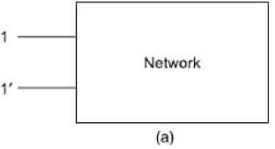

A **two-port network** is simply a network inside a black box, and the network has only two pairs of accessible terminals; usually one pair represents the input and the otherrepresents the output. Such a building block is very common in electronic systems, communication systems, transmission, and distribution systems. The Figure(b) shows a two- port network, or a two terminal pair network, in which the four terminals have beenpaired intoports 1-1' and 2-2'.

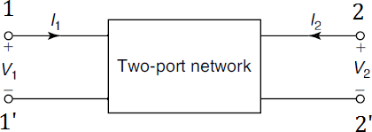

The terminals 1-1' together constitute a port. Similarly, the terminals 2-2' constitute another port. Two ports containing no sources in their branches are called passive ports;among them are power transmission lines and transformers. Two ports containing sources in their branches are called active ports. A voltage and current assigned to each of the two ports.

The voltage and current at the input terminals are V1 and I1; whereas V2 and I2 are specified at the output port. It is also assumed that the currents I1 and I2 are entering into the networkatthe upperterminals1and2,respectively.Thevariablesofthetwo-portnetworkare V1, V2, and I1, I2.Two of these are dependent variables; the other two are independent variables.The numberofpossible combinations generated bythe fourvariables, taken twoata time is six. Thus, there are six possible sets of equations describing a two-port network.

**OPEN-CIRCUITIMPEDANCEPARAMETERS(ZPARAMETERS)**

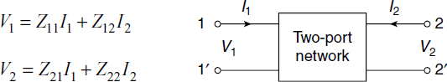A two-port network is redrawn as in Figure. Here, we consider V1 and V2 as dependent variables and I1 and I2 as independent variables. Let Z11, Z12, Z21 and Z22 are the Z-parameters. The voltage V1 and V2 in terms of I1 and I2 are expressed as follows:

Intermsofmatrixequations,thefollowingcanbe obtained:

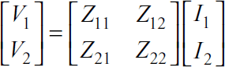



The individual Z-parameters can be found as indicated in the following. When the output-port is open-circuited, that is, when I2= 0, the equation will be as follows:

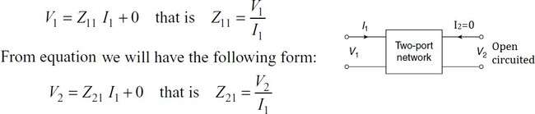

When the input port is open-circuited, that is, when I1= 0, then equation (11.1) will be given as follows:

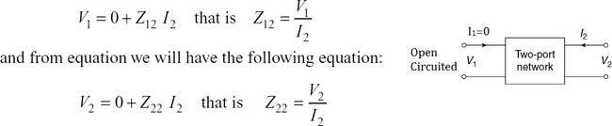

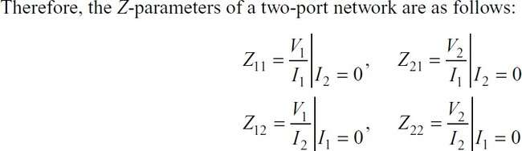

Alltheseparametersarealsocalled open-circuitimpedanceparameters.

*Z*11isknownasthedriving-pointimpedanceattheinputport,whenoutputportisopen- circuited.

*Z*21is known as the transfer impedance at the input port, when output port is open-circuited. *Z*22isknownasthedriving-pointimpedanceattheoutputport,wheninputportisopen- circuited.

*Z*12isknownasthetransferimpedanceattheoutputport,wheninputportisopen-circuited.

As these impedance parameters are measured with either the input or output port open- circuited, these are called open-circuit impedance parameters. The equivalent circuit of thetwo-port network in terms of Z parameters is shown in Fig.

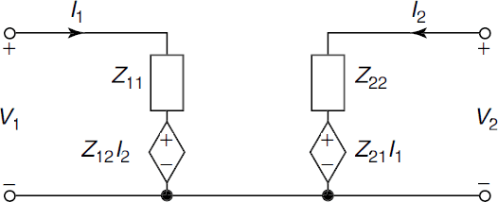

**The network is to be reciprocal if Z12=Z21 Thenetworkistobesymmetricalif Z11=Z22**

**PROBLEMSONZ-PARAMETERS**

1. 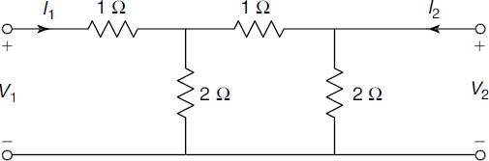FindZ-parametersforthenetworkshowninFig.

**SOL:**

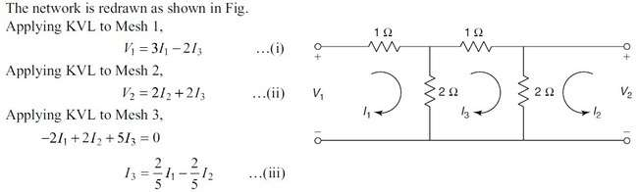

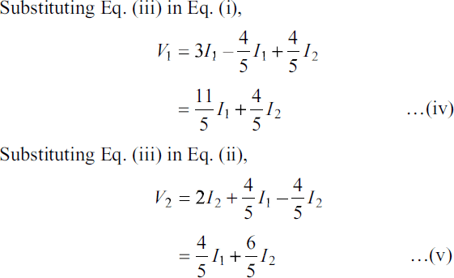

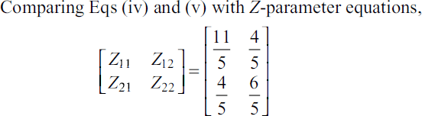

1. 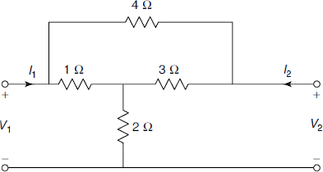Findtheopen-circuitimpedanceparametersforthenetworkshowninFig.Determine whether the network is symmetrical and reciprocal.

**SOL:**

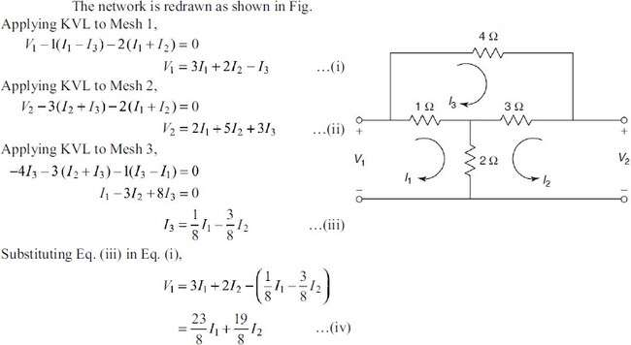

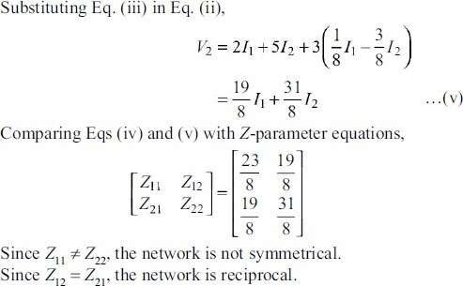

1. FindZ21and Z22forthenetworkshownionthefig.

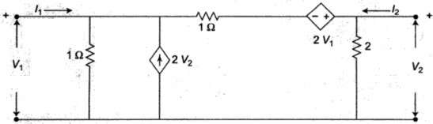

**SOL:**



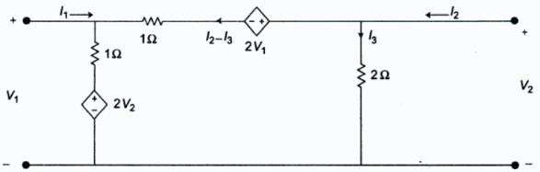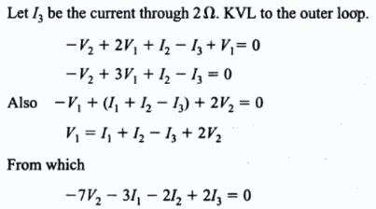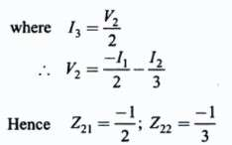

**SHORT-CIRCUITADMITTANCEPARAMETERS(or)Y-PARAMETERS**

The admittance parameters are also called Y-parameters. To determine Y-parameters, V1and V2 aretakenasindependentvariablesandI1 andI2 asdependentvariables.PortcurrentsI1 and I2 are expressed in terms of the voltages V1 and V2. The network equations are written as follows:



Theequationscanberepresentedinmatrixformas follows:

[I]=[Y][V]



where Y11, Y12, Y21 and Y22 are admittance parameters and these can be determined as in the following.

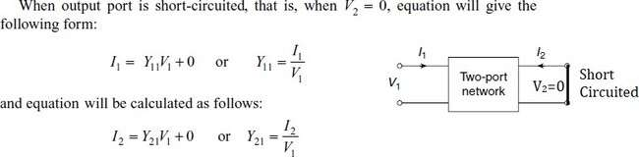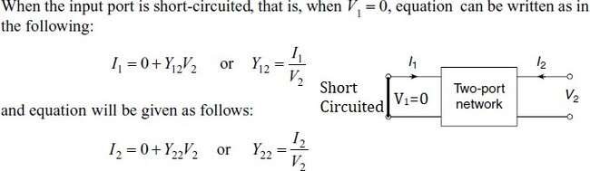

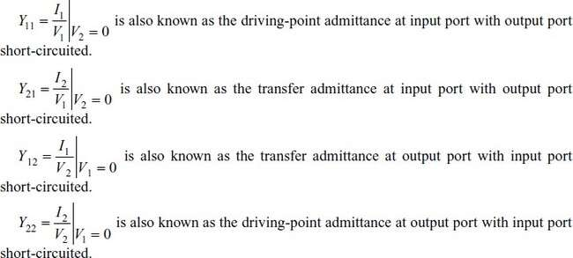

As these admittance parameters are measured with either input or output port short-circuited, these are called short-circuit admittance parameters.

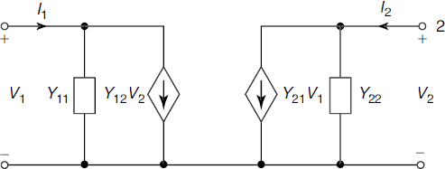Theequivalentcircuitofthetwo-portnetworkintermsofYparametersisshowninFig.

**If the network is reciprocal if Y12 = Y21Ifthenetworkissymmetricalif Y11=Y22**

**PROBLEMSONY-PARAMETERS**

1. FindY-parametersforthenetworkshowninFig.

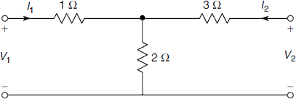

**SOL:**

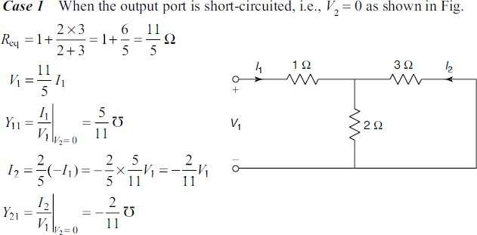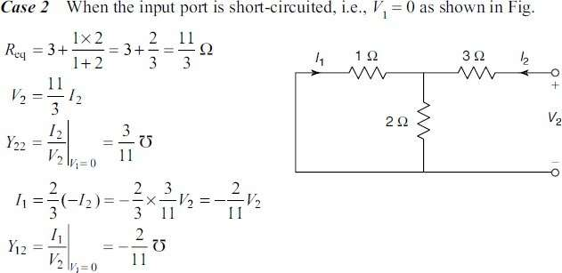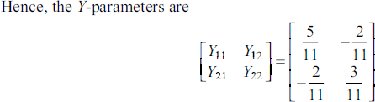

1. 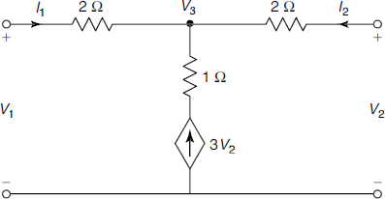FindY-parametersofthenetworkshowninFig.

**SOL:**

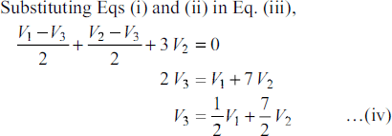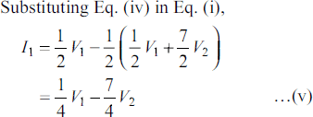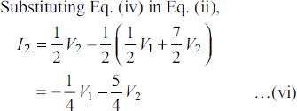

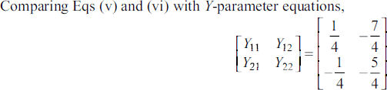

1. 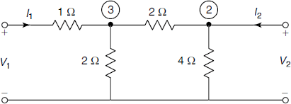Determine Y-parameters for the network shown in Fig. Determine whether the network issymmetrical and reciprocal.

**SOL:**

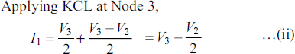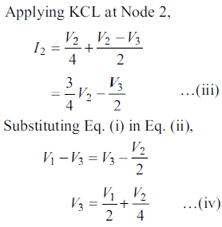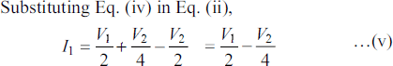

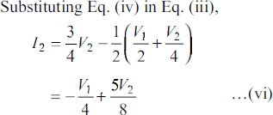

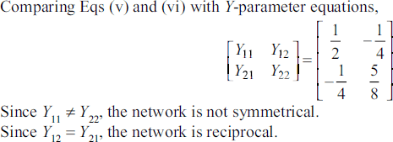

**ΤRANSMISSIONPARAMETERS(or)ABCDPARAMETERS**

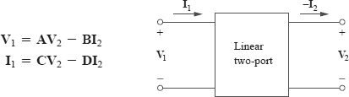The transmission parameters or chain parameters or ABCD parameters serve to relate the voltage and current at the input port to voltage and current at the output port.

Here, the negative sign is used with I2 and not for parameters B and D. The reason the current I2carries a negative sign is that in transmission field, the output current is assumed to be coming out of the output port instead of going into the port.

Inmatrixform,wecanwrite



The two-port parameters in above equations provide a measure of how a circuittransmits voltage and current from a source to a load. They are useful in the analysis of transmission lines (such as cable and fiber) because they express sending-end variables (V1 and I1) in terms of the receiving-end variables (V2 and ‒I2). For this reason, they are called transmission parameters. Theyare also known as ABCD parameters. Theyare used in the design of telephone systems, microwave networks, and radars.

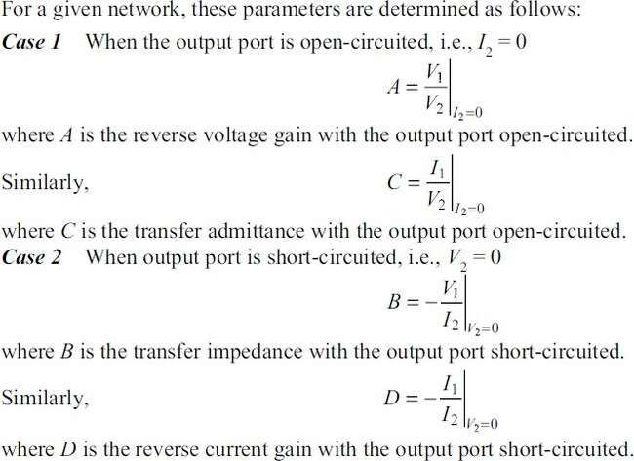

Insimpleform,

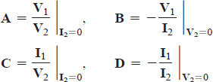

Thus,thetransmissionparametersarecalled, specifically,

**A=Open-circuitvoltageratio**

**B=Negativeshort-circuittransferimpedance**

**C=Open-circuittransferadmittance**

**D=Negativeshort-circuitcurrentratio**

A and D are dimensionless, B is in ohms, and C is in siemens. Since the transmission parameters provide a direct relationship between input and output variables, they are very useful in cascaded networks.

**ThenetworkistobereciprocalifAD−BC=1 The network is to be symmetrical if A = D**

**PROBLEMSONABCD-PARAMETERS**

1. FindtheABCDparametersforthenetworkshowninthefig.

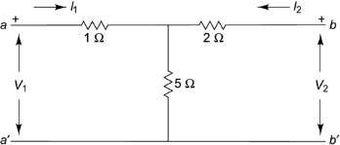

**SOL:**

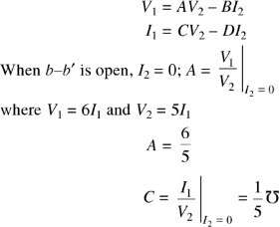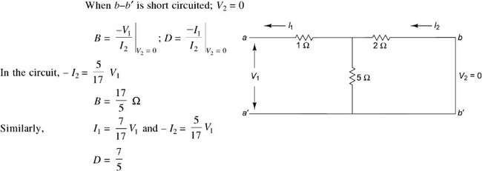

1. ObtainABCDparametersforthenetworkshowninFig

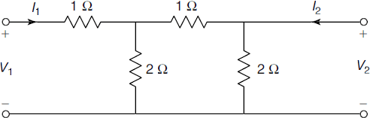

**SOL:**

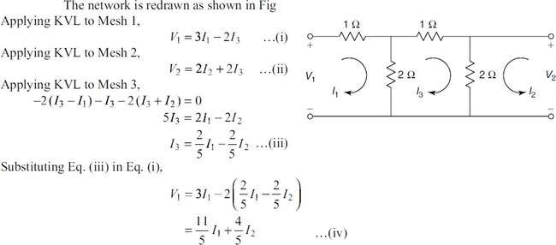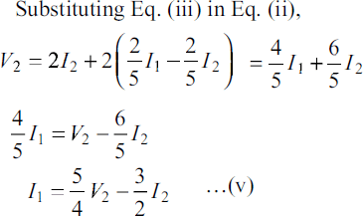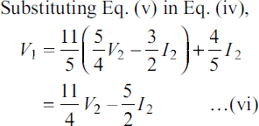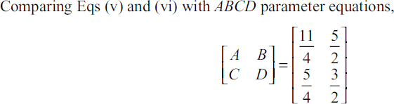

1. Findtransmissionparametersforthetwo-portnetworkshowninFig

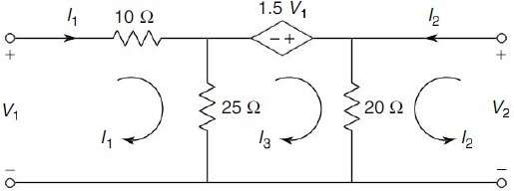

**SOL:**

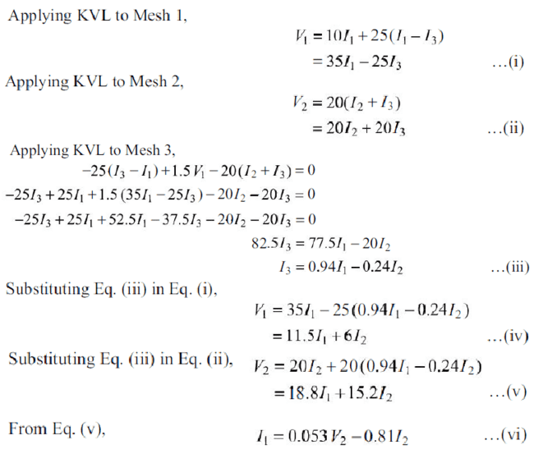

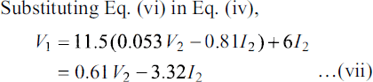

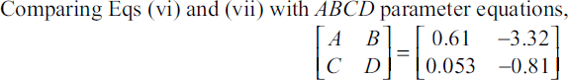

**INVERSEΤRANSMISSIONPARAMETERS(or)A’B’C’D’ PARAMETERS**

Theinversetransmissionparametersservetorelatethevoltageandcurrentatthe output port to the voltage and current at the input port.

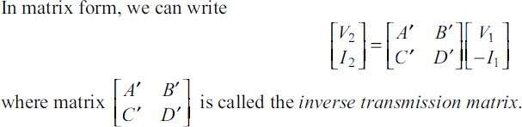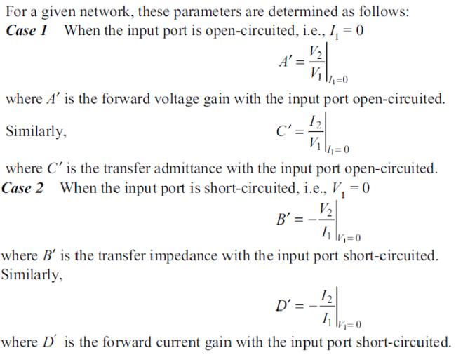

**ThenetworkistobereciprocalifA’D’−B’C’=1 The network is to be symmetrical if A’ = D’**

**PROBLEMSONA’B’C’D’-PARAMETERS**

1. FindtheinversetransmissionparametersforthenetworkshowninFig

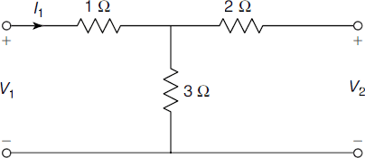

**SOL:**

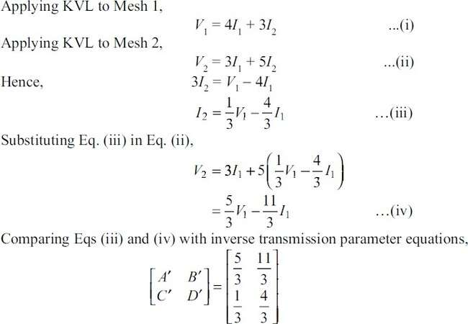

1. FindtheinversetransmissionparametersforthenetworkshowninFig

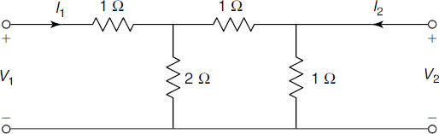

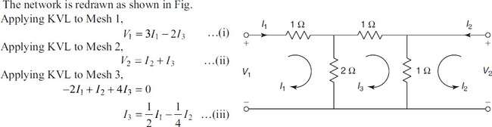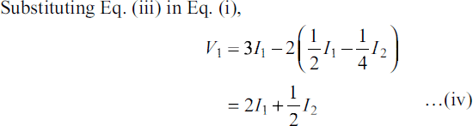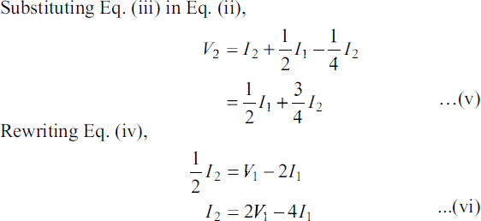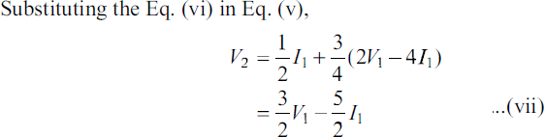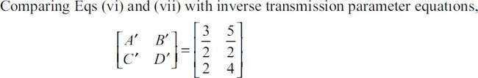

**HYBRIDPARAMETERS(or)h-PARAMETERS**

The hybrid parametersof a two-port network may be defined by expressing the voltage of input port V1 and current of output port I2 in terms of current of input port I1 and voltage of output port V2.

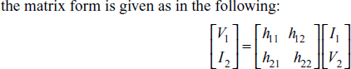

TheindividualhparameterscanbedefinedbysettingI1=0andV2=0.

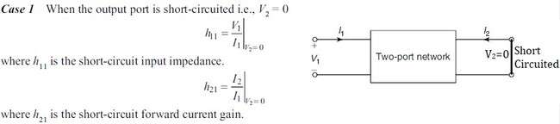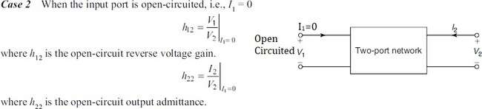

Insimpleform,

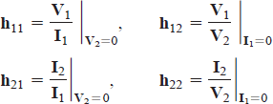

**Thenetworkistobereciprocalif h12= −h21**

**Thenetworkistobesymmetricalif h11h22−h12h21=1**

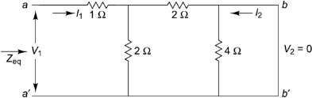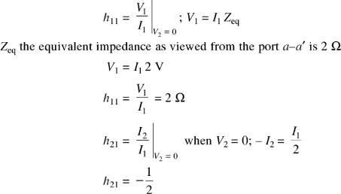

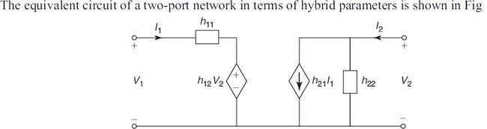ItisevidentfromEq.thattheparametersrepresentimpedance,avoltagegain,acurrent gain, and admittance, respectively. Therefore, they are called the hybrid parameters.

**PROBLEMSONh-PARAMETERS**

1. Findthehparametersofthenetworkshowninthefig.

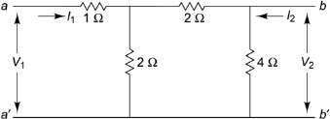

**SOL:**

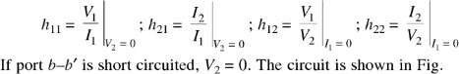

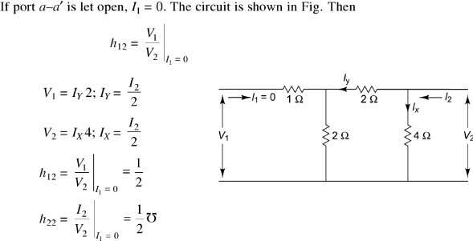

1. Findthehybridparametersforthetwo-portnetworkofFig.

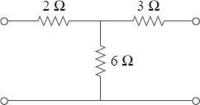

**SOL:**

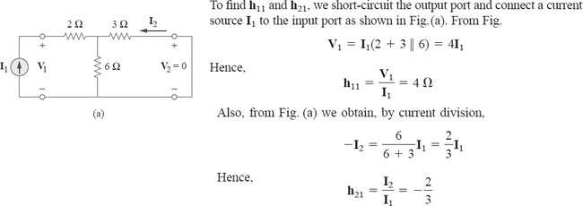

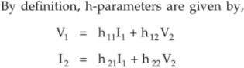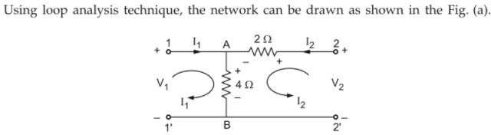

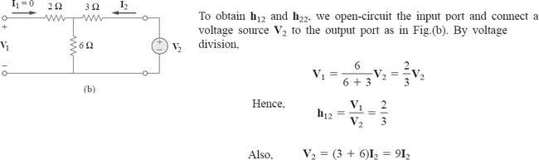



1. 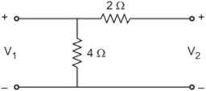Findthehybridparametersforthetwo-portnetworkofFig.

**SOL:**

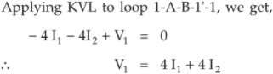

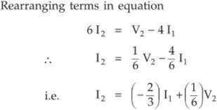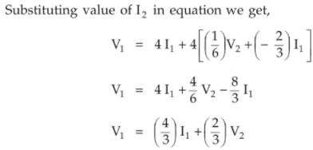

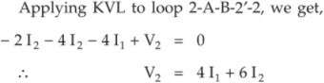

Hence

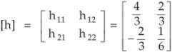

**INVERSEHYBRIDPARAMETERS(or)g–PARAMETERS**

The inverse hybrid parameters of a two-port network may be defined by expressing the current of the input port I1and voltage of the output port V2in termsof the voltage of the input port V1and the current of the output port I2.

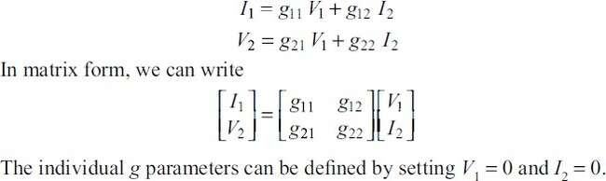

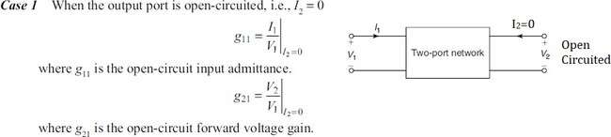

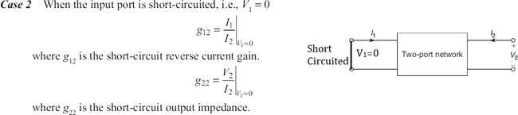

The equivalent circuit of a two-port network in terms of inverse hybrid parameters isshown in Fig.

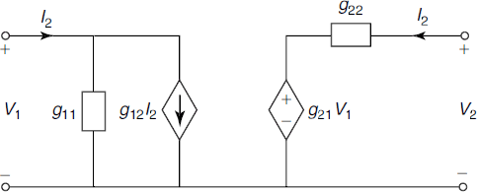

**Thenetworkistobereciprocalif g12=− g21**

**Thenetworkistobesymmetricalif g11g22−g12g21=1**

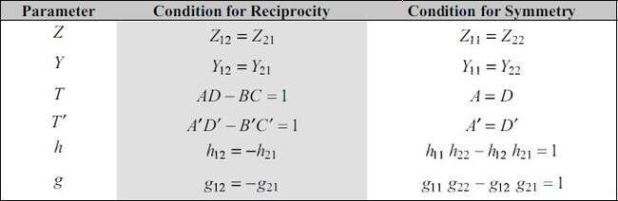**NOTE:Conditionsforreciprocityandsymmetry**

**PROBLEMSONg-PARAMETERS**

1. 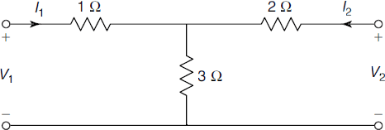Findg-parametersforthenetworkshown inFig.

**SOL:**

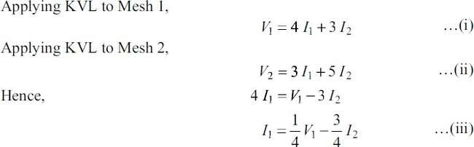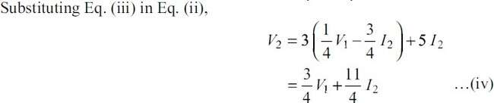

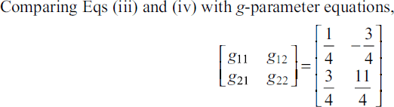

1. Findg-parametersforthenetworkshown inFig.

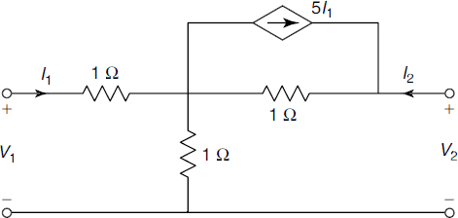

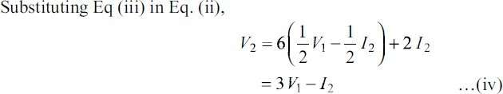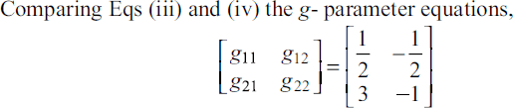

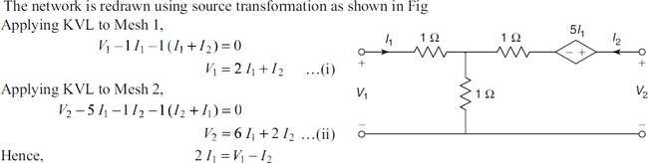**SOL:**

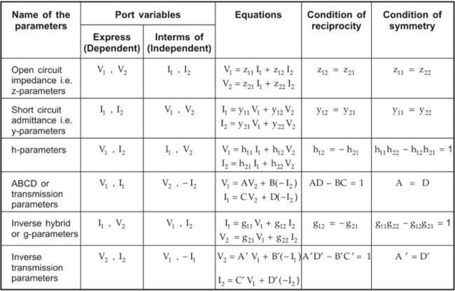**SUMMARYOFTWOPORTNETWORK PARAMETERS:**

**INTER-RELATIONSHIPSBETWEENTHETWO-PORTNETWORKPARAMETERS**

**(OR)**

**CORRELATIONOFTWO-PORTNETWORKPARAMETERSL**

**CASE-I:Z-PARAMETERSINTERMSOFOTHER PARAMETERS**

* 1. **Z-parametersinTermsofY-parameters:**

Weknowthat,theequationsofY-parametersare



From equation(ii), Y22V2=I2–Y21V1



SubstituteV2inequation(i)

Let ΔY=Y11Y22–Y12Y21



From equation(i), Y11V1=I1–Y12V2

SubstituteV1inequation(ii)





###### ----(iv)

Weknowthat,theequationsofZ-parametersare



Comparingeq(v),(vi)witheq(iii),eq(iv)

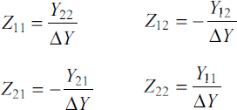

* 1. **Z-parametersinTermsofABCD-parameters:**

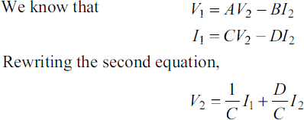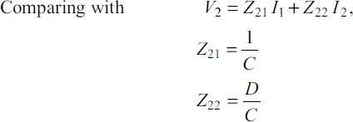

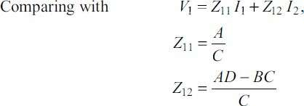Hence

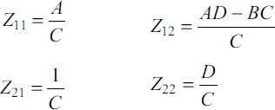

* 1. **Z-parametersinTermsofHybrid(h)-parameters:**

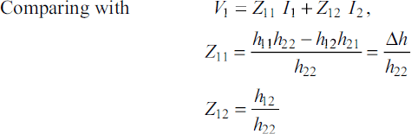

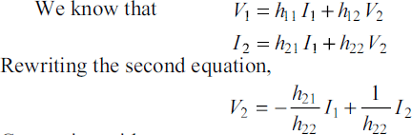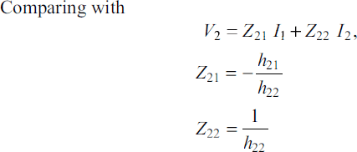

**Hence**

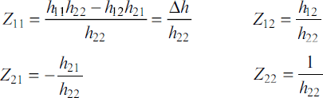

**CASE-II:Y-PARAMETERSINTERMSOFOTHERPARAMETERS**

* 1. **Y-parametersinTermsofZ-parameters:**

Weknowthat,theequationsofZ-parametersare



From equation(ii)



SubstituteI2inequation(i)



Let



From equation(i)



SubstituteI1inequation(ii)

Weknowthat,theequationsofY-parametersare



Comparingeq(v),(vi)witheq(iii),eq(iv)

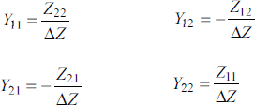

* 1. **Y-parametersinTermsofABCD-parameters:**

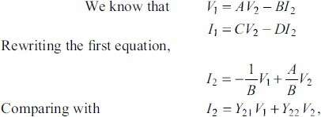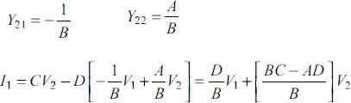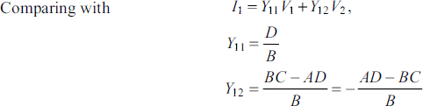

* 1. **Y-parametersinTermsofHybrid(h)-parameters:**

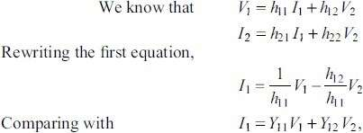

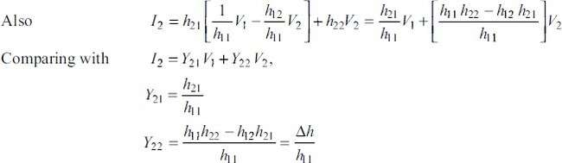

**CASE-III:ABCD-PARAMETERSINTERMSOFOTHERPARAMETERS**

* 1. 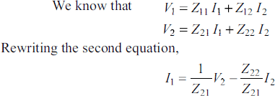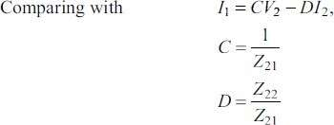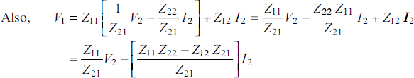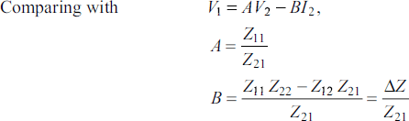**ABCD-parametersinTermsofZ-parameters:**
  2. **ABCD-parametersinTermsofY-parameters:**

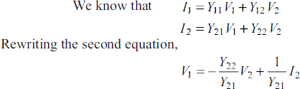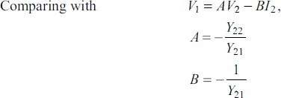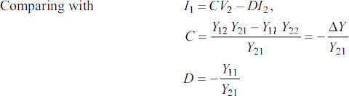

* 1. **ABCD-parametersinTermsofHybrid(h)-parameters:**

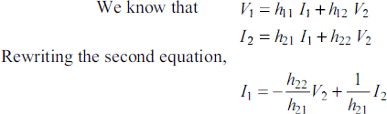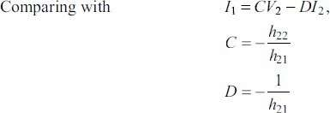

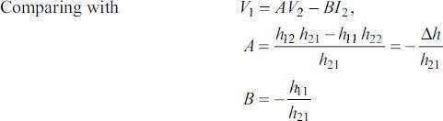

**CASE-IV:HYBRID(h)-PARAMETERSINTERMSOFOTHER PARAMETERS**

* 1. **Hybrid(h)-parametersinTermsofZ-parameters:**

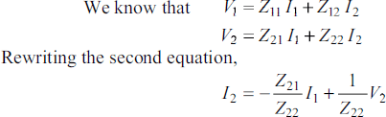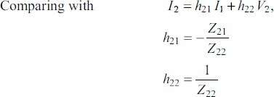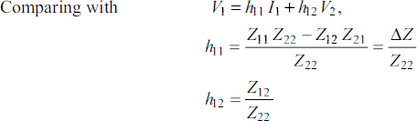

* 1. **Hybrid(h)-parametersinTermsofY-parameters:**

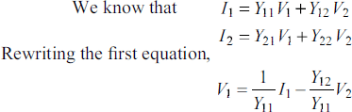

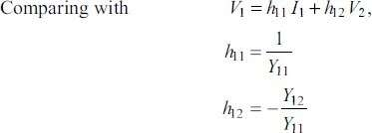

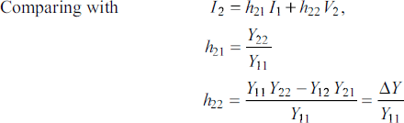

* 1. 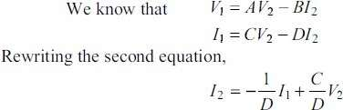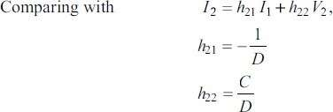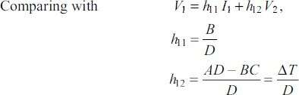**Hybrid(h)-parametersinTermsofABCD-parameters:**

**T-CIRCUITREPRESENTATIONOFTWO-PORTNETWORK**

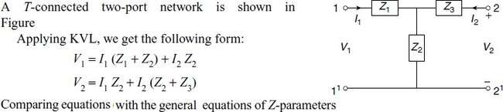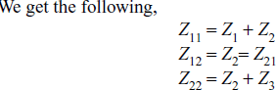

Fromtheaboveequations, theT-networkimpedancesare

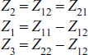

**Π-CIRCUITREPRESENTATIONOFTWO-PORTNETWORK**

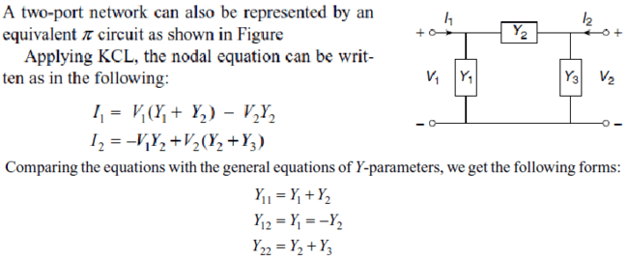

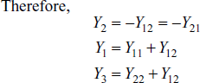

1. TheZparametersofatwo-portnetworkareZ11=20Ω,Z22=30Ω,Z12=Z21=10Ω. Find Y and ABCD parameters.

**SOL:**

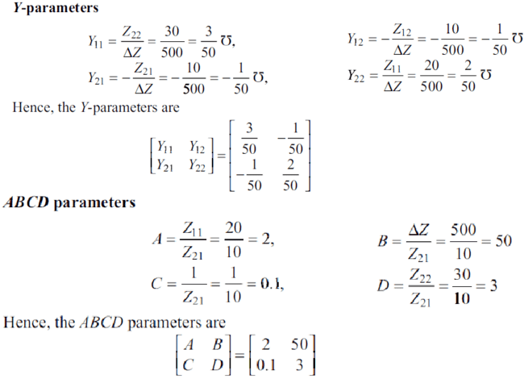

1. The Currents I1and I2entering at Port 1 and Port 2 respectively of a two-port network are given by the following equations:



FindY,ZandABCDparametersforthenetwork.

**SOL:**

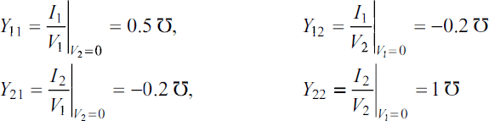

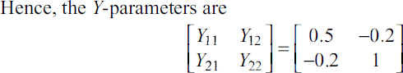

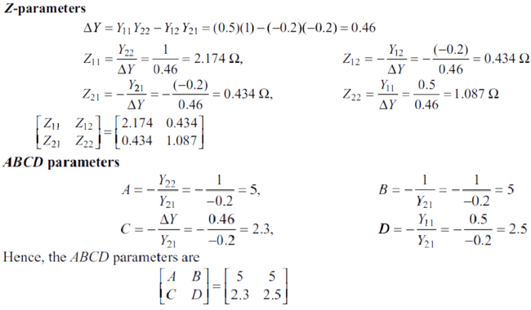

1. TheZ-parametersofatwo-portnetworkare:Z11 =10Ω,Z12 =Z21 =5Ω,Z22 =20Ω. Find the equivalent T-network.

**SOL:**

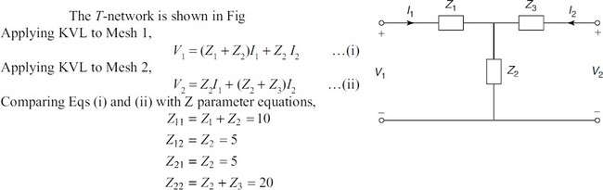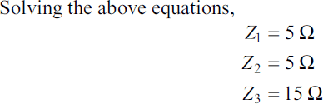

1. TheAdmittanceparametersofatwo-portnetworkareY11=0.09mho,Y12=Y21=−0.05

mhoandY22=0.07mho.FindtheequivalentΠ-network.

**SOL:**

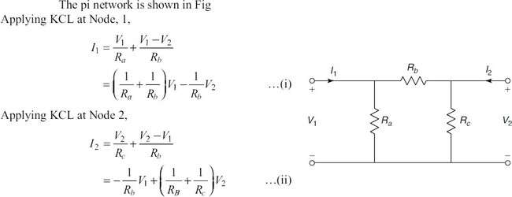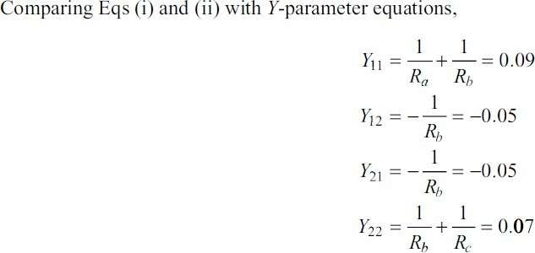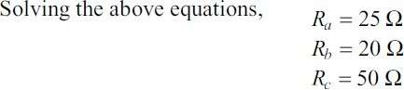

**CONCEPTOFTRANSFORMEDNETWORK**

In any network, the parameters can be solved by using differential equation method and using Laplace transform method. To analyze any network on a transform basis, the only additional step required is to represent all the network elements in terms of' complex impedance and admittance with associated initial energy sources. Therefore, we define the transform impedance and admittance and then find out their expression for each of the circuit elements like resistance, inductance, and capacitance.

For a single element, the transform impedance is defined as the ratio of the transform of the element voltage to the transform of the element current for zero initial current in an inductor and zero initial voltage in a capacitor.



Similarly, the transform admittance is defined as the ratio oftransform of the elementcurrent for zero initial current in an inductor and zero initial voltage in a capacitor.



* 1. **Resistance:**Foraresistance,thevoltageandcurrentarerelatedinthetime domainbyOhm's law.



Thecorrespondingtransformequationsare



Thetransformimpedanceoftheresistor



Similarly,thetransformadmittanceof'theresistor



From the above results, we can say that the resistor is frequency independentto the complexfrequency.

* 1. **Inductance:**Forinductance,thetimedomainrelationbetweenthecurrentandvoltage inductance as

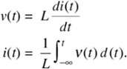

Theequivalenttransformequationforthe voltage



wherei(0+)istheinitialcurrentpresentintheinductorati=0+.

Iftheinitialcurrenti(0+)=0,thetransformimpedancefortheinductor



andthetransformadmittance becomes



* 1. **Capacitance:**Forcapacitance,thetimedomainrelationbetweenvoltageandcurrentis expressed as

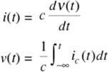

Theequivalenttransformequationforthevoltageexpressionis



Theaboveequation becomes



Byconsideringtheinitialchargeonthecapacitorzero. The equation becomes



ThetransformimpedanceofthecapacitoristheratiooftransformvoltageV(s)tothetransform current I(s) and is



Thetransformadmittanceofthecapacitoristheratiooftransformcurrent I(s)tothetransform voltage V(s) is



**TWO-PORTPARAMETERSUSINGTRANSFORMEDVARIABLES**

Forthetwo-portnetworkwithoutinternalsources,thedrivingpointimpedance function at port 1-1' is the ratio ofthe transformvoltage at port 1-1' tothe transformcurrent at the same port.



Similarly, the driving point impedance at port 2-2' is the ratio of transform current at the same port



Forthetwo-portnetwork,thedrivingpointadmittanceisdefinedastheratioof the transform current at any port to the transform voltage at the same port.

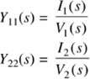

The four other network functions are called transfer functions. These functions give therelation between voltage or current at one port to the voltage or current at the other port as shown hereunder.

1. 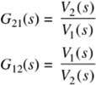**VoltageTransferRatio:**Itisdefinedastheratioofvoltagetransformatoneporttothe voltage transform at the other port and is denoted by G(s)
2. **CurrentTransferRatio:**Itisdefinedastheratioofcurrenttransformatoneporttothe current transform at the other port and is denoted by 𝞪(s).

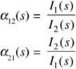

1. **TransferImpedance:**Itisdefinedastheratioofvoltagetransformatoneporttothe current transform at the other port. and is denoted by Z(s).

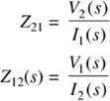

1. **TransferAdmittance:**Itisdefinedastheratioofcurrenttransformatoneporttothe voltage transform at the other port and is denoted by Y(s).

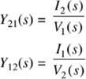

The above network functions are found by forming the system of equations using nodal ormeshanalysisandtakingthetransformsofequationsbysettingtheinitialconditiontozeroand solving for ratio of the response to excitation.

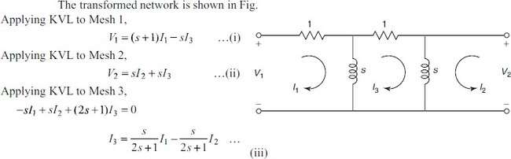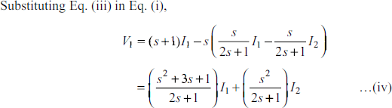

**PROBLEMSONTRANSFORMEDNETWORKS**

1. FindtheZ-parametersforthenetworkshowninFig.

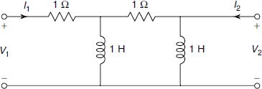

**SOL:**

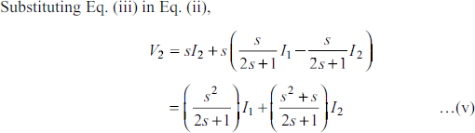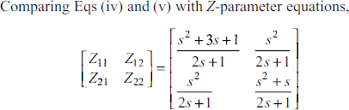

1. DetermineY-parametersforthenetworkshowninFig.

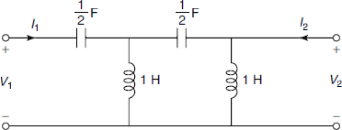

**SOL:**

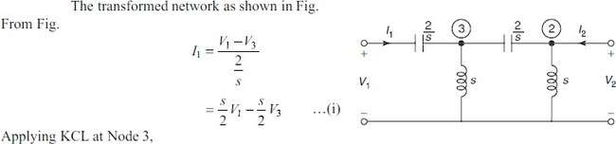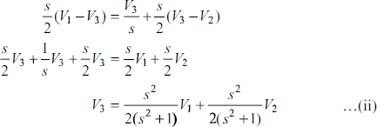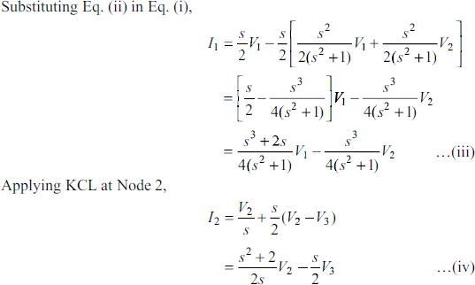

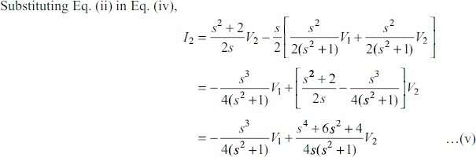

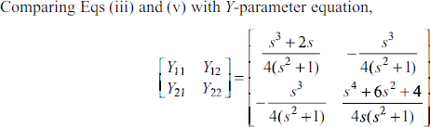

1. DeterminethetransmissionparametersforthenetworkshowninFig

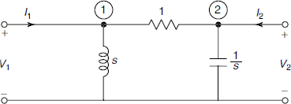

**SOL:**

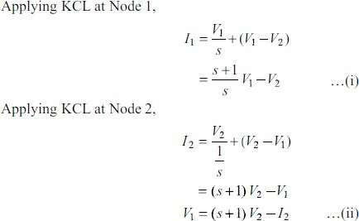

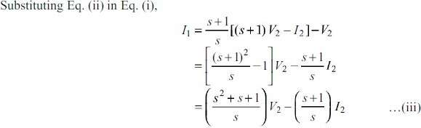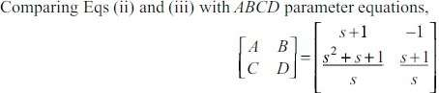

1. Findh-parametersforthenetworkshown inFig.



**SOL:**



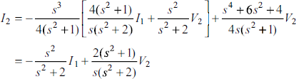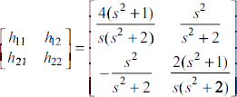

**INTERCONNECTIONOFTWO-PORTNETWORKS**

When the two networks are interconnected, the input and output quantities are to be determined with Cascade Connection, series and parallel connections. The cascade connection is useful to determine ABCD parameters of two interconnected networks; the series connection is useful to determine Z parameters of two interconnected networks; the parallel connection is useful to determine Y parameters of two interconnected networks. With the help ofrelationship between two-port parameters, the other parameters also are to be determined.

* 1. **CASCADECONNECTION:**

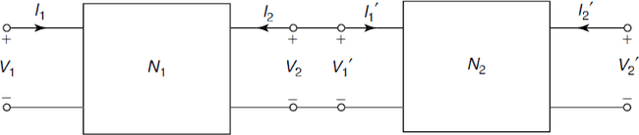TheFigureshows two-portnetworksconnectedincascade.Inthecascadeconnection,the output port of the first network becomes the input port of the second network. Since it is assumed that input and output currents are positive when they enter the network, we have

LetA1,B1,C1,D1bethetransmissionparametersofthenetworkN1andA2,B2,C2,D2bethe transmission parameters of the network N2.

ForthenetworkN1,

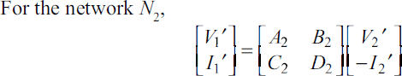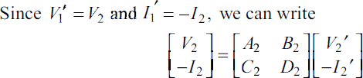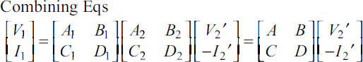

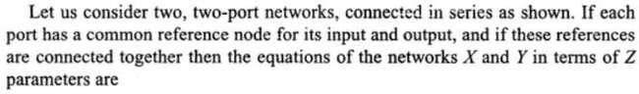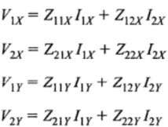



The aboveequation showsthat theresultant ABCDmatrixof the cascade connectionis the product of the individual ABCD matrices.

* 1. **SERIESCONNECTION:**

The Figure shows two-port networks connected in series. In a series connection, both the networks carry the same input current. Their output currents are also equal.

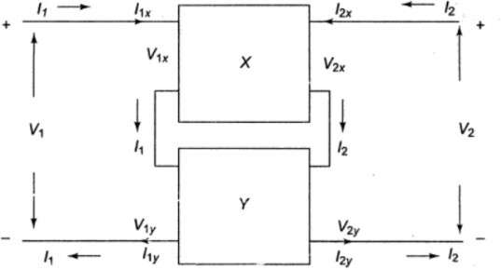



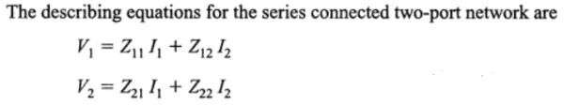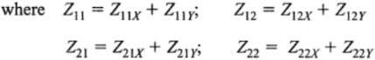

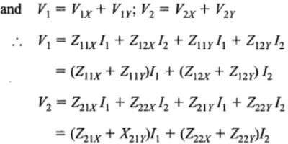

Thus,theresultantZ-parametermatrixfortheseries-connectednetworksisthesumof Z-parameters of each individual two-port network.

* 1. **PARALLELCONNECTION:**

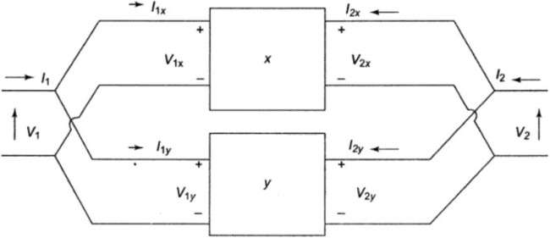The Figure shows two-port networks connectedinparallel. In the parallel connection,the two networks have the same input voltages and the same output voltages.

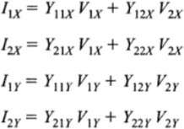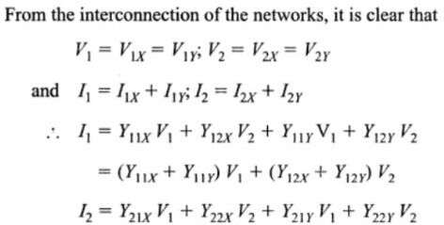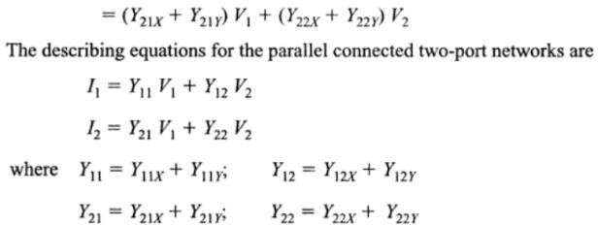

**PROBLEMSONINTERCONNECTEDNETWORKS**

1. 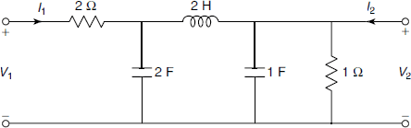DetermineABCDparametersfortheladdernetworkshowninFig.

**SOL:**

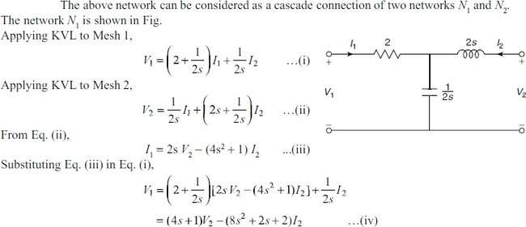

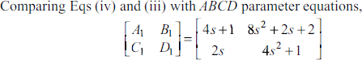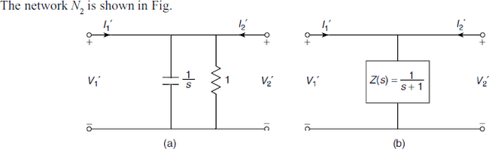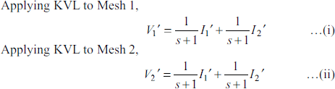

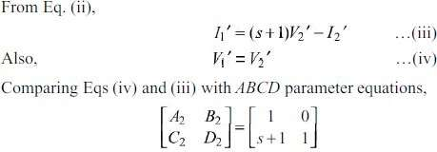

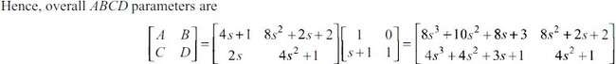

1. FindY-parametersforthenetworkshown inFig.

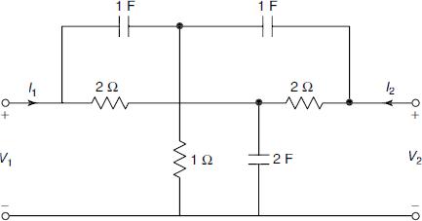

**SOL:**

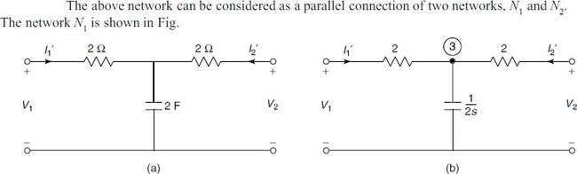

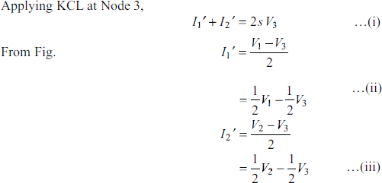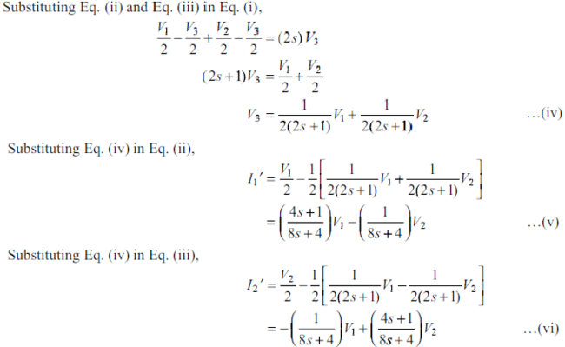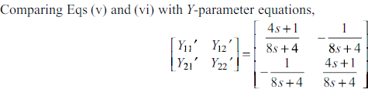

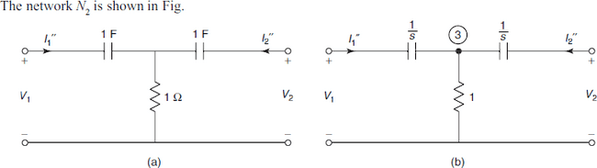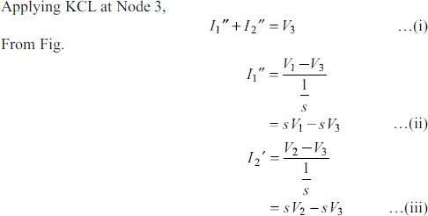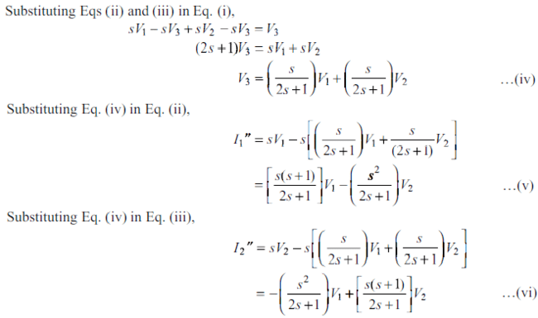

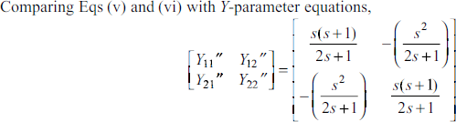

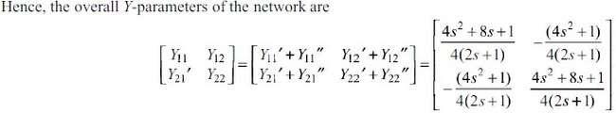

1. Two identical sections of the network shown in Fig. are connected in series. Obtain Z-parameters of the overall connection.

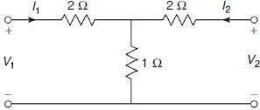

**SOL:**

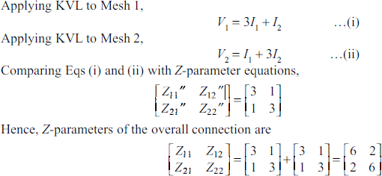

**UNIT-IV**

FOURIERTRANSFORMS

* 1. **Introduction**

The Fourier series expresses any periodic function into a sum of sinusoids. The Fourier transform is the extension of this idea to non-periodic functions by taking the limiting formofFourierserieswhenthefundamentalperiodismadeverylarge(infinite). Fourier transform finds its applications in astronomy, signal processing, linear time invariant (LTI) systems etc.

**SomeusefulresultsincomputationoftheFouriertransforms:**

1. ∞𝑒−𝑎𝑥sin𝜆𝑥𝑑𝑥= 𝜆

∫0 𝑎2+𝜆2

1. ∞𝑒−𝑎𝑥cos𝜆𝑥𝑑𝑥= 𝑎

∫0

1. ∞sin𝜆𝑥

∫

𝑎2+𝜆2

𝜋

𝑑𝑥=,𝜆>0

0 𝑥 2

When𝜆=1, ∞𝑠𝑖𝑛𝑥𝑑𝑥=𝜋

∫0 𝑥 2

1. sin𝑎𝑥=𝑒𝑖𝑎𝑥−𝑒−𝑖𝑎𝑥

2𝑖

1. cos𝑎𝑥=𝑒𝑖𝑎𝑥+𝑒−𝑖𝑎𝑥

2

1. ∞𝑒−𝑎2𝑥2𝑑𝑥=√𝜋

∫0

When𝑎=1,

2𝑎

∞𝑒−𝑥2𝑑𝑥=√𝜋

∫

0 2

1. HeavisideStepFunctionorUnitstepfunction𝐻(𝑡)or𝑈(𝑡)={0,when𝑡<0

1,when𝑡≥0

At𝑡 = 0,𝐻(𝑡) issometimestakenas0.5orit maynothaveanyspecific value. Shifting at𝑡 = 𝑎

𝐻(𝑡− 𝑎)or𝑈(𝑡− 𝑎)={0,when𝑡<𝑎

1,when𝑡≥𝑎

1. DiracDeltaFunctionorUnitImpulseFunctionisdefinedas𝛿(𝑡−𝑎)=0*,t*≠*a*

*such*that∫∞𝛿(𝑡−𝑎)𝑑𝑡=1,𝑎≥0.Itiszeroeverywhereexceptonepoint'*a*'.

0

Deltafunctioninsometimesthoughtofhavinginfinitevalueat𝑡= 𝑎.Thedelta function can be viewed as the derivative of the Heaviside step function

**Dirichlet’sConditionsforExistenceofFourierTransform**

Fouriertransformcanbeappliedtoanyfunction𝑓(𝑥)ifitsatisfiesthefollowing conditions:

1. 𝑓(𝑥)isabsolutelyintegrable i.e.∫∞|𝑓(𝑥)|𝑑𝑥isconvergent.

−∞

1. Thefunction𝑓(𝑥)hasafinitenumberofmaximaandminima.
2. 𝑓(𝑥)hasonlyafinitenumberof discontinuitiesinanyfinite
   1. **FourierTransform,InverseFourierTransformandFourierIntegral**

**C:\Users\dell\Desktop\Capture.JPG**

TheFouriertransformof𝑓(𝑥),−∞<𝑥<∞,denoted by𝑓̅(λ)whereλ∈N,isgivenby

𝐹{𝑓(𝑥)}≡𝑓̅(λ)=1 ∞𝑒𝑖𝜆𝑥𝑓(𝑥)𝑑𝑥 …①

√2𝜋∫−∞

AlsoinverseFouriertransformof𝑓̅(λ)gives𝑓(𝑥)as:

𝑓(𝑥)=1 *∞*𝑒−𝑖𝜆𝑥𝑓̅(λ)𝑑𝜆…②

√2𝜋∫−*∞*

Rewriting①as𝑓̅(λ)= 1 ∞𝑒𝑖𝜆𝑡𝑓(𝑡)𝑑𝑡 andusingin②, Fourierintegral

√2𝜋∫−∞

representationof 𝑓(𝑥)isgivenby:

𝑓(𝑥)=1 ∞ ∞𝑒𝑖𝜆(𝑡−𝑥)𝑓(𝑡)𝑑𝑡𝑑𝜆

2𝜋∫−∞∫−∞

* + 1. **FourierSineTransform(F.S.T.)**

FourierSinetransformof𝑓(𝑥),0<𝑥<∞,denotedby𝑓𝑠̅(λ),isgiven by

2

{ } ()

𝐹𝑓(𝑥)≡𝑓̅λ=√

∞𝑓(𝑥)sin𝜆𝑥 𝑑𝑥…③

𝑠 𝑠

𝜋∫0

AlsoinverseFourierSinetransformof𝑓𝑠̅(λ)gives𝑓(𝑥)as:

2 ∞

𝑓𝑥=√ 𝑓̅(λ)sin𝜆𝑥𝑑𝜆…④

()

𝜋∫0 𝑠

Rewriting③as () 2 ∞𝑓(𝑡)sin𝜆𝑡𝑑𝑡 andusingin④,Fouriersineintegral

𝑠 𝜋∫0

𝑓̅λ=√

representationof 𝑓(𝑥)isgivenby:

* + 1. **FourierCosineTransform(F.C.T.)**

FourierCosinetransformof𝑓(𝑥),0<𝑥<∞,denotedby𝑓𝑐̅(λ),isgivenby

𝐹{𝑓(𝑥)}≡𝑓̅ (λ)=√2 ∞𝑓(𝑥)cos𝜆𝑥𝑑𝑥…⑤

𝑐 𝑐

𝜋∫0

AlsoinverseFourierCosinetransformof𝑓𝑐̅(λ)gives𝑓(𝑥)as:

2 ∞

𝑓𝑥=√ 𝑓̅(λ)cos𝜆𝑥𝑑𝜆…⑥

()

𝜋∫0 𝑐

Rewriting⑤as () 2 ∞𝑓(𝑡)cos𝜆𝑡𝑑𝑡andusingin⑥,Fouriercosineintegral

𝑐 𝜋∫0

𝑓̅λ=√

representationof 𝑓(𝑥)isgivenby:

𝑓(𝑥)=2 ∞∞𝑓(𝑡)cos𝜆𝑡cos𝜆𝑥 𝑑𝑡𝑑𝜆

𝜋∫0∫0

**Remark:**

* Parameterλmaybetakenas*p,s*orωasperusualnotations.
* Fouriertransformof𝑓(𝑥)maybegivenby𝑓̅(λ)=1 ∞𝑒−𝑖𝜆𝑥𝑓(𝑥)𝑑𝑥,

√2𝜋∫−∞

thenInverseFouriertransformof𝑓̅(λ)isgivenby𝑓(𝑥)=1 *∞*𝑒𝑖𝜆𝑥𝑓̅(λ)𝑑𝜆

√2𝜋∫−*∞*

* SometimesFouriertransformof𝑓(𝑥)istakenas𝑓̅(λ)=

∞

∫−∞

𝑒𝑖𝜆𝑥𝑓(𝑥)𝑑𝑥,

therebyInverse Fouriertransformisgivenby𝑓(𝑥)=1 *∞*𝑒−𝑖𝜆𝑥𝑓̅(λ)𝑑𝜆

∫

2𝜋−*∞*

∞

SimilarlyifFourierSinetransformistakenas 𝑓̅𝑠(λ)=∫ 𝑓(𝑥)sin𝜆𝑥 𝑑𝑥,

0

thenInverse Sinetransformisgivenby𝑓(𝑥)=2 ∞𝑓̅(λ)sin𝜆𝑥 𝑑𝜆

𝜋∫0 𝑠

SimilaristhecasewithFourierCosinetransform.

**Example1**StategivingreasonswhethertheFouriertransformsofthefollowing

functionsexist: i.sin1

𝑥

**Solution:**i.Thegraphofsin1

𝑥

1. 𝑒𝑥 iii.𝑓(𝑥)={1, if𝑥is rational

0,if𝑥is irrational

oscillatesinfinitenumberoftimesat𝑥=𝑛𝜋,𝑛∈Z

∴𝑓(𝑥)sin1

𝑥

ishavinginfinitenumberofmaximaandminimaintheinterval

(−∞,∞).HenceFouriertransformof 𝑓(𝑥)=sin1

𝑥

doesnotexist.

* 1. For𝑓(𝑥)=𝑒𝑥,∫∞|𝑒𝑥|𝑑𝑥isnotconvergent.HenceFouriertransform of

−∞

𝑒𝑥doesnotexist.

* 1. 𝑓(𝑥)={1, if𝑥is rational

0,if𝑥is irrational

ishavinginfinitenumberofmaximaand

minimaintheinterval(−∞,∞).HenceFouriertransformof𝑓(𝑥)doesnotexist.

**Example2**FindFourierSinetransformof

* + 1. 1

𝑥

* + 1. 2𝑒−3𝑥+ 3𝑒−2𝑥

**Solution:**i.Bydefinition,wehave𝐹{𝑓(𝑥)}≡𝑓̅(λ)=√2 ∞𝑓(𝑥)sin𝜆𝑥𝑑𝑥

2 ∞1

()

∴𝑓̅λ=√

𝑠 𝑠

2𝜋 𝜋

𝜋∫0

𝑠 𝜋∫0

sin𝜆𝑥𝑑𝑥=√.=√

𝑥 𝜋2 2

ii. Bydefinition,𝐹{𝑓(𝑥)}≡𝑓̅(λ)=√2 ∞𝑓(𝑥)sin𝜆𝑥𝑑𝑥

𝑠 𝑠

𝜋∫0

2 ∞

()

∴𝑓̅λ=√ (2𝑒−3𝑥+3𝑒−2𝑥) sin 𝜆𝑥𝑑𝑥

𝑠 𝜋∫0

2 ∞ 2

2𝑒−3𝑥

=√ sin𝜆𝑥𝑑𝑥+√

∞3𝑒−2𝑥sin𝜆𝑥𝑑𝑥

𝜋∫0

22𝑒−3𝑥

𝜋∫0

∞

23𝑒−2𝑥 ∞

=√[

𝜋

9+𝜆

2(−3sin𝜆𝑥−𝜆cos𝜆𝑥]

0

+ √[

𝜋

4+𝜆

2(−2sin𝜆𝑥−𝜆cos𝜆𝑥]

0

2 2𝜆

[

= √ 0+

]+√2[0+3𝜆

]=√2[2𝜆

+3𝜆

]=√2[ 5𝜆3+35𝜆 ]

𝜋 9+𝜆2

𝜋 4+𝜆2

𝜋9+𝜆2

4+𝜆2

𝜋(9+𝜆2)(4+𝜆2)

**Example3**FindFouriertransformofDeltafunction𝛿(𝑥−𝑎)

**Solution:**𝐹{𝛿(𝑥−𝑎)}=1 ∞𝑒𝑖𝜆𝑥.𝛿(𝑥−𝑎)𝑑𝑥

√2𝜋∫−∞

= 1

√2𝜋

𝑒𝑖𝜆𝑎

∞

∴∫−∞

𝑓(𝑡)

𝛿(𝑡−𝑎)𝑑𝑡=𝑓(𝑎) byvirtueoffundamentalpropertyofDeltafunction

where 𝑓(𝑡)isanydifferentiable function.

**Example4**ShowthatFourier sineand cosinetransformsof𝑥𝑛−1are]𝑛sin𝑛𝜋and

]𝑛cos𝑛𝜋

respectively.

𝜆𝑛 2

𝜆𝑛 2

**Solution:**Bydefinition**,**∫∞𝑒−𝑡𝑡𝑛−1𝑑𝑡=]𝑛

0

Putting𝑡=𝑖𝜆𝑥sothat𝑑𝑡=𝑖𝜆𝑑𝑥

⇒∫∞𝑒−𝑖𝜆𝑥(𝑖𝜆𝑥)𝑛−1𝑖𝜆𝑑𝑥=]𝑛

0

⇒ ∞𝑥𝑛−1𝑒−𝑖𝜆𝑥𝑑𝑥=]𝑛𝑖−𝑛

∫0 𝜆𝑛

⇒ ∞𝑥𝑛−1(cos𝜆𝑥−𝑖sin𝜆𝑥)𝑑𝑥=]𝑛(cos𝑛𝜋−𝑖sin𝑛𝜋)

∫0 𝜆𝑛 2 2

∴𝑖−𝑛=(cos𝑛𝜋−𝑖sin𝑛𝜋)

2 2

⇒ ∞𝑥𝑛−1cos𝜆𝑥𝑑𝑥−𝑖 ∞𝑥𝑛−1sin𝜆𝑥𝑑𝑥=]𝑛cos𝑛𝜋−𝑖]𝑛sin𝑛𝜋

∫0 ∫0

𝜆𝑛 2

𝜆𝑛 2

Equatingrealandimaginaryparts,we get

∞𝑥𝑛−1cos𝜆𝑥𝑑𝑥=]𝑛cos𝑛𝜋and ∞𝑥𝑛−1sin𝜆𝑥 𝑑𝑥=]𝑛sin𝑛𝜋

∫0 𝜆𝑛 2 ∫0

𝜆𝑛 2

⇒𝑓̅(λ)=]𝑛cos𝑛𝜋and𝑓̅(λ)=]𝑛sin𝑛𝜋

𝑐 𝜆𝑛 2

𝑠 𝜆𝑛 2

𝑥, 0<𝑥<1

**Example 5** Find Fourier Cosine transform of 𝑓(𝑥)={2−𝑥,1<𝑥<2

0, 𝑥>2

**Solution:**Bydefinition,we have { } () 2 ∞𝑓(𝑥)cos𝜆𝑥𝑑𝑥

𝑐 𝑐

𝐹𝑓(𝑥)≡𝑓̅λ=√

∴𝑓̅(λ)=√2 ∞𝑓(𝑥)cos𝜆𝑥𝑑𝑥

𝜋∫0

𝑐 𝜋∫0

2 1

[

=√ ∫𝑥cos𝜆𝑥𝑑𝑥+

0

𝜋

2

2

∫1(2−𝑥)cos𝜆𝑥𝑑𝑥+

∞

∫20.cos𝜆𝑥𝑑𝑥]

2 [[(

= √

)(sin𝜆𝑥)

()(

cos𝜆𝑥 1 [(

)(sin𝜆𝑥) (

)( cos𝜆𝑥

𝑥

𝜋 𝜆

−1 −

𝜆2)]+

2−𝑥

−−1

𝜆

− 𝜆2)]]

2sin𝜆 cos𝜆 1

0

1

[

= √ + −

−cos2𝜆−sin𝜆+cos𝜆]=√2[2cos𝜆−cos2𝜆−1]

𝜋 𝜆

𝜆2

𝜆2

𝜆2

𝜆 𝜆2 𝜋

𝜆2

**Example 6**Find FourierSineand Cosine transformof𝑓(𝑥)=𝑒−𝑥andhenceshowthat

∞cos𝑚𝑥𝑑𝑥=𝜋𝑒−𝑚= ∞𝑥sin𝑚𝑥𝑑𝑥

∫0 1+𝑥2 2 ∫0 1+𝑥2

**Solution:**TofindFourierSinetransform

2

{ } ()

𝐹𝑓(𝑥)≡𝑓̅λ=√

∞𝑓(𝑥)sin𝜆𝑥 𝑑𝑥

𝑠 𝑠

𝜋∫0

2 ∞ 2 𝜆

()

√

⇒𝑓̅λ=√ 𝑒−𝑥sin𝜆𝑥𝑑𝑥= (

)……①

𝑠 𝜋∫0

𝜋1+𝜆2

TakinginverseFourierSinetransformof①

2 ∞

()

𝑓𝑥=√ 𝑓̅(λ)sin𝜆𝑥𝑑𝜆

𝜋∫0 𝑠

⇒𝑓(𝑥)=2 ∞ 𝜆

𝑠𝑖𝑛𝜆𝑥𝑑𝜆…..②

𝜋∫0

1+𝜆2

Substituting𝑓(𝑥)=𝑒−𝑥in②

⇒𝑒−𝑥=2

∞𝜆𝑠𝑖𝑛𝜆𝑥𝑑𝜆

𝜋∫0

1+𝜆2

Replacing𝑥by𝑚onbothsides

⇒𝑒−𝑚=2

∞ 𝜆𝑠𝑖𝑛𝜆𝑚𝑑𝜆

𝜋∫0

1+𝜆2

Nowbypropertyofdefiniteintegrals

𝑏

∫𝑎𝑓(𝑥)𝑑𝑥=

𝑏

∫𝑎𝑓(𝑦)𝑑𝑦

∴𝜋𝑒−𝑚=

∞𝑥sin𝑚𝑥𝑑𝑥

….③

2 ∫0

1+𝑥2

SimilarlytakingFourierCosinetransformof𝑓(𝑥)=𝑒−𝑥

2

{ } ()

𝐹𝑓(𝑥)≡𝑓̅λ=√

∞𝑓(𝑥)cos𝜆𝑥𝑑𝑥

𝑐 𝑐

𝜋∫0

⇒𝑓̅(λ)=√2 ∞𝑒−𝑥cos𝜆𝑥𝑑𝑥=√2(1

)……④

𝑐 𝜋∫0

𝜋1+𝜆2

TakinginverseFourierCosinetransformof④

2 ∞

𝑓𝑥=√ 𝑓̅(λ)cos𝜆𝑥𝑑𝜆

()

∫

𝜋0

⇒𝑓(𝑥)=2 ∞

𝑐

1 cos𝜆𝑥𝑑𝜆…..⑤

𝜋∫0

1+𝜆2

Substituting𝑓(𝑥)=𝑒−𝑥in⑤

⇒𝑒−𝑥=2

∞cos𝜆𝑥𝑑𝜆

𝜋∫0

1+𝜆2

Replacing𝑥by𝑚onbothsides

⇒𝑒−𝑚=2

∞cos𝜆𝑚𝑑𝜆

𝜋∫0

1+𝜆2

Againbypropertyofdefiniteintegrals

𝑏

∫𝑎𝑓(𝑥)𝑑𝑥=

𝑏

∫𝑎𝑓(𝑦)𝑑𝑦

∴𝜋𝑒−𝑚=

∞cos𝑚𝑥𝑑𝑥

….⑥

2 ∫0

1+𝑥2

From③and⑥,weget

∞cos𝑚𝑥𝑑𝑥=𝜋𝑒−𝑚= ∞𝑥sin𝑚𝑥𝑑𝑥

∫0 1+𝑥2 2 ∫0 1+𝑥2

**Example7**FindFouriertransformof𝑓

(𝑥)

1−𝑥2,|𝑥|<1

={0, |𝑥|>1

andhenceevaluate

∞(𝑥cos𝑥−sin𝑥) 𝑥

∫0 𝑥3

cos𝑑𝑥

2

**Solution:**Fouriertransformof𝑓(𝑥)isgiven by

𝐹{𝑓(𝑥)} ≡𝑓̅(λ)=1 ∞𝑒𝑖𝜆𝑥𝑓(𝑥)𝑑𝑥

√2𝜋∫−∞

=1 1(1−𝑥2)𝑒𝑖𝜆𝑥𝑑𝑥

√2𝜋∫−1

1 2 𝑒𝑖𝑥

−1

𝑒𝑖𝑥

𝑒𝑖𝑥 1

= [(1 −𝑥

√2𝜋

)(𝑖𝜆)−(−2𝑥)(𝑖2𝜆2)+(−2)(𝑖3𝜆3)]

=1[2𝑒𝑖− 2𝑒𝑖+2𝑒−𝑖+ 2𝑒−𝑖]

√2𝜋

𝑖2𝜆2

𝑖3𝜆3

𝑖2𝜆2

𝑖3𝜆3

=√2[−𝑒𝑖+𝑒−𝑖+𝑒𝑖−𝑒−𝑖] ∴𝑖2=−1and𝑖3=−𝑖

𝜋 𝜆2 𝑖𝜆3

=√2[−2cos𝜆+2sin𝜆]

𝜋 𝜆2

𝜆3

∴𝑓̅(λ)=2√2(sin𝜆−𝜆cos𝜆)…..①

√𝜋

𝜆3

TakinginverseFouriertransformof①

𝑓(𝑥)=1 *∞*𝑒−𝑖𝜆𝑥𝑓̅(λ)𝑑𝜆

⇒𝑓(𝑥)=2

√2𝜋∫−*∞*

∞𝑒−𝑖𝜆𝑥(sin𝜆−𝜆cos𝜆)𝑑𝜆

𝜋∫−*∞*

𝜆3

⇒𝑓(𝑥)=2 ∞(cos𝜆𝑥−𝑖sin𝜆𝑥)(𝜆cos𝜆−sin𝜆)𝑑𝜆

∴𝑒−𝑖𝜆𝑥=cos𝜆𝑥−𝑖sin𝜆𝑥

𝜋∫−*∞*

𝜆3

⇒𝑓(𝑥)=2 ∞[cos𝜆𝑥(sin𝜆−𝜆cos𝜆)−𝑖sin𝜆𝑥(sin𝜆−𝜆cos𝜆)]𝑑𝜆….②

𝜋∫−*∞*

Substituting𝑓

(𝑥)

𝜆3

1−𝑥2,|𝑥|<1

={0, |𝑥|>1in②

𝜆3

1−𝑥2,|𝑥|<1 2 ∞

sin𝜆−𝜆cos𝜆

sin𝜆−𝜆cos𝜆

⇒{0, |𝑥|>1=𝜋∫−*∞*[cos𝜆𝑥(

𝜆3 )−𝑖sin𝜆𝑥(

𝜆3 )]𝑑𝜆

Equatingrealpartsonbothsides,we get

∞ sin𝜆−𝜆cos𝜆

𝜋(1−𝑥2),|𝑥|<1

∫−∞cos𝜆𝑥(

𝜆3 )𝑑𝜆={2

0, |𝑥|>1

Putting 𝑥=1onbothsides

2

∞cos𝜆(sin𝜆−𝜆cos𝜆)𝑑𝜆=𝜋(1−1)

∫−∞ 2

𝜆3 2 4

⇒2∞cos𝜆(sin𝜆−𝜆cos𝜆)𝑑𝜆 =3𝜋

∫

∴cos𝜆(sin𝜆−𝜆cos𝜆)isanevenfunctionof𝜆

0 2 𝜆3 8 2 𝜆3

Nowbypropertyofdefiniteintegrals

𝑏

∫𝑎𝑓(𝑥)𝑑𝑥=

𝑏

∫𝑎𝑓(𝑦)𝑑𝑦

∴ ∞(𝑥cos𝑥−sin𝑥) 𝑥

3𝜋

∫0 𝑥3

cos𝑑𝑥=−

2 16

**Example8**FindtheFouriercosine transformof𝑓(𝑥)= 1

1+𝑥2

**Solution:**TofindFouriercosinetransform

2

{ } ()

𝐹𝑓(𝑥)≡𝑓̅λ=√

∞𝑓(𝑥)cos𝜆𝑥𝑑𝑥

𝑐 𝑐

𝜋∫0

2 ∞

()

⇒𝑓̅λ=√

1 cos𝜆𝑥𝑑𝑥…..①

𝑐 𝜋∫0

1+𝑥2

Toevaluatetheintegralgivenby①

Let𝑔(𝑥)=𝑒−𝑥……②

2

{ } ()

𝐹𝑔(𝑥)≡𝑔̅ λ=√

∞𝑔(𝑥)cos𝜆𝑥 𝑑𝑥

𝑐 𝑐

𝜋∫0

2 ∞

()

⇒𝑔̅ λ=√ 𝑒−𝑥cos𝜆𝑥𝑑𝑥

𝑐 𝜋∫0

2 𝑒−𝑥

= √

[

∞

(−cos𝜆𝑥+𝜆sin𝜆𝑥)]

𝜋1+𝜆2 0

⇒𝑔̅𝑐

() 2 1

𝜋1+𝜆

λ=√ 2

AgaintakingInverseFouriercosinetransform

𝑔(𝑥)=2 ∞ 1 cos𝜆𝑥𝑑𝜆

𝜋∫0

⇒𝑔(𝜆)=2 ∞

1+𝜆2

1 cos𝜆𝑥𝑑𝑥

𝜋∫0

1+𝑥2

∞

⇒∫0

1

1+𝑥2

cos𝜆𝑥𝑑𝑥=𝜋

2

𝑔(𝜆)…..③

Using②in③,weget

⇒ ∞ 1

𝜋−𝜆

∫01+𝑥2cos𝜆𝑥𝑑𝑥=2𝑒

……④

Using④in①,weget

2 ∞ 1

()

𝑓̅λ=√

2𝜋

−𝜆

𝜋 −𝜆

𝑐 𝜋∫0

1+𝑥2cos𝜆𝑥𝑑𝑥=√𝜋.2𝑒

=√𝑒

2

**Example9**FindtheFouriersinetransformof 𝑓(𝑥)=𝑒−𝑎𝑥

𝑥

anduseittoevaluate

∞𝑡𝑎𝑛−1(𝑥)𝑠𝑖𝑛𝑥𝑑𝑥

∫

0 𝑎

**Solution:**TofindFouriersinetransform

2

{ } ()

𝐹𝑓(𝑥)≡𝑓̅λ=√

∞𝑓(𝑥)sin𝜆𝑥 𝑑𝑥

𝑠 𝑠

𝜋∫0

2 ∞𝑒−𝑎𝑥

()

⇒𝑓̅λ=√ sin𝜆𝑥𝑑𝑥

𝑠 𝜋∫0 𝑥

Toevaluatetheintegral,differentiatingbothsideswithrespectto𝜆

𝑑𝑓̅(λ)=√2

∞𝑒−𝑎𝑥(cos𝜆𝑥)𝑥𝑑𝑥

𝑑𝜆𝑠

𝜋∫0 𝑥

2 ∞𝑒−𝑎𝑥𝑐𝑜𝑠𝜆𝑥𝑑𝑥= 2 𝑎

=

√

√

𝜋∫0

𝜋𝑎2+𝜆2

Nowintegratingbothsideswithrespectto𝜆

2 𝑎

()

𝑓̅λ=√∫

𝑑𝜆

𝑠 𝜋

𝑎2+𝜆2

⇒𝑓̅(λ)=√2𝑡𝑎𝑛−1(𝜆)+𝑐

𝑠 𝜋 𝑎

when𝜆=0,𝑓𝑠̅(λ)=0,⇒c=0

∴𝑓𝑠̅(λ)

=√2

𝑡𝑎𝑛

−1(𝜆)

𝜋 𝑎

AgaintakingInverseFourierSinetransform

𝑓(𝑥)=2 ∞𝑡𝑎𝑛−1(𝜆)sin𝜆𝑥𝑑𝜆

𝜋∫0 𝑎

Substituting𝑓(𝑥)=𝑒−𝑎𝑥onbothsides

𝑥

𝑒−𝑎𝑥=2

∞𝑡𝑎𝑛−1(𝜆)sin𝜆𝑥𝑑𝜆

𝑥 𝜋∫0 𝑎

Putting𝑥=1onboth sides

𝜋𝑒−𝑎=

∞𝑡𝑎𝑛−1𝜆

sin𝜆𝑑𝜆

2 ∫0

⇒ ∞ 𝑡𝑎𝑛−1𝜆

𝑎

𝜋−𝑎

sin𝑥𝑑𝑥=𝑒

∫

0 𝑎 2

**Example10**If𝑡>0Showthati.

∞cos𝜆𝑡𝑑𝜆=𝜋𝑒−𝑎𝑡,𝑎>0

∫0𝜆2+𝑎2

2𝑎

ii. ∞𝜆sin𝜆𝑡𝑑𝜆=𝜋𝑒𝑎𝑡,𝑎≤0

∫0𝜆2+𝑎2 2

**Solution:**i.Let𝑓(𝑡)=𝜋𝑒−𝑎𝑡,𝑎>0,𝑡>0

2𝑎

TakingFouriercosinetransformof𝑓(𝑡),weget

2

{ } ()

𝐹𝑓(𝑡)≡𝑓̅λ=√

∞𝑓(𝑡)cos𝜆𝑡𝑑𝑡

𝑐 𝑐

𝜋∫0

=𝜋√2

∞𝑒−𝑎𝑡cos𝜆𝑡𝑑𝑡

2𝑎

𝜋∫0

=1 𝜋 𝑎

𝑎√2𝑎2+𝜆2

AlsoinverseFouriercosinetransformof𝑓𝑐̅(λ)gives𝑓(𝑡)as:

𝑓(𝑡)=√2 ∞𝑓̅(λ)cos𝜆𝑡𝑑𝜆

𝜋∫0 𝑐

=1 𝜋√2 ∞ 𝑎

cos𝜆𝑡𝑑𝜆

√

𝑎 2

𝜋∫0

𝑎2+𝜆2

⇒𝑓(𝑡)=

∞cos𝜆𝑡𝑑𝜆

∫0𝜆2+𝑎2

∴ ∞cos𝜆𝑡𝑑𝜆=𝜋𝑒−𝑎𝑡,𝑎>0

∫0𝜆2+𝑎2

2𝑎

ii.Againlet

𝑔(𝑡)=

𝜋𝑒

2

𝑎𝑡

,𝑎≤0,𝑡>0

TakingFouriersinetransformof𝑔(𝑡),weget

2

{ } ()

𝐹𝑔(𝑡)≡𝑔̅ λ=√

∞𝑔(𝑡)sin𝜆𝑡𝑑𝑡

𝑠 𝑠

𝜋∫0

=𝜋√2

2

∞

∫0𝑒

𝑎𝑡

sin𝜆𝑡𝑑𝑡,𝑎≤0

𝜋

= 𝜋 ∞𝑒−𝑎𝑡sin𝜆𝑡𝑑𝑡,𝑎>0

√2∫0

=√𝜋 𝜆

2𝑎2+𝜆2

AlsoinverseFouriersinetransformof𝑔̅𝑠(λ)gives 𝑔(𝑡)as:

2 ∞

𝑔𝑡=√ 𝑔̅(λ)sin𝜆𝑡𝑑𝜆

()

𝜋∫0 𝑠

= 𝜋√2 ∞

𝜆 sin𝜆𝑡𝑑𝜆

√2 𝜋∫0

𝑎2+𝜆2

⇒𝑔(𝑡)=

∞𝜆sin𝜆𝑡𝑑𝜆

∫0𝜆2+𝑎2

∴ ∞𝜆sin𝜆𝑡𝑑𝜆=𝜋𝑒𝑎𝑡,𝑎≤0

∫0𝜆2+𝑎2 2

−𝑥2

**Example11**ProvethatFouriertransformof𝑒

**Solution:**Fouriertransformof𝑓(𝑥)isgiven by

2is selfreciprocal.

𝐹{𝑓(𝑥)}≡𝑓̅(λ)=1 ∞𝑒𝑖𝜆𝑥𝑓(𝑥)𝑑𝑥

√2𝜋∫−∞

−𝑥2

1 ∞ −𝑥2

∴𝐹{𝑒

2} = 𝑓(𝜆)= ∫ 𝑒

2𝑒𝑖𝜆𝑥𝑑𝑥

√2𝜋−∞

1 ∞

−𝑥2

+𝑖𝜆𝑥

1 ∞ −12

= ∫ 𝑒2

𝑑𝑥= ∫ 𝑒2(𝑥

−2𝑖𝜆𝑥)

√2𝜋−∞ √2𝜋−∞

1 ∞ −12

()2

()2

= ∫ 𝑒2(𝑥

−2𝑖𝜆𝑥+

𝑖𝜆

−𝑖𝜆

)𝑑𝑥

√2𝜋−∞

1 ∞ −1(𝑥−𝑖𝜆)2+𝑖22

=2𝜋∫−∞𝑒2

√

−2

𝑒2 ∞ −1(𝑥−𝑖𝜆)2

2𝑑𝑥

= 2𝜋∫−∞𝑒2

√

𝑑𝑥

−2

𝑒2 ∞

−𝑧2

=√2𝜋∫−∞𝑒

2

𝑑𝑧 Byputting𝑧= (𝑥− 𝑖𝜆)

2𝑒

−2

2

∞−𝑧2

−𝑧2

= √2𝜋∫0

𝑒2

𝑑𝑧 𝑒

2 beingevenfunctionof𝑧

2𝑒

−2

2

∞−(

𝑧2

)

= ∫

0

√2𝜋

𝑒 √2

𝑑𝑧

Put𝑧

√2

=𝑡⇒𝑑𝑧=√2𝑑𝑡

−2

∴ 𝑓(𝜆) = 2√2𝑒2 ∞𝑒−𝑡2𝑑𝑡

√2𝜋 ∫0

−2  2

2𝑒2

√𝜋 −

∞−𝑡2

√𝜋

=

−𝑥2

.

√𝜋

−2

=𝑒

2

2 ∴∫0𝑒

𝑑𝑡=

2

∴𝐹{𝑒2}=𝑒2

HenceweseethatFouriertransformof𝑒

−𝑥2

2isgivenby𝑒

−𝑥2

−2

2.Variable𝑥istransformed

to𝜆.∴Wecansaythat Fouriertransformof𝑒2isself reciprocal.

**Example12**Find Fourier Cosinetransformof𝑒−𝑥2.

**Solution:**Bydefinition,𝐹{𝑓(𝑥)}≡𝑓̅(λ)=√2 ∞𝑓(𝑥)cos𝜆𝑥𝑑𝑥

𝑐 𝑐

𝜋∫0

⇒𝑓̅(λ)=√2 ∞𝑒−𝑥2cos𝜆𝑥𝑑𝑥

𝑐 𝜋∫0

2 ∞

= √

𝑒−𝑥2(𝑒𝑖𝑥+𝑒−𝑖𝑥)𝑑𝑥

𝜋∫0 2

=1 ∞(𝑒−𝑥2𝑒𝑖𝜆𝑥+𝑒−𝑥2𝑒−𝑖𝜆𝑥)𝑑𝑥

√2𝜋∫0

=1 ∞(𝑒−𝑥2+𝑖𝜆𝑥+𝑒−𝑥2−𝑖𝜆𝑥)𝑑𝑥

√2𝜋∫0

2 𝑖

𝑖2

𝑖2

2 𝑖

𝑖2

𝑖2

1 ∞ −(𝑥

=

(𝑒

−2 (2)𝑥+(2)−(2))+𝑒−(𝑥

+2(2)𝑥 +(2)−(2)))𝑑𝑥

√2𝜋∫0

1 ∞ 𝑖2

𝑖22

𝑖2

𝑖22

= ∫ (𝑒−(𝑥−2)+

4+ 𝑒−(𝑥+2)+

4)𝑑𝑥

√2𝜋0

−2

𝑒4 ∞

𝑖2

∞ 𝑖2

= [∫ 𝑒−(𝑥−2)𝑑𝑥+∫ 𝑒−(𝑥+2)

𝑑𝑥]

√2𝜋 0 0

=𝑒

−24

[√𝜋+√𝜋]=√𝜋𝑒

−24

√2𝜋 2

2 √2𝜋

2

1. −

⇒𝑓𝑐̅(λ)=e4

2

√

Or

FourierCosinetransformof𝑒−𝑥2can alsobefoundusingthemethodgiven below:

2 ∞ 2

()

𝑓̅λ=√ 𝑒−𝑥cos𝜆𝑥 𝑑𝑥

….①

𝑐 𝜋∫0

Differentiatingbothsideswithrespecttoλ

⇒𝑑𝑓̅(λ)=−√2

∞𝑥𝑒−𝑥2sin𝜆𝑥𝑑𝑥

𝑑𝜆𝑐

𝜋∫0

= √2

[sin𝜆𝑥.

𝑒−𝑥2∞

]

−√2

∞

∫0𝜆cos𝜆𝑥.

𝑒−𝑥2

𝑑𝑥

𝜋 2 0 𝜋 2

𝜆 2

=0−√

2

∞

∫0𝑒

−𝑥2

cos𝜆𝑥𝑑𝑥

….②

⇒𝑑

̅()

𝜆̅(

𝜋

) using①in②

𝑑𝜆𝑓𝑐λ=−2𝑓𝑐λ

𝑑𝑓𝑐(λ)

𝑑 𝜆

⇒ =−

𝑓𝑐̅(λ) 2

Integratingbothsideswithrespecttoλ

⇒log𝑓̅(λ)=−𝜆2+log𝑘,where log𝑘istheconstantof integration

𝑐 4

2

⇒𝑓𝑐̅(λ)=𝐾e−4…..③

⇒√2

∞𝑒−𝑥2

2

cos𝜆𝑥𝑑𝑥=𝑘e−4

𝜋0

∫

Puttingλ=0onbothsides

2 ∞𝑒−𝑥2𝑑𝑥=𝑘

√

𝜋∫0

⇒𝑘=√2.√𝜋=1…..④

𝜋 2 √2

Using④in③,weget

𝑓𝑐̅(λ)=

2

1e−4

√2

**Example13**FindFouriertransform of𝑥𝑒−𝑎𝑥2,𝑎>0

**Solution:**Bydefinition,𝐹{𝑥𝑒−𝑎𝑥2}=𝑓(𝜆)=1 ∞ 𝑥𝑒−𝑎𝑥2𝑒𝑖𝜆𝑥𝑑𝑥

=1 ∞

𝑥𝑒−𝑎𝑥2+𝑖𝜆𝑥𝑑𝑥

√2𝜋∫−∞

√2𝜋∫−∞

2 𝑖 𝑖2 𝑖2

=1 ∞

−𝑎(𝑥

𝑥𝑒

−2(2𝑎)𝑥+(2𝑎)−(2𝑎))𝑑𝑥

√2𝜋∫−∞

1 ∞ 𝑖2𝑖22

= ∫ 𝑥𝑒−𝑎(𝑥−2𝑎)+4𝑎𝑑𝑥

√2𝜋−∞

2

−2

𝑒4𝑎 ∞

𝑖𝜆

−𝑎(𝑥−𝑖)

𝑖𝜆 ∞

−𝑎(𝑥−𝑖)

=√2𝜋[∫−∞(𝑥−2𝑎)𝑒

2

2𝑎

𝑑𝑥+2𝑎∫−∞𝑒

2𝑎

𝑑𝑥]

−2

=𝑒4𝑎[

∞𝑡𝑒−𝑎𝑡2

𝑑𝑡+𝑖𝜆

∞𝑒−𝑎𝑡2

𝑑𝑡],Putting(𝑥−𝑖𝜆)=𝑡

√2𝜋

−2

=𝑒4𝑎

∫−∞

[0+𝑖𝜆

∞𝑒−𝑎𝑡2

2𝑎∫−∞

𝑑𝑡]

2𝑎

√2𝜋

−2

𝑎∫0

∴𝑡𝑒−𝑎𝑡2isoddfunctionand𝑒−𝑎𝑡2isevenfunctionin𝑡

=𝑒4𝑎

.𝑖𝜆

∞ 𝑒−(√𝑎𝑡)2

𝑑𝑡

√2𝜋

−2

=𝑒4𝑎

√2𝜋

𝑎∫0

.𝑖𝜆

𝑎√𝑎

∞𝑒−𝑧2

𝑑𝑧,Putting√𝑎𝑡=𝑧

−2

∫0

=𝑒4𝑎

√2𝜋

.𝑖𝜆

𝑎√𝑎

.√𝜋2

−2

∴∫∞𝑒−𝑧2

𝑑𝑧=√𝜋

2

⇒𝑓(𝜆)=𝑖𝜆𝑒4𝑎

0

2𝑎√2𝑎

**Example14**FindFouriercosineintegralrepresentationof𝑓(𝑥)={𝑥2,0<𝑥<𝑎

0 , 𝑥>𝑎

**Solution**: TakingFourierCosinetransform of𝑓(𝑥)={𝑥2,0<𝑥<𝑎

0 , 𝑥>𝑎

2

{ } ()

𝐹𝑓(𝑥)≡𝑓̅λ=√

∞𝑓(𝑥)cos𝜆𝑥𝑑𝑥

𝑐 𝑐

𝜋∫0

⇒𝑓̅ (λ)=√2 𝑎𝑥2cos𝜆𝑥 𝑑𝑥

𝑐 𝜋∫0

=√2[(𝑥2)(𝑠𝑖𝑛𝜆𝑥)−(2𝑥)(−𝑐𝑜𝑠𝜆𝑥)+(2)(−𝑠𝑖𝑛𝜆𝑥)]𝑎

𝜋 𝜆

𝜆2

𝜆3 0

2

()

⇒𝑓̅λ=√

[(𝑎2−2)𝑠𝑖𝑛𝜆𝑎+2𝑎𝑐𝑜𝑠𝜆𝑎]

𝑐 𝜋

𝜆 𝜆3

𝜆2

NowtakingInverseFourierCosinetransform

2

𝑓(𝑥)=2 ∞[(𝑎−2)𝑠𝑖𝑛𝜆𝑎+2𝑎𝑐𝑜𝑠𝜆𝑎]cos𝜆𝑥𝑑𝜆

𝜋∫0

𝜆 𝜆3

𝜆2

ThisistherequiredFouriercosineintegralrepresentationof𝑓(𝑥)={𝑥2,0<𝑥<𝑎

0 , 𝑥>𝑎

**Example15**If𝑓(𝑥)={sin𝑥,0<𝑥<𝜋

0, 𝑜𝑡ℎ𝑒𝑟𝑤𝑖𝑠𝑒

, provethat

𝑓(𝑥)=1

∞2cos𝜆𝑥+cos(𝜋+𝑥)𝜆+cos(𝜋−𝑥)𝜆

𝑑𝜆.Henceevaluate

𝜋𝑡

∞cos2𝑑𝑡

𝜋∫0

1−𝜆2

∫01−𝑡2

**Solution:**Given𝑓(𝑥)={sin𝑥,0<𝑥<𝜋

0, 𝑜𝑡ℎ𝑒𝑟𝑤𝑖𝑠𝑒

To find Fourier cosine integral representation of𝑓(𝑥), taking Fourier Cosine transform of𝑓(𝑥)

𝑓̅(λ)=√2 ∞𝑓(𝑥)𝑐𝑜𝑠𝜆𝑥𝑑𝑥=√2

𝜋

sin𝑥𝑐𝑜𝑠𝜆𝑥𝑑𝑥

𝑐 𝜋∫0

1

= √

𝜋∫0

𝜋(sin(𝜆+ 1)𝑥−sin(𝜆− 1)𝑥)𝑑𝑥

2𝜋∫0

=√1

2𝜋

[−cos(𝜆+1)𝑥

(𝜆+1)

cos(𝜆−1)𝑥𝜋

+ ]

(𝜆−1) 0

1 cos(𝜆+1)𝜋 cos(𝜆−1)𝜋 1

[

=√ − + +

− 1]

2𝜋

(𝜆+1)

(𝜆−1)

(𝜆+1)

(𝜆−1)

1cos𝜆𝜋 cos𝜆𝜋 1

[

= √ − +

− 1]

2𝜋(𝜆+1) (𝜆−1) (𝜆+1)

(𝜆−1)

=√1[(𝜆−1)cos𝜆𝜋−(𝜆+1)cos𝜆𝜋+𝜆−1−𝜆−1]

2𝜋

(𝜆+1)(𝜆−1)

(𝜆+1)(𝜆−1)

1−2cos𝜆𝜋−2 21+cos𝜆𝜋

() [ ] [ ]

⇒𝑓λ=√ = √

𝑐 2𝜋

𝜆2−1

𝜋 1−𝜆2

TakingInverseFourierCosinetransform, () 2 ∞𝑓̅(λ)cos𝜆𝑥𝑑𝜆

𝑓𝑥=√

⇒𝑓(𝑥)=2 ∞[1+cos𝜆𝜋]cos𝜆𝑥𝑑𝜆

𝜋∫0 𝑐

𝜋∫0

1−𝜆2

=1 ∞2cos𝜆𝑥 +2cos𝜆𝜋cos𝜆𝑥𝑑𝜆

𝜋∫0

1−𝜆2

=1 ∞2cos𝜆𝑥+cos(𝜋+𝑥)𝜆+cos(𝜋−𝑥)𝜆

𝑑𝜆

𝜋∫0

1−𝜆2

⇒𝑓(𝑥)=1

∞2cos𝜆𝑥+cos(𝜋+𝑥)𝜆+cos(𝜋−𝑥)𝜆

𝑑𝜆

𝜋∫0

1−𝜆2

Putting𝑓(𝑥)={sin𝑥,0<𝑥<𝜋

0, 𝑜𝑡ℎ𝑒𝑟𝑤𝑖𝑠𝑒

⇒1 ∞2cos𝜆𝑥+cos(𝜋+𝑥)𝜆+cos(𝜋−𝑥)𝜆

𝑑𝜆={sin𝑥,0<𝑥<𝜋

𝜋∫0

1−𝜆2

0, 𝑜𝑡ℎ𝑒𝑟𝑤𝑖𝑠𝑒

Putting𝑥=𝜋onboth sides

2

1 ∞2cos𝜋+cos(𝜋+𝜋)𝜆+cos(𝜋−𝜋)𝜆

⇒𝜋∫0

2 2 2 𝑑𝜆=1

1−𝜆2

𝜋

⇒ ∞cos2𝑑𝜆=𝜋⇒

𝜋𝑡

∞cos2𝑑𝑡=𝜋

∫01−𝜆2

2 ∫0

1−𝑡2 2

**Example 16** Solve the integral equation

∫∞𝑓(𝑥)𝑐𝑜𝑠𝜆𝑥𝑑𝑥

= {1− 𝜆,0≤𝜆≤1

0, 𝜆>1

Hencededucethat

0

∞𝑠𝑖𝑛2𝑡𝑑𝑡=𝜋

∫0 𝑡2 2

**Solution:**Giventhat

∞𝑓(𝑥)𝑐𝑜𝑠𝜆𝑥𝑑𝑥={1−𝜆,0≤𝜆≤1……①

∫0 0, 𝜆>1

⇒√2

2

∞𝑓(𝑥)𝑐𝑜𝑠𝜆𝑥𝑑𝑥={√

(1 − 𝜆),0≤𝜆≤1

𝜋∫0

𝜋

0,𝜆>1.

⇒𝑓𝑐̅(λ)={

2

√ 1− 𝜆,0≤𝜆≤1

( )

𝜋

0,𝜆>1.

TakingInverseFourierCosinetransform

𝑓(𝑥)=√2 ∞𝑓̅(λ)cos𝜆𝑥𝑑𝜆

𝜋∫0 𝑐

⇒𝑓(𝑥)=2 1(1−𝜆)cos𝜆𝑥𝑑𝜆

𝜋∫0

=2[(1 −𝜆

𝜋

2 𝑐𝑜𝑠𝑥

)(𝑠𝑖𝑛𝜆𝑥)−(−1)

𝑥

1 21−𝑐𝑜𝑠𝑥

(−𝑐𝑜𝑠𝜆𝑥)]

𝑥2

0

1

22𝑠𝑖𝑛2𝑥

=[−

𝜋

𝑥2

+𝑥2]=𝜋[

𝑥2

]= 2

𝜋 𝑥2

4𝑠𝑖𝑛2𝑥

⇒𝑓(𝑥)= 2….②

𝜋𝑥2

Using②in①,weget

∞4𝑠𝑖𝑛2𝑥

2

∫0 𝜋𝑥2

𝑐𝑜𝑠𝜆𝑥𝑑𝑥={

1− 𝜆,0≤𝜆≤1

0, 𝜆>1

Putting𝜆=0onboth sides

4 ∞𝑠𝑖𝑛2𝑥

⇒𝜋∫0

2𝑑𝑥=1

𝑥2

∞𝑠𝑖𝑛2𝑥 𝜋

⇒∫0

2𝑑𝑥=

𝑥2 4

Putting𝑥=𝑡,𝑑𝑥=2𝑑𝑡

2

∴ ∞𝑠𝑖𝑛2𝑡2𝑑𝑡=𝜋⇒ ∞𝑠𝑖𝑛2𝑡𝑑𝑡=𝜋

∫0 4𝑡2

4 ∫0

𝑡2 2

**Example17**Findthefunction 𝑓(𝑥)ifitsCosinetransformisgivenby:

(i)

sin𝑎𝜆

1

(ii){√2𝜋

(𝑎−𝜆),𝜆<2𝑎

2

𝜆

**Solution**:(i)Given that𝑓̅(λ)=sin𝑎𝜆

0 , 𝜆≥2𝑎

𝑐 𝜆

TakingInverseFourierCosinetransform

𝑓(𝑥)=2 ∞𝑓̅(λ)cos𝜆𝑥𝑑𝜆

𝜋∫0 𝑐

⇒𝑓(𝑥)=2 ∞sin𝑎𝜆cos𝜆𝑥𝑑𝜆

𝜋∫0 𝜆

=1.2

2𝜋

∞2sin𝑎𝜆cos𝜆𝑥

∫0 𝜆

𝑑𝜆

=1 ∞sin(𝑎+𝑥)𝜆𝑑𝜆+1 ∞sin(𝑎−𝑥)𝜆𝑑𝜆

𝜋∫0 𝜆 𝜋∫0 𝜆

Now0<𝑥<∞ ∴𝑎+𝑥>0

1[𝜋+𝜋],𝑎−𝑥>0𝑖.𝑒.𝑥<𝑎

∫

⇒𝑓(𝑥)={𝜋2 2

∴ ∞sin𝜆𝑥 𝜋

1[𝜋

𝜋2

−𝜋

2

],𝑎−𝑥<0𝑖.𝑒.𝑥>𝑎

𝑑𝑥=,𝜆>0

0 𝑥 2

⇒𝑓(𝑥)={1,𝑥<𝑎

0, 𝑥>𝑎

1

(ii)Giventhat𝑓𝑐̅(λ)={√2𝜋

(𝑎−𝜆),𝜆<2𝑎

2

0 , 𝜆≥2𝑎

TakingInverseFourierCosinetransform

𝑓(𝑥)=√2 ∞𝑓̅(λ)cos𝜆𝑥𝑑𝜆

𝜋∫0 𝑐

2

()

⇒𝑓𝑥=√

2𝑎

1(𝑎−𝜆)cos𝜆𝑥𝑑𝜆

𝜋∫0 √2𝜋 2

=1 2𝑎 (𝑎 −𝜆)cos𝜆𝑥𝑑𝜆

𝜋∫0 2

=1 [(𝑎−𝜆)(sin𝜆𝑥)−(−1)(−cos𝜆𝑥)]2𝑎

𝜋 2 𝑥

2 𝑥2 0

2

=1[−cos2𝑎𝑥+1]= 1 [1−cos2𝑎𝑥]=sin𝑎𝑥

𝜋 2𝑥2

2𝑥2

2𝜋𝑥2

𝜋𝑥2

**Example18**Findthefunction𝑓(𝑥)ifitsSinetransformisgiven by:

1. 𝑒−𝑎𝜆 (ii) 𝜆1+𝜆2

**Solution**:(i)Giventhat𝑓𝑠̅(λ)=𝑒−𝑎𝜆

TakingInverseFourierSinetransform

𝑓(𝑥)=2 ∞𝑓̅(λ)sin𝜆𝑥𝑑𝜆

𝜋∫0 𝑠

⇒𝑓(𝑥)=2

∞𝑒−𝑎𝜆

2 𝑥

𝜋∫0

sin𝜆𝑥𝑑𝜆=

.

𝜋𝑎2

+𝑥2

1. Giventhat𝑓̅(λ)= 𝜆

𝑠 1+𝜆2

TakingInverseFourierSinetransform

𝑓(𝑥)=2 ∞𝑓̅(λ)sin𝜆𝑥𝑑𝜆

𝜋∫0 𝑠

⇒𝑓(𝑥)=2 ∞ 𝜆 sin𝜆𝑥𝑑𝜆

𝜋∫01+𝜆2

=2 ∞ 𝜆2 sin𝜆𝑥𝑑𝜆=2 ∞(1+𝜆2)−1sin𝜆𝑥𝑑𝜆

𝜋∫0

=2

𝜆(1+𝜆2)

∞sin𝜆𝑥𝑑𝜆−2

𝜋∫0

∞sin𝜆𝑥

𝜆(1+𝜆2)

𝑑𝜆

𝜋∫0 𝜆

𝜋∫0

𝜆(1+𝜆2)

⇒𝑓(𝑥)=1−2

∞sin𝜆𝑥

𝑑𝜆

……①

𝜋∫0𝜆(1+𝜆2)

∞sin𝜆𝑥 𝜋

∴

∫0

Differentiatingwithrespectto𝑥

𝑑𝜆=,𝑥>0

𝜆 2

⇒𝑓′(𝑥)=0 −2 ∞𝜆cos𝜆𝑥𝑑𝜆

𝜋∫0𝜆(1+𝜆2)

⇒𝑓′(𝑥)=−2 ∞cos𝜆𝑥𝑑𝜆……②

𝜋∫0

Also𝑓′′(𝑥)=2

(1+𝜆2)

∞𝜆sin𝜆𝑥𝑑𝜆=𝑓(𝑥)

𝜋∫0 (1+𝜆2)

⇒𝑓′′(𝑥)−𝑓(𝑥)=0…..③

Thisisalineardifferentialequationwithconstantcoefficients

③maybewrittenas(𝐷2−1)𝑓(𝑥)=0

Auxiliaryequationis𝑚2− 1=0

⇒m=±1

Solutionof③isgivenby

𝑓(𝑥)=𝑐1𝑒𝑥+𝑐2𝑒−𝑥…..④

⇒ 𝑓′(𝑥) = 𝑐1𝑒𝑥 − 𝑐2𝑒−𝑥…..⑤ Nowfrom①,𝑓(𝑥) = 1,at𝑥 = 0

Usingin④,weget𝑐1+𝑐2=1….⑥

Againfrom②,𝑓′(𝑥)=−2 ∞ 1 𝑑𝜆,at𝑥=0

𝜋∫0(1+𝜆2)

⇒𝑓′(𝑥)=−2[tan−1𝜆]∞=−1at𝑥=0

𝜋 0

Usingin⑤,weget𝑐1−𝑐2=−1….⑦ Solving⑥and⑦,weget𝑐1=0,𝑐2=1 Using in ④,we get 𝑓(𝑥) = 𝑒−𝑥

**Note:** Solution of the differential equation 𝑓′′(𝑥) − 𝑓(𝑥) = 0 maybe written directly as 𝑓(𝑥) = 𝑒−𝑥

**Example19**FindtheFouriertransformofthe function𝑓(𝑥)=𝑒−𝑎|𝑥|,−∞<𝑥<∞

**Solution:**𝑓(𝑥)={𝑒𝑎𝑥,𝑥<0

𝑒−𝑎𝑥𝑥≥0

Fouriertransformof𝑓(𝑥)isgivenby𝐹{𝑓(𝑥)}≡𝑓̅(λ)=

∞

∫−∞

𝑒𝑖𝜆𝑥𝑓(𝑥)𝑑𝑥

⇒𝑓̅(λ)=

=

0

∫−∞

0

∫−∞

𝑒𝑎𝑥𝑒𝑖𝜆𝑥𝑑𝑥+

𝑒𝑥(𝑎+𝑖𝜆)𝑑𝑥+

∫∞𝑒−𝑎𝑥𝑒𝑖𝜆𝑥𝑑𝑥

∫∞𝑒−𝑥(𝑎−𝑖𝜆)𝑑𝑥

0

0

=[𝑒𝑥(𝑎+𝑖)]

0

(𝑎+𝑖𝜆)−∞

−[𝑒−𝑥(𝑎−𝑖)]

(𝑎−𝑖𝜆) 0

∞

⇒𝑓̅(λ)= 1

𝑎+𝑖𝜆

+ 1

𝑎−𝑖𝜆

= 2𝑎

𝑎2+𝜆2

**Result:**

∴𝐹{𝑒−𝑎|𝑥|}= 2𝑎

𝑎2+𝜆2

𝐹{𝑒−𝑎|𝑥|}=

2𝑎

𝑎2+2

⇒𝐹−1[

2𝑎

𝑎2+2

]=𝑒−𝑎|𝑥|

−1 1

**Example20**Find𝐹 [ 2 2]

(9+𝜆)(4+𝜆)

−1 1

**Solution:**𝐹 [ 2 2]

(9+𝜆)(4+𝜆)

1

=𝐹

5

−1[− 1

9+𝜆2

+ 1]

4+𝜆2

1 1 1

−1[

=𝐹 − + ]

5 32+𝜆2 22+𝜆2

=−1𝐹−1[6

]+1𝐹−1[4]

30 9+𝜆2 20 4+𝜆2

=−1𝑒−3|𝑥|+1𝑒−2|𝑥| ∴𝐹−1[2𝑎

]=𝑒−𝑎|𝑥|

30 20

𝑎2+𝜆2

**Example21**FindtheFouriertransformofthefunction𝑓(𝑥)=𝑒−𝑎𝑥𝑈(𝑥),𝑎>0

where𝑈(𝑥)representsunitstepfunction

**Solution:**𝑓(𝑥)=𝑒−𝑎𝑥{0,𝑥<0

1,𝑥≥0

={0, 𝑥<0

𝑒−𝑎𝑥,𝑥≥0

Fouriertransformof𝑓(𝑥)isgivenby𝐹{𝑓(𝑥)}≡𝑓̅(λ)=

∞

∫−∞

𝑒𝑖𝜆𝑥𝑓(𝑥)𝑑𝑥

⇒𝑓̅(λ)=

=

∫∞𝑒−𝑎𝑥𝑒𝑖𝜆𝑥𝑑𝑥

∫∞𝑒−𝑥(𝑎−𝑖𝜆)𝑑𝑥

0

0

=−[

⇒𝑓̅(λ)= 1

𝑒−𝑥(𝑎−𝑖)∞

]

(𝑎−𝑖𝜆) 0

𝑎−𝑖𝜆

∴𝐹{𝑓(𝑥)}= 1

𝑎−𝑖𝜆

or𝐹{𝑒−𝑎𝑥𝑈(𝑥)}= 1

𝑎−𝑖𝜆

**Result:**

𝐹{𝑒−𝑎𝑥𝑈(𝑥)}=

1

𝑎−𝑖

⇒𝐹−1[

1

𝑎−𝑖

]=𝑒−𝑎𝑥𝑈(𝑥)=𝑒−𝑎𝑥𝐻(𝑥)

**Note: If Fourier transform of**𝑓(𝑥)=𝑒−𝑎𝑥𝑈(𝑥) **is taken as**

∞𝑒−𝑖𝑥𝑒−𝑎𝑥𝑈(𝑥)𝑑𝑥**,then**𝐹−1[1

]=𝑒−𝑎𝑥𝑈(𝑥)=𝑒−𝑎𝑥𝐻(𝑥)

∫−∞

𝑎+𝑖

**Example22**Findtheinversetransformofthefollowingfunctions:

i. 1

2−3𝑖𝜆−𝜆2

ii. 1

8+6𝑖𝜆−𝜆2

iii. 5

6−5𝑖𝜆−𝜆2

**Solution:**i.𝐹 [ ]=𝐹 [ ]=𝐹 [ − ]

−1 1 −1 1 −11 1

2−3𝑖𝜆−𝜆2

(1−𝑖𝜆)(2−𝑖𝜆)

(1−𝑖𝜆)

(2−𝑖𝜆)

−1 1 −1 1

=𝐹 [ ]−𝐹 [ ]

(1−𝑖𝜆) (2−𝑖𝜆)

=𝑒−𝑥𝐻(𝑥)−𝑒−2𝑥𝐻(𝑥) ∴𝐹−1[1

𝑎−𝑖𝜆

]=𝑒−𝑎𝑥𝐻(𝑥)

(𝑒−𝑥−𝑒−2𝑥),𝑥≥0

−1 1

⇒𝐹 [ ]={

1. 𝐹−1[ 1

2−3𝑖𝜆−𝜆2

]=𝐹−1[ 1

0, 𝑥<0

]=𝐹−1[ 1 − 1 ]

8+6𝑖𝜆−𝜆2

(4+𝑖𝜆)(2+𝑖𝜆)

(4+𝑖𝜆) (2+𝑖𝜆)

−1 1 −1 1

=𝐹 [ ]−𝐹 [ ]

(4+𝑖𝜆) (2+𝑖𝜆)

=𝑒−4𝑥𝐻(𝑥)−𝑒−2𝑥𝐻(𝑥) ∴𝐹−1[1

𝑎+𝑖𝜆

]=𝑒−𝑎𝑥𝐻(𝑥)

(𝑒−𝑥−𝑒−2𝑥),𝑥≥0

−1 1

⇒𝐹 [ ]={

8+6𝑖𝜆−𝜆2

1. 𝐹−1[ 5 ]=5𝐹−1[ 1

0, 𝑥<0

]=5𝐹−1[ 1

− 1 ]

6−5𝑖𝜆−𝜆2

(2−𝑖𝜆)(3−𝑖𝜆)

(2−𝑖𝜆)

(3−𝑖𝜆)

−1 1 −1 1

=5𝐹 [ ]−5𝐹 [ ]

(2−𝑖𝜆) (3−𝑖𝜆)

=5𝑒−2𝑥𝐻(𝑥)−5𝑒−3𝑥𝐻(𝑥) ∴𝐹−1[1

𝑎−𝑖𝜆

]=𝑒−𝑎𝑥𝐻(𝑥)

5(𝑒−2𝑥−𝑒−3𝑥),𝑥≥0

−1 5

⇒𝐹 [ ]={

6−5𝑖𝜆−𝜆2

0, 𝑥<0

**Example23**FindtheFouriertransformof𝑓(𝑥)= 1

2−𝑖𝑥

**Solution:**Weknow𝐹−1[ 1

𝑎−𝑖𝜆

]=𝑒−𝑎𝑥𝐻(𝑥)

⇒𝐹−1 [ 1

2−𝑖𝜆

]=𝑒−2𝑥H(𝑥)

⇒1 *∞* 1𝑒−𝑖𝜆𝑥𝑑𝜆=𝑒−2𝑥H(𝑥)

2𝜋∫−*∞*2−𝑖𝜆

Interchanging𝑥and𝜆,weget

1 *∞* 1

∫

2𝜋−*∞*2−𝑖𝑥

𝑒−𝑖𝜆𝑥𝑑𝑥=𝑒−2𝜆H(𝜆)

={0 , 𝜆<0

𝑒−2𝜆,𝜆≥0

⇒ *∞* 1𝑒−𝑖𝜆𝑥𝑑𝑥={0, 𝜆<0

∫−*∞*2−𝑖𝑥

2𝜋𝑒−2𝜆,𝜆≥0

⇒F{ 1

2−𝑖𝑥

}={0, 𝜆<0

2𝜋𝑒−2𝜆,𝜆≥0

* 1. **PropertiesofFourierTransforms**

**Linearity:**If 𝑓(𝜆)and 𝑔(𝜆)areFouriertransformsof𝑓(𝑥)and𝑔(𝑥)respectively,then

𝐹{𝑎𝑓(𝑥)+𝑏𝑔(𝑥)}=𝑎𝑓(𝜆)+𝑏𝑔(𝜆)

**Proof:**𝐹{𝑎𝑓(𝑥)+𝑏𝑔(𝑥)}=1 ∞[𝑎𝑓(𝑥)+𝑏𝑔(𝑥)]𝑒𝑖𝜆𝑥𝑑𝑥

∫

√2𝜋−∞

=𝑎1 ∞𝑓(𝑥)𝑒𝑖𝜆𝑥𝑑𝑥+𝑏1 ∞𝑔(𝑥)𝑒𝑖𝜆𝑥𝑑𝑥

√2𝜋∫−∞

=𝑎𝑓(𝜆)+𝑏𝑔(𝜆)

√2𝜋

∫−∞

**Changeofscale:**If𝑓(𝜆)isFouriertransformsof𝑓(𝑥),then

𝐹{

𝑓(𝑎𝑥)}=

1𝑓

𝑎

(𝜆)

𝑎

**Proof:** 𝐹{𝑓(𝑎𝑥)}=1 ∞𝑓(𝑎𝑥).𝑒𝑖𝜆𝑥

√2𝜋∫−∞

Putting𝑎𝑥=𝑡⇒𝑎𝑑𝑥=𝑑𝑡

1 ∞ 𝑡𝑑𝑡 1 1 ∞

∴𝐹{𝑓(𝑎𝑥)}= ∫ 𝑓(𝑡). 𝑒𝑖𝜆𝑎.=. ∫ 𝑓(𝑡).𝑒𝑖(𝑎)𝑡𝑑𝑡

√2𝜋

=1𝑓

𝑎

−∞

(𝜆)

𝑎

𝑎 𝑎

√2𝜋−∞

**ShiftingProperty:**If𝑓(𝜆)isFouriertransformsof𝑓(𝑥),then𝐹{𝑓(𝑥−𝑎)}=𝑒𝑖𝜆𝑎𝑓(𝜆)

**Proof:** 𝐹{𝑓(𝑥−𝑎)}=1 ∞𝑓(𝑥−𝑎).𝑒𝑖𝜆𝑥

√2𝜋∫−∞

Putting(𝑥− 𝑎)=𝑡⇒𝑑𝑥=𝑑𝑡

∴𝐹{𝑓(𝑥−𝑎)}=1 ∞𝑓(𝑡).𝑒𝑖𝜆(𝑡+𝑎)𝑑𝑡

=𝑒𝑖𝜆𝑎1

√2𝜋∫−∞

∞𝑓(𝑡).𝑒𝑖𝜆𝑡𝑑𝑡

=𝑒𝑖𝜆𝑎𝑓(𝜆)

√2𝜋∫−∞

**ModulationTheorem:**If𝑓(𝜆)isFouriertransformsof𝑓(𝑥),then

1. 𝐹{𝑓(𝑥)cos𝑎𝑥}=1{𝑓(𝜆+𝑎)+𝑓(𝜆−𝑎)}

2

1. *F*[𝑓(𝑥)cos𝑎𝑥]= 1{𝑓(𝜆+𝑎) +𝑓(𝜆−𝑎)}

***s*** 2 𝑠 𝑠

1. *F*[𝑓(𝑥)sin𝑎𝑥]= 1{𝑓(𝜆+𝑎)−𝑓(𝜆−𝑎)}

***c*** 2 𝑠 𝑠

1. *F*[𝑓(𝑥)cos𝑎𝑥]= 1{𝑓(𝜆+𝑎) +𝑓(𝜆−𝑎)}

***c*** 2 𝑐 𝑐

1. *F*[𝑓(𝑥)sin𝑎𝑥]= 1{𝑓(𝜆−𝑎) −𝑓(𝜆+𝑎)}

***s*** 2 𝑐 𝑐

**Proof:**i.𝐹{𝑓(𝑥)cos𝑎𝑥}=1 ∞𝑓(𝑥)cos𝑎𝑥.𝑒𝑖𝜆𝑥

√2𝜋∫−∞

=1 ∞

𝑓(𝑥)𝑒𝑖𝑎𝑥+𝑒−𝑖𝑎𝑥𝑒𝑖𝜆𝑥𝑑𝑥

√2𝜋∫−∞ 2

=1[1

∞𝑓(𝑥)𝑒𝑖(𝜆+𝑎)𝑥𝑑𝑥+1

∞𝑓(𝑥)𝑒𝑖(𝜆−𝑎)𝑥𝑑𝑥]

2√2𝜋∫−∞ √2𝜋∫−∞

=1{𝑓(𝜆+𝑎) +𝑓(𝜆−𝑎)}

2

2 ∞

ii. *F*[() ]

𝑓𝑥cos𝑎𝑥=√ 𝑓(𝑥)cos𝑎𝑥

sin𝜆𝑥𝑑𝑥

***s*** 𝜋∫0

1 2

= √

∞𝑓(𝑥)[sin(𝜆+𝑎)𝑥+sin(𝜆−𝑎)𝑥]𝑑𝑥

2 𝜋∫0

=1[√2 ∞𝑓(𝑥)sin(𝜆+𝑎)𝑥𝑑𝑥+√2

∞𝑓(𝑥)sin(𝜆−𝑎)𝑥𝑑𝑥]

2 𝜋∫0

=1{𝑓

1. 𝑠

𝜋∫0

(𝜆+𝑎)+𝑓𝑠(𝜆−𝑎)}

2 ∞

iii.*F*[() ]

𝑓𝑥sin𝑎𝑥=√ 𝑓(𝑥)sin𝑎𝑥

cos𝜆𝑥𝑑𝑥

***c*** 𝜋∫0

=1√2 ∞𝑓(𝑥)[sin(𝜆+𝑎)𝑥−sin(𝜆−𝑎)𝑥]𝑑𝑥

2 𝜋∫0

=1[√2 ∞𝑓(𝑥)sin(𝜆+𝑎)𝑥𝑑𝑥−√2

∞𝑓(𝑥)sin(𝜆−𝑎)𝑥𝑑𝑥]

2 𝜋∫0

=1{𝑓

2 𝑠

𝜋∫0

(𝜆+𝑎)−𝑓𝑠(𝜆−𝑎)}

2 ∞

iv. *F*[() ]

𝑓𝑥cos𝑎𝑥=√ 𝑓(𝑥)cos𝑎𝑥

cos𝜆𝑥𝑑𝑥

***c*** 𝜋∫0

=1√2 ∞𝑓(𝑥)[cos(𝜆+𝑎)𝑥+cos(𝜆−𝑎)𝑥]𝑑𝑥

2 𝜋∫0

=1[√2 ∞𝑓(𝑥)cos(𝜆+𝑎)𝑥𝑑𝑥+√2

∞𝑓(𝑥)cos(𝜆−𝑎)𝑥𝑑𝑥]

2 𝜋∫0

=1{𝑓

2 𝑐

𝜋∫0

(𝜆+𝑎)+𝑓𝑐(𝜆− 𝑎)}

2 ∞

v.*F*[() ]

𝑓𝑥sin𝑎𝑥=√ 𝑓(𝑥)sin𝑎𝑥

sin𝜆𝑥𝑑𝑥

***s*** 𝜋∫0

=1√2 ∞𝑓(𝑥)[cos(𝜆−𝑎)𝑥−cos(𝜆+𝑎)𝑥]𝑑𝑥

2 𝜋∫0

=1[√2 ∞𝑓(𝑥)cos(𝜆−𝑎)𝑥𝑑𝑥−√2

∞𝑓(𝑥)cos(𝜆+𝑎)𝑥𝑑𝑥]

2 𝜋∫0

𝜋∫0

=1{𝑓

2 𝑐

(𝜆−𝑎)−𝑓𝑐(𝜆+ 𝑎)}

**Convolutiontheorem:**Convolutionoftwofunctions𝑓(𝑥)and𝑔(𝑥)isdefinedas

𝑓(𝑥)*𝑔(𝑥)=

∞

∫−∞

𝑓(𝑢)𝑔(𝑥−𝑢)𝑑𝑢

If𝑓(𝜆)and𝑔(𝜆)areFouriertransformsof𝑓(𝑥) and 𝑔(𝑥)respectively,then Convolution theorem for Fourier transforms states that

𝐹{𝑓(𝑥)*𝑔(𝑥)}=𝐹{𝑓(𝑥)}.𝐹{𝑓𝑔(𝑥)}≡𝑓(𝜆).𝑔(𝜆)

**Proof:**Bydefinition𝑓̅(λ)=1 ∞𝑒𝑖𝜆𝑥𝑓(𝑥)𝑑𝑥and𝑔̅(λ)=

∞𝑒𝑖𝜆𝑥𝑔(𝑥)𝑑𝑥

√2𝜋∫−∞

Now 𝑓(𝑥)*𝑔(𝑥)=

∞

∫−∞

𝑓(𝑢)𝑔(𝑥−𝑢)𝑑𝑢

∫−∞

∴𝐹{𝑓(𝑥)*𝑔(𝑥)}=

∞

∫−∞

𝑒𝑖𝜆𝑥[

∞

∫−∞

𝑓(𝑢)𝑔(𝑥−𝑢)𝑑𝑢]𝑑𝑥

Changingtheorderofintegration,weget

∴𝐹{𝑓*𝑔}=

∞ ∞

𝑓(𝑢)[ 𝑒𝑖𝜆𝑥𝑔(𝑥−𝑢)𝑑𝑥]𝑑𝑢

∫−∞ ∫−∞

Putting𝑥−𝑢=𝑡⇒𝑑𝑥=𝑑𝑡intheinnerintegral,weget

𝐹{𝑓*𝑔}=

∞

𝑓(𝑢)[

∞𝑒𝑖𝜆(𝑢+𝑡)𝑔(𝑡)𝑑𝑡]𝑑𝑢

∫−∞

∞

=

∫−∞

𝑒𝑖𝜆𝑢𝑓(𝑢)[

∞𝑒𝑖𝜆𝑡𝑔(𝑡)𝑑𝑡]𝑑𝑢

∫−∞ ∫−∞

= ∫−∞

∞

𝑒𝑖𝜆𝑢𝑓(𝑢)𝑔(𝜆)𝑑𝑢

= 𝑔(𝜆)

∞

∫−∞

𝑒𝑖𝜆𝑢𝑓(𝑢)𝑑𝑢

=𝑓(𝜆).𝑔(𝜆)

**Example24**Find the Fouriertransformof𝑒−𝑥2.HencefindFouriertransformsof

2 −𝑥2 2 2

i.𝑒−𝑎𝑥

,𝑎>0ii.𝑒

2 iii.𝑒2(𝑥−3)

1. 𝑒−𝑥

cos2𝑥

**Solution:**F{𝑒−𝑥2}=𝑓(𝜆)=1

∞𝑒−𝑥2𝑒𝑖𝜆𝑥𝑑𝑥

∫

√2𝜋−∞

=1 ∞𝑒−𝑥2+𝑖𝜆𝑥𝑑𝑥

√2𝜋∫−∞

2 𝑖

𝑖2

𝑖2

=1 ∞

−(𝑥

𝑒

−2(2)𝑥+(2)−(2))𝑑𝑥

√2𝜋∫−∞

1 ∞

𝑖2

𝑖22

= ∫ 𝑒−(𝑥−2)+4

𝑑𝑥

√2𝜋−∞

−2 2

𝑒4 ∞

𝑖

= ∫ 𝑒−(𝑥−2)

𝑑𝑥

√2𝜋 −∞

−2

=𝑒4

∞𝑒−𝑧2𝑑𝑧 Byputting𝑧=(𝑥−𝑖𝜆)

√2𝜋∫−∞ 2

2

=2𝑒−4

∞−𝑧2

−𝑧2

√2𝜋∫0𝑒

−2

𝑑𝑧 𝑒

2

beingevenfunctionof𝑧

2𝑒4 √𝜋

1 −

∴𝑓(𝜆)= .

√2𝜋 2

=𝑒

√2

4…..①

∴We have𝐹{𝑓(𝑥)}=𝑓(𝜆)=1

√2

𝑒−𝜆24

if𝑓(𝑥)=𝑒−𝑥2

1. Now𝐹{𝑒−𝑎𝑥2}=𝐹{𝑒(√𝑎√𝑥)2}

=1

√𝑎

𝑓(𝜆) Bychangeofscaleproperty….②

√𝑎

−𝑎𝑥2

1 2

1 1 −( )

1 −2

∴𝐹{𝑒

}= .𝑒

√𝑎√2

4√𝑎

= 𝑒

√2𝑎

4𝑎 Using①in②

1. Putting𝑎=1

2

2

in i.

2.

− 2

𝐹{𝑒

−𝑥2

}=1

√2.1

2

.𝑒

.4=𝑒−

2

2

1. Tofind𝐹{𝑒−2(𝑥−3)3}, Put𝑎=2ini.

𝐹{𝑒−2𝑥2}=

2

2

1𝑒−8

2

1−2

∴𝐹{𝑒−2(𝑥−3)

}=𝑒3𝑖𝜆.𝑒

2

8∴Byshiftingproperty 𝐹{𝑓(𝑥−𝑘)}=𝑒𝑖𝜆𝑘𝑓(𝜆)

1. TofindFouriertransformof𝐹{𝑒−𝑥2𝑐𝑜𝑠2𝑥}

𝐹{𝑓(𝑥)cos𝑎𝑥}=1𝑓(𝜆+𝑎)+𝑓(𝜆−𝑎)Bymodulationtheorem

2

Now𝐹{𝑒−𝑥2

}≡𝑓(𝜆)=

1𝑒

√2

2

−4.

∴𝐹{𝑒−𝑥2

𝑐𝑜𝑠2𝑥}=

1[1

2√2

(+2)2

𝑒− 4 +

1𝑒

√2

(−2)2

− 4 ]

**Example25Using**Convolutiontheorem,find𝐹−1[ 1 ]

12−7𝑖𝜆−𝜆2

**Solution:**𝐹−1[ 1

]=𝐹−1[ 1 ]=𝐹−1[ 1

. 1 ]

12−7𝑖𝜆−𝜆2

(4−𝑖𝜆)(3−𝑖𝜆)

(4−𝑖𝜆)

(3−𝑖𝜆)

NowbyConvolutiontheorem

𝐹{𝑓(𝑥)*𝑔(𝑥)}=𝑓(𝜆).𝑔(𝜆)⇒𝐹−1[𝑓(𝜆).𝑔(𝜆)]=𝑓(𝑥)*𝑔(𝑥)

−1 1 1

∴𝐹 [ .

]=𝐹−1[ 1

]* 𝐹−1[ 1 ]

(4−𝑖𝜆)

(3−𝑖𝜆)

(4−𝑖𝜆)

(3−𝑖𝜆)

=𝑒−4𝑥𝐻(𝑥)*𝑒−3𝑥𝐻(𝑥) ∴𝐹−1[1]=𝑒−𝑎𝑥𝐻(𝑥)

𝑎−𝑖𝜆

∞

=∫−∞

𝑒−4𝑢𝐻(𝑢)𝑒−3(𝑥−𝑢)𝐻(𝑥−𝑢)𝑑𝑢

=𝑒−3𝑥

∞

∫−∞

∴𝑓(𝑥)*𝑔(𝑥)=

𝑒−𝑢𝐻(𝑢)𝐻(𝑥−𝑢)𝑑𝑢

∞

∫−∞

𝑓(𝑢)𝑔(𝑥−𝑢)𝑑𝑢

Now𝐻(𝑢)𝐻(𝑥−𝑢)={1, 𝑢≥0,𝑥−𝑢≥0, 𝑖.𝑒.0≤𝑢≤𝑥

0,𝑢<0,𝑥− 𝑢<0, 𝑖.𝑒.𝑢<0 and𝑢>𝑥

−1 1 −3𝑥

∴𝐹 [ ]=𝑒

𝑥𝑒−𝑢𝑑𝑢=−𝑒−3𝑥[𝑒−𝑢]𝑥=−𝑒−3𝑥[𝑒−𝑥−1],𝑥≥0

12−7𝑖𝜆−𝜆2

∫0 0

=𝑒−3𝑥− 𝑒−4𝑥,𝑥≥0

𝑒−3𝑥−𝑒−4𝑥,𝑥≥0

−1 1

⇒𝐹 [ ]={

12−7𝑖𝜆−𝜆2

0, 𝑥<0

**Example26**FindtheinverseFouriertransformsof𝑒3𝑖

2−𝑖𝜆

**Solution:**i.Weknowthat𝐹−1[1]=𝑒−𝑎𝑥𝐻(𝑥)

𝑎−𝑖𝜆

∴𝐹−1 [1]=𝑒−2𝑥𝐻(𝑥)

2−𝑖𝜆

NowByshiftingproperty𝐹{𝑓(𝑥−𝑘)}=𝑒𝑖𝜆𝑘𝑓(𝜆)

⇒𝐹−1[𝑒𝑖𝜆𝑘𝑓(𝜆)]=𝑓(𝑥−𝑘)

∴𝐹−1[𝑒3𝑖]=𝑒−2(𝑥−3)𝐻(𝑥−3)

2−𝑖𝜆

* 1. **FourierTransformsofDerivatives**

Let𝑢(𝑥,𝑡)beafunctionoftwoindependentvariables𝑥and𝑡,suchthatFourier

transformof𝑢(𝑥,𝑡)is denotedby𝑢(𝜆,𝑡)i.e𝑢(𝜆,𝑡)=

∞

∫−∞

𝑒𝑖𝜆𝑥𝑢(𝑥,𝑡)𝑑𝑥

Againlet𝑢,𝛛𝑢

𝛛𝑥

,𝛛2𝑢,…→0as𝑥→±∞,

𝛛𝑥2

ThenFouriertransformsof𝛛𝑢,𝛛2𝑢,…withrespectto𝑥aregivenby:

𝛛𝑥𝛛𝑥2

1. 𝐹{𝛛𝑢}=

∞ ∞

𝑒 𝑑𝑥=𝑒 𝑢] −𝑖𝜆

𝑖𝜆𝑥𝛛𝑢 [𝑖𝜆𝑥

∞𝑒𝑖𝜆𝑥𝑢𝑑𝑥=−𝑖𝜆 𝑢(𝜆,𝑡)

𝛛𝑥

∫−∞

𝛛𝑥

−∞ ∫−∞

𝐹{𝛛2𝑢}=

∞𝑒𝑖𝜆𝑥𝛛2𝑢𝑑𝑥=[𝑒𝑖𝜆𝑥𝛛𝑢]∞−𝑖𝜆

∞𝑒𝑖𝜆𝑥𝛛𝑢𝑑𝑥=(−𝑖𝜆)2𝑢(𝜆,𝑡)

𝛛𝑥2

⋮

∫−∞

𝛛𝑥2

𝛛𝑥−∞

∫−∞

𝛛𝑥

𝐹{𝝏𝑛𝑢}=(−𝑖)𝑛𝑢(,𝑡)

𝝏𝑥𝑛

1. Fourier sinetransform of𝛛2𝑢is givenby:

𝛛𝑥2

𝛛𝑢 [ 𝛛𝑢

𝐹{𝛛2𝑢}=

∞2 ∞

sin𝜆𝑥𝑑𝑥=sin𝜆𝑥 ] −𝜆

∞cos𝜆𝑥𝛛𝑢𝑑𝑥

𝑠𝛛𝑥2

∫0𝛛𝑥2

∫

𝛛𝑥0 0

𝛛𝑥

=0−𝜆[cos𝜆𝑥.𝑢(𝑥,𝑡)]∞−𝜆2

∞sin𝜆𝑥𝛛2𝑢𝑑𝑥

∴𝐹𝑠

{𝝏2𝑢}=𝑢(0,𝑡)−2𝑢

𝝏𝑥

2 𝑠

(,𝑡)

0 ∫0

𝛛𝑥2

1. Fourier cosine transform of𝛛2𝑢is given by:

𝛛𝑥2

𝐹{𝛛2𝑢}=

∞𝛛2𝑢cos𝜆𝑥𝑑𝑥=[cos𝜆𝑥𝛛𝑢]∞+𝜆

∞sin𝜆𝑥𝛛𝑢𝑑𝑥

𝑐𝛛𝑥2

∫0𝛛𝑥2

∫

𝛛𝑥0 0

𝛛𝑥

=−[𝛛𝑢]

2

+𝜆[sin𝜆𝑥 .𝑢(𝑥,𝑡)]∞−𝜆2 ∞cos𝜆𝑥𝛛𝑢𝑑𝑥

𝛛𝑥

𝑥=0

0 ∫0

𝛛𝑥2

∴𝐹

{𝝏2𝑢}=−[𝝏𝑢]

−2𝑢

(,𝑡)

𝑐𝝏𝑥2

𝝏𝑥𝑥=0 𝑐

1. Fouriertransformsof𝛛𝑢withrespectto𝑥aregivenby:

𝛛𝑡

𝐹{𝛛𝑢}=

∞𝑒𝑖𝜆𝑥𝛛𝑢𝑑𝑥=𝑑

∞𝑒𝑖𝜆𝑥𝑢(𝑥, 𝑡)𝑑𝑥

𝛛𝑡

∫−∞

𝛛𝑡

𝑑𝑡∫−∞

∴𝐹{𝝏𝑢}=𝑑𝑢(,𝑡)

𝝏𝑡 𝑑𝑡

Similarly𝐹

{𝝏𝑢}=𝑑𝑢

(,𝑡)

𝑠𝝏𝑡 𝑑𝑡 𝑠

𝐹{𝝏𝑢}=𝑑𝑢

(,𝑡)

𝑐𝝏𝑡 𝑑𝑡 𝑐

* 1. **Applications of Fourier Transforms to boundary value problems** Partialdifferentialequationtogetherwithboundary andinitialconditionscanbeeasily solved using Fourier transforms. In one dimensional boundaryvalue problems, the partial differential equations can easily be transformed into an ordinary differential equation by applyingasuitabletransformandsolutiontoboundaryvalueproblemisobtainedby applyinginversetransform.Intwodimensionalproblems,itissometimesrequiredto apply the transforms twice and the desired solution is obtained by double inversion.

**Algorithmtosolvepartialdifferentialequationswithboundaryvalues:**

1. Apply the suitable transform to given partial differential equation. For this check the range of 𝑥
   1. If−∞<𝑥<∞,thenapplyFouriertransform.
   2. If0<𝑥<∞,thencheckinitialvalueconditions
      1. Ifvalueof𝑢(0,𝑡)isgiven,thenapplyFouriersinetransform
      2. Ifvalueof[𝛛𝑢]

𝛛𝑥

𝑥=0

isgiven,thenapplyFouriercosinetransform

Anordinarydifferentialequationwillbeformedafterapplyingthetransform.

1. Solvethedifferentialequationusingusualmethods.
2. ApplyBoundaryvalueconditionstoevaluatearbitraryconstants.
3. Applyinversetransformtogettherequiredexpressionfor𝑢(𝑥,𝑡).

**Example27**Thetemperature𝑢(𝑥,𝑡)atanypointofaninfinitebarsatisfiestheequation

𝛛𝑢=𝛛2𝑢,−∞<𝑥<∞,𝑡>0andtheinitialtemperaturealongthelength

𝛛𝑡 𝛛𝑥2

ofthebarisgivenby𝑢(𝑥,0)={1𝑓𝑜𝑟|𝑥|<1

0𝑓𝑜𝑟|𝑥|>1

Determinetheexpressionfor 𝑢(𝑥,𝑡).

**Solution:**Asrangeof𝑥is(−∞,∞),applyingFouriertransformtobothsidesofthe given equation :

𝐹{𝛛𝑢}=𝐹{𝛛2𝑢}

𝛛𝑡

𝛛𝑥2

⇒𝑑𝑢(𝜆,𝑡)=−𝜆2𝑢(𝜆,𝑡)∴𝐹{𝛛𝑢}=𝑑𝑢(𝜆,𝑡)and𝐹{𝛛2𝑢}=(−𝑖𝜆)2𝑢(𝜆,𝑡)

𝑑𝑡

𝛛𝑡

𝑑𝑡

𝛛𝑥2

Rearrangingtheordinarydifferentialequationinvariableseparableform:

⇒𝑑𝑢

𝑢

=−𝜆2𝑑𝑡…① where𝑢≈𝑢(𝜆,𝑡)

Solving①usingusualmethodsofvariableseparabledifferentialequations

log𝑢=−𝜆2𝑡+log𝐴

⇒log𝑢

𝐴

=−𝜆2𝑡

⇒𝑢(𝜆,𝑡)=𝐴𝑒 −𝜆2𝑡…②

Putting𝑡=0onbothsides

⇒𝑢(𝜆,0)=𝐴…③

Nowgiventhat𝑢(𝑥,0)={1𝑓𝑜𝑟|𝑥|<1

0𝑓𝑜𝑟|𝑥|>1

TakingFouriertransformonbothsides,weget

⇒𝑢(𝜆,0)=1 ∞𝑢(𝑥,0)𝑒𝑖𝜆𝑥𝑑𝑥

√2𝜋∫−∞

=1 1𝑒 𝑖𝜆𝑥𝑑𝑥

√2𝜋∫−1

=1

√2𝜋

1[𝑒

𝑖𝜆

𝑖𝜆𝑥1

−1

]

=1 1[𝑒𝑖𝜆−𝑒−𝑖𝜆]=1

2𝑖[𝑒𝑖−𝑒−𝑖]

√2𝜋

⇒𝑢(𝜆,0)= 2

√2𝜋

𝑖𝜆

𝑠𝑖𝑛𝜆…④

𝜆

√2𝜋

𝑖𝜆

2𝑖

From③and④,weget

𝐴=2

√2𝜋

𝑠𝑖𝑛𝜆…⑤

𝜆

Using⑤in②,weget

𝑢(𝜆,𝑡)=2

√2𝜋

𝑠𝑖𝑛𝜆

𝜆

𝑒−𝜆2𝑡

TakingInverseFouriertransform

𝑢(𝑥,𝑡)=1 ∞𝑒−𝑖𝜆𝑥𝑢(𝜆,𝑡)𝑑𝜆

√2𝜋∫−∞

⇒𝑢(𝑥,𝑡)=2

∞𝑠𝑖𝑛𝜆

𝑒−𝜆2𝑡𝑒−𝑖𝜆𝑥𝑑𝜆

2𝜋∫−∞𝜆

⇒𝑢(𝑥,𝑡)=1 ∞𝑠𝑖𝑛𝜆𝑒−𝜆2𝑡(cos𝜆𝑥−𝑖sin𝜆𝑥)𝑑𝜆

𝜋∫−∞𝜆

⇒𝑢(𝑥,𝑡)=2 ∞𝑒−𝜆2𝑡(sin𝜆cos𝜆𝑥)𝑑𝜆 ∴(sin𝜆sin𝜆𝑥)isoddfunctionof𝜆

𝜋∫0 𝜆 𝜆

**Example28**UsingFouriertransform,solvetheequation𝛛𝑢=𝑘𝛛2𝑢,0<𝑥<∞,𝑡>0

subjecttoconditions:

𝛛𝑡

𝛛𝑥2

* 1. 𝑢(0,𝑡)=0, 𝑡>0
  2. 𝑢(𝑥,0)=𝑒−𝑥,𝑥>0
  3. 𝑢and𝛛𝑢both tendto zero as 𝑥→±∞

𝛛𝑥

**Solution:**Asrangeof𝑥is(0,∞),andalsovalueof𝑢(0,𝑡)isgivenininitialvalue conditions, applying Fourier sine transform to both sides of the given equation:

𝐹{𝛛𝑢}=𝑘𝐹{𝛛2𝑢}

𝑠𝛛𝑡 𝑠𝛛𝑥2

⇒𝑑𝑢

𝑠

𝑑𝑡

(𝜆,𝑡) =𝑘𝜆𝑢(0,𝑡)−𝑘𝜆2𝑢𝑠

(𝜆,𝑡)

∴𝐹{𝛛𝑢}=𝑑𝑢

(𝜆,𝑡)and𝐹{𝛛2𝑢}=𝜆𝑢(0,𝑡)−𝜆2𝑢

(𝜆,𝑡)

𝑠𝛛𝑡 𝑑𝑡𝑠

𝑠𝛛𝑥2 𝑠

⇒𝑑𝑢

𝑠

𝑑𝑡

(𝜆,𝑡) =−𝑘𝜆2𝑢𝑠

(𝜆,𝑡) ∴𝑢(0,𝑡)=0

Rearrangingtheordinarydifferentialequationinvariableseparableform:

⇒𝑑𝑢

𝑢

=−𝑘𝜆2𝑑𝑡…① where𝑢≈𝑢𝑠

(𝜆,𝑡)

Solving①usingusualmethodsofvariableseparabledifferentialequations

log𝑢=−𝑘𝜆2𝑡+ log𝐴

⇒log𝑢

𝐴

=−𝑘𝜆2𝑡

⇒𝑢(𝜆,𝑡)=𝐴𝑒−k𝜆2𝑡…②

𝑠

Putting𝑡=0onbothsides

⇒𝑢𝑠(𝜆,0)=𝐴…③

Nowgiventhat𝑢(𝑥,0)=𝑒−𝑥

TakingFouriersinetransformonbothsides,weget

⇒𝑢

(𝜆,0)=√2 ∞𝑢(𝑥,0)sin𝜆𝑥𝑑𝑥

𝑠 𝜋∫0

=√2 ∞𝑒−𝑥sin𝜆𝑥𝑑𝑥

⇒𝑢𝑠

𝜋∫0

2

(𝜆,0)=√

𝜋

𝜆 1+𝜆2…

From③and④,weget

④

𝐴=√2

𝜋

𝜆 1+𝜆2…

Using⑤in②,weget

⑤

𝑢𝑠

(𝜆,𝑡)=√2

𝜋

𝜆1+𝜆2

𝑒−𝑘𝜆2𝑡

TakingInverseFouriersinetransform

2 ∞

𝑢𝑥,𝑡=√ 𝑢(𝜆,𝑡)sin𝜆𝑥𝑑𝜆

( )

∫

𝜋0

⇒𝑢(𝑥,𝑡)=2 ∞

𝑠

𝜆 𝑒−𝑘𝜆2𝑡sin𝜆𝑥𝑑𝜆

𝜋∫01+𝜆2

**Example29** Thetemperature𝑢(𝑥,𝑡)inasemi-infiniterod0<𝑥<∞isdetermined

bythedifferentialequation𝛛𝑢=2𝛛2𝑢subjecttoconditions:

𝛛𝑡

𝛛𝑥2

1. 𝑢=0,when𝑡=0,𝑥≥0
2. 𝛛𝑢=−𝑘(𝑎𝑐𝑜𝑠𝑡𝑎𝑛𝑡),when 𝑥=0,𝑡>0

𝛛𝑥

**Solution:**Asrangeof𝑥is(0,∞),andalsovalueof[𝛛𝑢]

𝛛𝑥

𝑥=0

isgivenininitialvalue

conditions,applyingFouriercosinetransformtobothsidesoftheequation:

𝐹{𝛛𝑢}=2𝐹{𝛛2𝑢}

𝑐𝛛𝑡 𝑐𝛛𝑥2

⇒𝑑𝑢

𝑐

𝑑𝑡

(𝜆,𝑡)=−2[𝛛𝑢]

𝛛𝑥

𝑥=0

−2𝜆2𝑢𝑐

(𝜆,𝑡)

∴𝐹{𝛛𝑢}=𝑑𝑢

2

(𝜆,𝑡)and𝐹{𝛛𝑢}=−[𝛛𝑢]

−𝜆2𝑢

(𝜆,𝑡)

𝑐𝛛𝑡 𝑑𝑡𝑐

𝑐𝛛𝑥2

𝛛𝑥

𝑐

𝑥=0

⇒𝑑𝑢

𝑐

𝑑𝑡

(𝜆,𝑡)=2𝑘−2𝜆2𝑢𝑐

(𝜆,𝑡)

⇒𝑑𝑢+2𝜆2𝑢=2𝑘…① where𝑢≈𝑢

𝑑𝑡

𝑐

(𝜆,𝑡)

Thisisalineardifferentialequationoftheform𝑑𝑦+𝑃𝑦=𝑄

𝑑𝑥

where𝑃=2𝜆2,𝑄=2𝑘

IntegratingFactor(IF)=𝑒∫𝑃𝑑𝑡=𝑒∫2𝜆2𝑑𝑡=𝑒2𝜆2𝑡

Solutionof① isgivenby

𝑢.𝑒2𝜆2𝑡=∫2𝑘.𝑒2𝜆2𝑡𝑑𝑡+𝐴

⇒𝑢.𝑒2𝜆2𝑡=

2𝑘𝑒22𝑡

2𝜆2

+𝐴

⇒𝑢𝑐

(𝜆,𝑡)=𝑘

𝜆2

+𝐴𝑒−2𝜆2𝑡…②

Putting𝑡=0onbothsides

⇒𝑢𝑐

(𝜆,0)=𝑘

𝜆2

+ 𝐴…③

Nowgiventhat𝑢(𝑥,0)=0

TakingFouriercosinetransformonbothsides,weget

∞

⇒𝑢𝑐(𝜆,0)= ∫0𝑢(𝑥,0)cos𝜆𝑥𝑑𝑥=0

⇒𝑢𝑐(𝜆,0)=0…④

From③and④,weget

𝐴=−𝑘…⑤

𝜆2

Using⑤in②,weget

𝑢𝑐

(𝜆,𝑡)=𝑘(1−𝑒−2𝜆2𝑡)

𝜆2

TakingInverseFouriercosinetransform

𝑢(𝑥,𝑡)=2 ∞𝑢(𝜆,𝑡)cos𝜆𝑥𝑑𝜆

𝜋∫0

2𝑘 ∞

𝑐

1−𝑒−22𝑡

⇒𝑢(𝑥,𝑡)= ∫ ( )cos𝜆𝑥𝑑𝜆

𝜋0 𝜆2

**Example30**UsingFouriertransforms,solvetheequation𝛛𝑦=𝑘𝛛2𝑦,𝑥>0 ,𝑡>0

subjecttoconditions:

1. 𝑦=𝛼,𝑤ℎ𝑒𝑛𝑥=0,𝑡>0
2. 𝑦=0,𝑤ℎ𝑒𝑛𝑡=0,𝑥>0

𝛛𝑡

𝛛𝑥2

**Solution:**Asrangeof𝑥is(0,∞),andalsovalueof𝑦(0,𝑡)isgivenininitialvalue conditions, applying Fourier sine transform to both sides of the given equation:

𝐹{𝛛𝑦}=𝑘𝐹{𝛛2𝑦}

𝑠𝛛𝑡 𝑠𝛛𝑥2

⇒𝑑𝑦

𝑑𝑡𝑠

(𝜆,𝑡)=𝑘𝜆𝑦(0,𝑡) −𝑘𝜆2𝑦

(𝜆,𝑡)

2

𝑠

∴𝐹{𝛛𝑦}=𝑑𝑦(𝜆,𝑡)and𝐹{𝛛𝑦}=𝜆𝑦(0,𝑡)−𝜆2𝑦(𝜆,𝑡)

𝑠𝛛𝑡 𝑑𝑡𝑠

𝑠𝛛𝑥2 𝑠

⇒𝑑𝑦

𝑑𝑡𝑠

(𝜆,𝑡)=𝑘𝛼𝜆−𝑘𝜆2𝑦

(𝜆,𝑡) ∴𝑦(0,𝑡)=𝛼

⇒𝑑𝑦+𝑘𝜆2𝑦=𝑘𝛼𝜆…① where𝑦≈𝑦

𝑠

𝑑𝑡 𝑠

(𝜆,𝑡)

Thisisalineardifferentialequationoftheform𝑑𝑦+𝑃𝑦=𝑄

𝑑𝑥

where𝑃=𝑘𝜆2,𝑄=𝑘𝛼𝜆

IntegratingFactor(IF)=𝑒∫𝑃𝑑𝑡=𝑒∫𝑘𝜆2𝑑𝑡=𝑒𝑘𝜆2𝑡

Solutionof① isgivenby

𝑦.𝑒𝑘𝜆2𝑡=∫𝑘𝛼𝜆.𝑒𝑘𝜆2𝑡𝑑𝑡+𝐴

⇒𝑦.𝑒𝑘𝜆2𝑡=

𝑘𝛼𝜆𝑒𝑘2𝑡

𝑘𝜆2

+𝐴

⇒𝑦𝑠

(𝜆,𝑡)

𝛼

=+ 𝐴𝑒

𝜆

−𝑘𝜆2𝑡…②

Putting𝑡=0onbothsides

⇒𝑦𝑐

(𝜆,0)=𝛼+𝐴…③

𝜆

Nowgiventhat𝑦(𝑥,0)=0

TakingFouriersinetransformonbothsides,weget

∞

⇒𝑦𝑠(𝜆,0)=∫0𝑦(𝑥,0)sin𝜆𝑥𝑑𝑥=0

⇒𝑦𝑠(𝜆,0)=0…④

From③and④,weget

𝐴=−𝛼…⑤

𝜆

Using⑤in②,weget

𝑦𝑠

(𝜆,𝑡)=𝛼 (1−𝑒−𝑘𝜆2𝑡)

𝜆

TakingInverseFouriersinetransform

𝑦(𝑥,𝑡)=2 ∞𝑦(𝜆,𝑡)sin𝜆𝑥 𝑑𝜆

𝜋∫0

2𝛼 ∞

𝑠

1−𝑒−𝑘2𝑡

⇒𝑦(𝑥,𝑡)=

𝜋∫0(

)sin𝜆𝑥𝑑𝜆

𝜆

**Example31**Aninfinitestringisinitiallyatrestanditsinitialdisplacementisgiven by𝑓(𝑥),−∞<𝑥<∞. Determine the displacement 𝑦(𝑥,𝑡) of the string.

**Solution:**Theequationofthevibratingstringisgivenby

𝛛2𝑦=𝑐2𝛛2𝑦

𝛛𝑡2 𝛛𝑥2

Initialconditions are

1. 𝛛𝑦] =0

𝛛𝑡

𝑡=0

1. 𝑦(𝑥,0)=𝑓(𝑥)

TakingFouriertransformonbothsides

𝐹{𝛛2𝑦}=𝑐2𝐹{𝛛2𝑦}

𝛛𝑡2 𝛛𝑥2

⇒𝑑2𝑦(𝜆,𝑡)=−𝑐2𝜆2𝑦(𝜆,𝑡) where𝐹{𝑦(𝑥,𝑡)}≡𝑦(𝜆,𝑡)

𝑑𝑡2

⇒𝑑2𝑦+𝑐2𝜆2𝑦=0…① where𝑦≈𝑦(𝜆,𝑡)

𝑑𝑡2

Solutionof①isgivenby

𝑦(𝜆,𝑡)=𝐴cos𝑐𝑝𝑡+ 𝐵sin𝑐𝑝𝑡…②

Putting𝑡=0onbothsides

𝑦(𝜆,0)=𝐴…③

Giventhat𝑦(𝑥,0)=𝑓(𝑥)

⇒𝑦(𝜆,0)=𝑓(𝜆)…④

From③and④

𝐴=𝑓(𝜆)…⑤

Using⑤in ②

𝑦(𝜆,𝑡)=𝑓(𝜆)cos𝑐𝑝𝑡+𝐵sin𝑐𝑝𝑡…⑥

⇒𝛛𝑦=−𝑐𝑝𝑓(𝜆)sin𝑐𝑝𝑡+ 𝑐𝑝𝐵cos𝑐𝑝𝑡

𝛛𝑡

⇒𝛛𝑦]

=𝑐𝑝𝐵…⑦

𝛛𝑡

𝑡=0

Alsogiventhat𝛛𝑦]

=0… 

𝛛𝑡

𝑡=0

From⑦and,weget𝐵=0…⑨

Using⑨in⑥,weget

𝑦(𝜆,𝑡)=𝑓(𝜆)cos𝑐𝑝𝑡

TakinginverseFouriertransform

𝑦(𝑥,𝑡) =1 ∞𝑦(𝜆,𝑡)𝑒−𝑖𝜆𝑥𝑑𝜆

√2𝜋∫−∞ 

⇒𝑦(𝑥,𝑡)=1 ∞𝑓(𝜆)cos𝑐𝑝𝑡𝑒−𝑖𝜆𝑥𝑑𝜆

√2𝜋∫−∞

**Exercise2A**

1. FindtheFouriertransformof𝑓(𝑥)=𝑎− |𝑥|,|𝑥|≤𝑎

{ 0, |𝑥|≤𝑎

2

Henceprovethat ∞sin𝑥𝑑𝑥=𝜋

∫0 𝑥2 2

1. Solve the integral equation∫∞𝑓(𝑥)cos𝜆𝑥𝑑𝑥=𝑒−𝜆,𝜆>0

0

𝑥,0<𝑥<1

1. ObtainFouriersineintegralofthefunction𝑓(𝑥)={2− 𝑥,1<𝑥<2

0,𝑥>2

1. ProvethatFourierintegralofthefunction𝑓(𝑥)={1, |𝑥|≤1

0, 𝑜𝑡ℎ𝑒𝑟𝑤𝑖𝑠𝑒

1. FindtheFouriersineandcosinetransformsof𝑥𝑒−𝑎𝑥

isgivenby

𝑓(𝑥)=2 ∞sin𝜆cos𝜆𝑥𝑑𝜆. Henceshowthat ∞sin𝑥𝑑𝑥=𝜋

∫

𝜋∫0 𝜆

0 𝑥 2

1. Thetemperature𝑢(𝑥,𝑡)atanypointofasemiinfinitebarsatisfiestheequation

𝛛𝑢=𝛛2𝑢,0<𝑥<∞,𝑡>0,subjecttoconditions

𝛛𝑡 𝛛𝑥2

* 1. 𝑢(0,𝑡)=0,t>0
  2. .𝑢(𝑥,0)={1, 0<𝑥<1

0, 𝑥>1

Determinetheexpressionfor𝑢(𝑥,𝑡)

1. Determinethedistributionoftemperatureinthesemiinfinitemedium,𝑥≥ 0, whenthe endat𝑥=0ismaintainedat zerotemperatureandinitialdistributionoftemperatureis

𝑓(𝑥).

1. 2(1−cos𝑎𝜆)
2. 𝑓(𝑥)= 2

**Answers**

3. 𝑓(𝑥)=2

∞(2 sin𝜆−sin2𝜆)sin𝜆𝑥𝑑𝜆

𝜆2

𝜋(1+𝑥2)

𝜋∫0

𝜆2

2 2

1. 2𝑎𝜆 , 𝑎−𝜆 6.𝑢(𝑥,𝑡) =2 ∞1−cos𝜆𝑒−𝜆2𝑡sin𝜆𝑥𝑑𝜆

(𝑎2+𝜆2)2

(𝑎2+𝜆2)2

𝜋∫0 𝜆

7.𝑢(𝑥,𝑡)=2 ∞ 𝑓̅(𝜆)𝑒−𝑐2𝜆2𝑡sin𝜆𝑥𝑑𝜆

𝜋∫0 𝑠

**UNIT-V**

**Filters**

